CMTTHE401 - Interpret and discuss Christian
Scripture and Theology

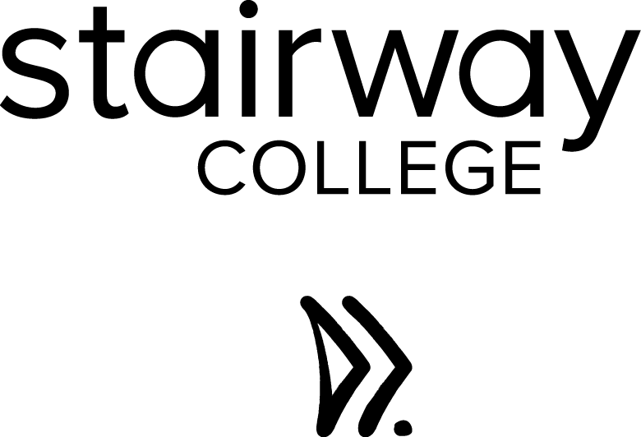

Assessment

STUDENT NAME:

Unit Information

Application
This unit applies to individuals working in Christian communities who need to interpret and discuss Christian scripture and theology relevant to the specific community.

Instructions to Assessors
As the Assessor for this unit, you have the responsibility to ensure the following:
- Provide support and assistance to the student throughout all stages of their course
- Provide feedback to the student throughout their course, and upon submission of their assignments; this feedback needs to be detailed to inform the student of their progress towards completing, or their completion of unit requirements
- Gather quality evidence which will assist you in making an informed assessment decision
- Undertake the assessment by ensuring that the ‘Rules of Evidence’ are met, namely, valid, current, sufficient and authentic.
- Collect and assess evidence in line with the ‘Principles of Assessment’, namely, valid, reliable, flexible and fair.
- Ensure that you observed the principles of reasonable adjustment where appropriate
- Ensure that all the assessment documentation is completed correctly and thoroughly
- Provide an assessment decision to the student, and ensure that it is recorded appropriate on the documentation

Instructions to Students
Unit | CMTTHE401 - Interpret and discuss Christian Scripture and Theology
Assessment Methods | In this assessment, you will find the following tasks:  - Short Answer Questions  - Project Tasks  You are required to satisfactory complete all short answer questions and tasks to be deemed competent in this unit.
Time Frame | Complete this assessment by TBC.
Resources | To complete this unit the following resources are provided to you:  - Support from the Stairway College team  - Allocated a Trainer/Assessor
Submission | Once you have completed all the Short Answer Questions and Project tasks, please submit them via the student portal. For larger files, we suggest that you use compressed zip files. Where multiple documents are present please ensure that they are clearly labelled and referenced.  You will receive email notification once your assessment is submitted. If you do not hear from us within a business day of submitting your assignment, please contact the Stairway College support team.
Feedback | Upon your assessment being received by your Assessor, you can expect to receive formal feedback within 20 business days. If you do not hear from your Assessor within 20 business days, you are encouraged to contact us. You can expect to receive in depth feedback about your assessment tasks. You will be advised if you have obtained competency in the unit, or whether further work is required at which time you will be provided with guidance and an opportunity to resubmit your assessment.
Student Rights | Please refer to the Student Handbook which outlines your rights as a student and which include your opportunity to appeal assessment decisions and reasonable adjustment processes.
Support | At any time during your course, your trainer is available to discuss the content, and the assessment requirements with you. The Stairway College support team is also available.

STUDENT DECLARATION
Candidate Name:
Address:
Contact Number:
Email Address:

Assessment Task: | CMTTHE401 - Interpret and discuss Christian Scripture and Theology
Declaration: | I declare that:  - I have understood the requirements of the Assessment Task, and felt ready to undertake the assessment prior to completing them.  - I have read and understood my rights as a Student as set out in the Student Handbook.  - All information in this document and attached is true and correct and is all my own work.  - No part of this assignment has been completed for me by another person, or been plagiarised in any form.
Signature:
Date:

ASSESSOR SIGNOFF PAGE
Student Name
Unit Title |  | CMTTHE401 - Interpret and discuss Christian Scripture and Theology
Evidence Requirement |  |  | Meets Requirements |  | Date | Comments
 |  |  | Yes (√) | No (x)
- Compare theological beliefs
- Compare Christian sources related to theological views
- Appropriately utilise theological sources and other materials on a specific topic
- Identify and describe the beliefs of groups with other views
Short Answer Questions
Project Tasks
Rules of Evidence compliance – The assessor is to confirm by checking the following items
Attempts | One
 | Two
 | Three
Final Decision at the time of assessment (Please tick yes or no)
Assessor’s Name |  |  |  |  |  |  | Date
Signature
Feedback:

Short Answer Questions
Instructions: There is no specific length for short answer questions. Most questions can be answered in one or two paragraphs, and/or 5 dot points which are explained. This is a guide only, and the question can be used to gauge the length required. If you have questions please contact the Stairway College support team.
- Name four sources of information that contain theological language.
Student answer:
☐ Satisfactory  ☐ Not Yet Satisfactory | Assessor Feedback:
- The gospels illustrate that Jesus and the Pharisees held different views about the Sabbath (e.g. Matt 12:1-14). Describe both views. In your answer ensure that you highlight the key differences and similarities in the views. Communicate in a non-judgemental manner and show tolerance.
View One:
View Two:
☐ Satisfactory  ☐ Not Yet Satisfactory | Assessor Feedback:
- Name and describe four tools that you could use to study the Bible
Tool One:
Tool Two:
Tool Three:
Tool Four:
☐ Satisfactory  ☐ Not Yet Satisfactory | Assessor Feedback:
Overall performance | ☐ Satisfactory  ☐ Not Yet Satisfactory | Trainer:
 |  | Signature:
 |  | Date:
Comments

Task One – Journal and Research
Part One
This course will be taught over a number of weeks. Keep a personal journal during the course to record what God is doing in your life. At the end of the course review your journal and provide answers to the below questions.
- What did I learn in the course? Identify three learnings.
- What input did I receive from my mentor/peers/friends during the course? List three.
- What is God saying to me? List three.
- How have I applied what I've learnt from this course? List three.
- What else am I going to do as a result of the teaching in this course?

Suggested length: 300-500 words |  | Resources:
Your Answer:
☐ Satisfactory  ☐ Not Yet Satisfactory | Assessor Feedback:
Part Two
Present research notes that reflect an understanding and appreciation of at least two differing Christian groups/denominations (e.g. the way each approach the topic of ‘communion’). It is important that your notes are sensitive and honouring to both groups.
In your notes describe:
- The key beliefs of each group.
- What has influenced these key beliefs?
- What each group have in common regarding their beliefs along with what beliefs differ.
- What are your personal beliefs on this topic? Include a scripture reference.
- How are your personal beliefs different and similar to each group?
Note: this will require research beliefs of another denomination; remember to reference your sources.

Suggested length: 200 – 600 words |  | Resources:
Your Answer:

☐ Satisfactory  ☐ Not Yet Satisfactory | Assessor Feedback:
Part Three
Produce (draw/paint/sketch) at least two iconographic images. These images may be directly sourced from your research or your own interpretation on an iconic image.
Sources may be from a variety of art styles such as Byzantine, Renaissance or Contemporary abstract.

Suggested length: Two images |  | Resources:
Your Answer:
☐ Satisfactory  ☐ Not Yet Satisfactory | Assessor Feedback:
Overall performance | ☐ Satisfactory  ☐ Not Yet Satisfactory | Trainer:
 |  | Signature:
 |  | Date:
Comments

Task Two – Understand Theological Themes
Part One
Select and research two parables/illustrative stories or an event as described in scripture that has particular relevance to you. Select one from the Old Testament and one from the New Testament that relate to the same theme/topic.
In your research refer to multiple sources on the theme/topic, such as: scripture, commentaries, articles, course notes, etc. Cleary reference four different sources (one source must be a Bible commentary).
In a written piece discuss and compare the chosen parables/illustrative stories/events in scripture. Include a comparison of the research sources by identifying where they are different and where they are similar. Also, include a comment on the context of each parable/illustrative story/event.

Suggested length: 100 - 500 words |  | Resources:
Your Answer:
☐ Satisfactory  ☐ Not Yet Satisfactory | Assessor Feedback:
Part Two
Imagine you had a conversation with somebody who held an opinion that the Old Testament is completely irrelevant for believers today. In a written piece, describe how you would explain your views on the Old Testament parable/illustrative story/event you chose in Part A. Also describe how you would explain the significance it has had on your life. Remember to be sensitive and honouring in what you communicate.

Suggested length: 50 - 200 words |  | Resources: Observation Form
Your Answer:
☐ Satisfactory  ☐ Not Yet Satisfactory | Assessor Feedback:
Part Three
Produce an image for each that reflects and enhances an understanding and appreciation of the scripture.
The art work will be accompanied by notes that relate the interpretation to a contemporary application.

Suggested length: One image |  | Resources: Observation Form
Your Answer:
☐ Satisfactory  ☐ Not Yet Satisfactory | Assessor Feedback:
Overall performance | ☐ Satisfactory  ☐ Not Yet Satisfactory | Trainer:
 |  | Signature:
 |  | Date:
Comments

Task Three - Artistic Cover Design
& Art Work ComparisoN
Part One
Select and study two passages of scripture relating to the God Artist: one from the Old Testament and one from the New Testament (ensure two different theological beliefs are covered in the chosen passages). Consider parallel themes and teaching.
In your research, reference a variety of sources such as commentaries and books (note: reference at least four sources for each passage and at least one source must be a Bible commentary for each passage). Identify what each source believes about each passage. Then compare what each source believes about the chosen passage/s (ie. what is similar and what is different). Furthermore, make note of any differences between the old and new covenants.
Write notes on each passage. Your notes also need to reflect an understanding of the historical setting/significance and historical influences/context. Examples will be discussed in class such as the temple/ tabernacle and Jesus’ teaching on the Holy Spirit. Remember to accurately reference your sources.

Suggested length: 100 - 300 words each |  | Resources:
Your Answer:
☐ Satisfactory  ☐ Not Yet Satisfactory | Assessor Feedback:
Part Two
Produce a cover and a margin design that reflect in some way the theological teaching from a passage of scripture. The illustrations are to have notations to expand on the ideas illustrated.

Suggested length: One design |  | Resources: Observation Form
Your Answer:
☐ Satisfactory  ☐ Not Yet Satisfactory | Assessor Feedback:
Part Three
Prepare a ten minute short talk for a small group of adult believers (e.g. a church small group with adults over the age of eighteen) about one of the art pieces you have completed during the course. Prepare notes for this talk that include the below points.
- Identify the theological themes/topics expressed in the art work (e.g. love, hope, faith, etc).
Identify at least two.
- Describe the art work and the significance to you personally (i.e. give personal testimony)
- Two key scriptures that relate to the art work
- How can the audience apply what they have learned from this art work to their life?
Deliver the short talk and arrange for an observer to complete the below ‘observation form’.
Suggested length: 100-300 words |  | Resources: Observation Form
Your Answer:
☐ Satisfactory  ☐ Not Yet Satisfactory | Assessor Feedback:
Overall performance | ☐ Satisfactory  ☐ Not Yet Satisfactory | Trainer:
 |  | Signature:
 |  | Date:
Comments

STUDENT FEEDBACK (Student to Complete)
Did you understand the study requirements before undertaking this assessment? | YES or NO
Were the assessment questions easy to understand? | YES or NO
Did you know where you could get help if you needed any during this unit? | YES or NO
Did the learning resources provided help you to complete this unit? | YES or NO
Did you have enough time to complete this assessment? | YES or NO
Did you feel that you developed skills after undertaking this assessment? | YES or NO
Any other comments?

