
Learner Guide


CHC50121 - Diploma of Early Childhood Education and Care
CHCECE043 - Nurture creativity in children

Version Control & Document History
Date | Summary of Modifications | Version
21 July 2021 | Version 1.0 released for publishing | 1.0

Table of Contents

This Learner Guide 5
Introduction 13
I. Understand the Role of the Arts in Development and Learning 25
1.1 Explore the Role of the Arts in Early Childhood Development and Learning 26
1.2 Understand the Concept of Creative Freedom and Its Positive Connection to Development and Learning 28
1.3 Identify the Connection Between Creativity and Different Learning Dispositions 30
1.4 Provide Opportunities for Children to be Exposed to a Range of Art Forms and Artists From Diverse Cultures 33
1.5 Provide Experiences That Allow Children to be Exposed to Aboriginal and/or Torres Strait Islander People’s Art Forms and Artists 37
II. Creating Experiences That Nurture Creativity 40
2.1 Identify Opportunities That Nurture Creativity, Based on Children’s Interest and Cultural Backgrounds 41
2.2 Structure and Document Opportunities and Intentional Teaching Strategies That Assist Children to Explore the Arts 52
2.2.1 Structure Opportunities to Explore the Arts 53
2.2.2. Intentional Teaching Strategies 69
2.2.3. Document Opportunities and Intentional Teaching Strategies 72
2.3 Research and Organise Resources Required for Creative Activities 75
2.4 Select and Promote the Use of Diverse Natural and Found Materials and Make Them Available to Children 76
2.5 Identify and Use Opportunities to Make Sustainable Resources 79

III. Nurture Creativity Through Teaching and Learning 83
3.1 Provide Time for Children to be Creative and Encourage Efforts to Extend Over Days or Weeks 84
3.2 Teach Children How to Use and Care for Materials and Equipment According to the Nature of the Activity 86
3.3 Plan and Create Opportunities for Children to Collaborate Creatively With Each Other 88
3.4 Encourage Children to Use Creativity to Overcome Challenges 90
3.5 Use Flexibility to Respond to Children’s Interest and Needs 92
IV. Nurture Creativity Through Engagement With Children 95
4.1 Support Children to Feel a Sense of Value and Responsibility for Equipment and Materials Through Encouragement and Modelling 96
4.2 Use Strategies That Model Creativity by Improvising With Equipment and Materials 99
4.3 Encourage Children to Pursue Their Own Original Ideas, Interpretations and Expressions 102
4.4 Invite Children to Ask Questions and Assist Them to Find Their Own Answers 104
4.5 Engage Children in Talking About Their Creations and Ask Them Open-Ended Questions 107
4.6 Model and Share Enthusiasm for Creative Work With Children 109
4.7 Show Respect and Seek Permission From Children Regarding Their Creative Work 110
4.8 Encourage Children to Respect and Appreciate the Creative Effort of Their Peers 112
V. Evaluate Experiences 115
5.1 Monitor Children’s Role in Creativity Through Observation and Critical Reflection 116
5.2 Identify and Use Opportunities to Gather Feedback From Colleagues, Families and Children 119
5.3 Use and Expand on Children’s Ideas in Relation to Creativity 120
5.4 Collaborate With Others to Regularly Evaluate Children’s Participation in Experiences and Document Outcomes According to Service Policies and Procedures 122
5.5 Use Evaluation Outcomes to Inform Future Practices 128
References 131

This Learner Guide
CHCECE043 - Nurture creativity in children (Release 1)
This unit describes the performance outcomes, skills and knowledge required to develop, implement and evaluate experiences that nurture creativity in children through construction, digital technologies, dramatic play, imaginative play, movement, music and visual art.
This unit applies to educators who both develop and implement learning experiences in the context of an approved learning framework in regulated children’s education and care services in Australia. Work is undertaken independently, but according to the philosophy of the service.
The skills in this unit must be applied in accordance with Commonwealth and State/Territory legislation, Australian standards and industry codes of practice.
No occupational licensing, certification or specific legislative requirements apply to this unit at the time of publication.
A complete copy of the above unit of competency can be downloaded from the TGA website:
https://training.gov.au/Training/Details/CHCECE043

Accessing the Intranet Pages and External Links
As a worker, a trainee, or a future worker, you want to enjoy your work and become known as a valuable team member. This unit of competency will help you acquire the knowledge and skills to work effectively as an individual and in groups. It will give you the basis to contribute to the goals of the organisation which employs you.
It is essential that you begin your training by becoming familiar with the industry standards to which organisations must conform.

This Learner Guide Covers
Nurture creativity in children
- Understand the role of the arts in development and learning
- Create experiences that nurture creativity
- Nurture creativity through teaching and learning
- Nurture creativity through engagement with children
- Evaluate experiences

Learning Program
As you progress through this unit of study, you will develop skills in locating and understanding an organisation’s policies and procedures. You will build up a sound knowledge of the industry standards within which organisations must operate. You will become more aware of the effect that your own skills in dealing with people have on your success or otherwise in the workplace. Knowledge of your skills and capabilities will help you make informed choices about your further study and career options.

Additional Learning Support
To obtain additional support, you may:
- Search for other resources. You may find books, journals, videos and other materials which provide additional information about topics in this unit.
- Search for other resources in your local library. Most libraries keep information about government departments and other organisations, services and programs. The librarian should be able to help you locate such resources.
- Contact information services such as Infolink, Equal Opportunity Commission, Commissioner of Workplace Agreements, Union organisations, and public relations and information services provided by various government departments. Many of these services are listed in the telephone directory.
- Contact your facilitator.

Facilitation
Your training organisation will provide you with a facilitator. Your facilitator will play an active role in supporting your learning. Your facilitator will help you at any time during working hours to assist with:
- How and when to make contact,
- what you need to do to complete this unit of study, and
- what support will be provided.
Here are some of the things your facilitator may do to make your study easier:
- Give you a clear visual timetable of events for the semester or term in which you are enrolled, including any deadlines for assessments.
- Provide you with online webinar times and availability.
- Use ‘action sheets’ to remind you about tasks you need to complete, and updates on websites.
- Make themselves available by telephone for support discussion and provide you with industry updates by email where applicable.
- Keep in touch with you during your studies.

Flexible Learning
Studying to become a competent worker is an interesting and exciting thing to do. You will learn about current issues in this area. You will establish relationships with other students, fellow workers, and clients. You will learn about your own ideas, attitudes, and values. You will also have fun. (Most of the time!)
At other times, studying can seem overwhelming and impossibly demanding, particularly when you have an assignment to do and you aren’t sure how to tackle it, your family and friends want you to spend time with them, or a movie you want to see is on television.
Sometimes being a student can be hard.
Here are some ideas to help you through the hard times. To study effectively, you need space, resources, and time.

Space
Try to set up a place at home or at work where:
- You can keep your study materials,
- you can be reasonably quiet and free from interruptions, and
- you can be reasonably comfortable, with good lighting, seating, and a flat surface for writing.
If it is impossible for you to set up a study space, perhaps you could use your local library. You will not be able to store your study materials there, but you will have quiet, a desk and chair, and easy access to the other facilities.

Study Resources
The most basic resources you will need are:
- A chair
- A desk or table
- A computer with Internet access
- A reading lamp or good light
- A folder or file to keep your notes and study materials together
- Materials to record information (pen and paper or notebooks, or a computer and printer)
- Reference materials, including a dictionary
Do not forget that other people can be valuable study resources. Your fellow workers, work supervisor, other students, your facilitator, your local librarian, and workers in this area can also help you.

Time
It is important to plan your study time. Work out a time that suits you and plan around it. Most people find that studying, in short, concentrated blocks of time (an hour or two) at regular intervals (daily, every second day, once a week) is more effective than trying to cram a lot of learning into a whole day. You need time to ‘digest’ the information in one section before you move on to the next, and everyone needs regular breaks from study to avoid overload. Be realistic in allocating time for study. Look at what is required for the unit and look at your other commitments.
Make up a study timetable and stick to it. Build in ‘deadlines’ and set yourself goals for completing study tasks. Allow time for reading and completing activities. Remember that it is the quality of the time you spend studying rather than the quantity that is important.

Study Strategies
Different people have different learning ‘styles’. Some people learn best by listening or repeating things out loud. Some learn best by ‘doing’, some by reading and making notes. Assess your own learning style and try to identify any barriers to learning which might affect you. Are you easily distracted? Are you afraid you will fail? Are you taking study too seriously? Not seriously enough? Do you have supportive friends and family? Here are some ideas for effective study strategies:
- Make notes. This often helps you to remember new or unfamiliar information. Do not worry about spelling or neatness, as long as you can read your own notes. Keep your notes with the rest of your study materials and add to them as you go. Use pictures and diagrams if this helps.
- Underline keywords when you are reading the materials in this Learner Guide. (Do not underline things in other people’s books.) This also helps you to remember important points.
- Talk to other people (fellow workers, fellow students, friends, family, or your facilitator) about what you are learning. As well as help you to clarify and understand new ideas, talking also gives you a chance to find out extra information and to get fresh ideas and different points of view.

Using this Learner Guide
A Learner Guide is just that, a guide to help you learn. A Learner Guide is not a textbook. Your Learner Guide will:
- Describe the skills you need to demonstrate to achieve competency for this unit.
- Provide information and knowledge to help you develop your skills.
- Provide you with structured learning activities to help you absorb knowledge and information and practice your skills.
- Direct you to other sources of additional knowledge and information about topics for this unit.

How to Get the Most Out of Your Learner Guide
Some sections are quite long and cover complex ideas and information. If you come across anything you do not understand:
- Talk to your facilitator.
- Research the area using the books and materials listed under Resources.
- Discuss the issue with other people (your workplace supervisor, fellow workers, fellow students).
- Try to relate the information presented in this Learner Guide to your own experience and to what you already know.
- Ask yourself questions as you go. For example, ‘Have I seen this happening anywhere?’ ‘Could this apply to me?’ ‘What if...’ This will help you to ‘make sense’ of new material, and to build on your existing knowledge.
- Talk to people about your study. Talking is a great way to reinforce what you are learning.
- Make notes.
- Work through the activities. Even if you are tempted to skip some activities, do them anyway. They are there for a reason, and even if you already have the knowledge or skills relating to a particular activity, doing them will help to reinforce what you already know. If you do not understand an activity, think carefully about the way the questions or instructions are phrased. Read the section again to see if you can make sense of it. If you are still confused, contact your facilitator or discuss the activity with other students, fellow workers or with your workplace supervisor.

Additional Research, Reading, and Note-Taking
If you are using the additional references and resources suggested in the Learner Guide to take your knowledge a step further, there are a few simple things to keep in mind to make this kind of research easier.
Always make a note of the author’s name, the title of the book or article, the edition, when it was published, where it was published, and the name of the publisher. This includes online articles. If you are taking notes about specific ideas or information, you will need to put the page number as well. This is called the reference information. You will need this for some assessment tasks, and it will help you to find the book again if you need to.
Keep your notes short and to the point. Relate your notes to the material in your Learner Guide. Put things into your own words. This will give you a better understanding of the material.
Start off with a question you want answered when you are exploring additional resource materials. This will structure your reading and save you time.

Introduction
The development of a child’s creativity relies upon the interaction and environment they are exposed to during their early years. As an educator, your role plays a big part in nurturing children’s creativity through the activities and experiences you prepare for them. This learner guide will help you understand how every interaction contributes to children’s creative development.
The freedom to express oneself without judgement and prejudice will be advantageous to children in early education. This stage in a child’s life can be ideal for developing a sense of creativity, confidence, imagination, language, and emotional capacity among children. You must understand the contributing factors and areas of learning to maximise opportunities and nurture children’s creativity.
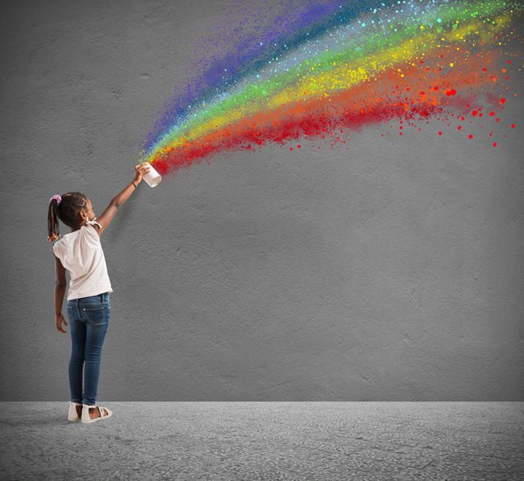

This learner guide will discuss the following topics to equip educators like you in nurturing creativity in children:

Early Years Learning Framework
The Australian and State/Territory Governments, in collaboration with the early childhood sector and academics, developed Belonging, Being & Becoming - The Early Years Learning Framework (EYLF) for Australia as means of standardising the principles, practices, and outcomes used in early childhood education and care. It is a learning framework that encourages a holistic approach in teaching through play-based learning instead of traditional academic milestones. A holistic approach in early childhood education and care connects children’s development with their environment and builds strong relationships through active learning and social activities.
The EYLF does not require educators to follow a certain way of teaching or what to teach; instead, it provides direction about intent, pedagogy, and outcomes for children’s learning—it gives the foundation for a specific, local curriculum. These pedagogical practices include:
- adopting holistic approached
- being responsive to children
- planning and implementing learning through play
- intentional teaching
- creating physical and social learning environments that have a positive impact on children’s learning
- valuing the cultural and social contexts of children and their families

- providing for continuity in experiences and enabling children to have a successful transition
- assessing and monitoring children’s learning to inform provision and to support children in achieving learning outcomes.
Sourced from The Early Years Learning Framework for Australia, used under CC BY 4.0. © Commonwealth of Australia

These practices will help educators like you to plan content relevant to their local context and be responsive to children’s interests and ideas as they work towards achieving the broad outcomes of the EYLF. The planned programs and activities are learning opportunities that should encourage curiosity and exploration, which will lead to the development of learning dispositions. Children’s exploration is a doorway to creativity. They will learn new ways to speak out their minds, express ideas in different ways, and use their imagination to discover solutions to their problems. All these are fueled by creativity.
Outcome 4 of the EYLF states that ‘Children are confident and involved learners.’ It highlights children’s ability to be responsible for their own learning and develop self-esteem as they approach new experiences. Under this, it says that:

Sourced from The Early Years Learning Framework for Australia, used under CC BY 4.0. © Commonwealth of Australia

Although all statements are relevant in a child’s development, the first statement is especially evident in how children express wonder and interest in their environments and use play to investigate, imagine, and explore ideas. The development of these qualities in children demonstrates the importance of allowing them to explore and develop creativity. As an educator, you play a role in making this happen.

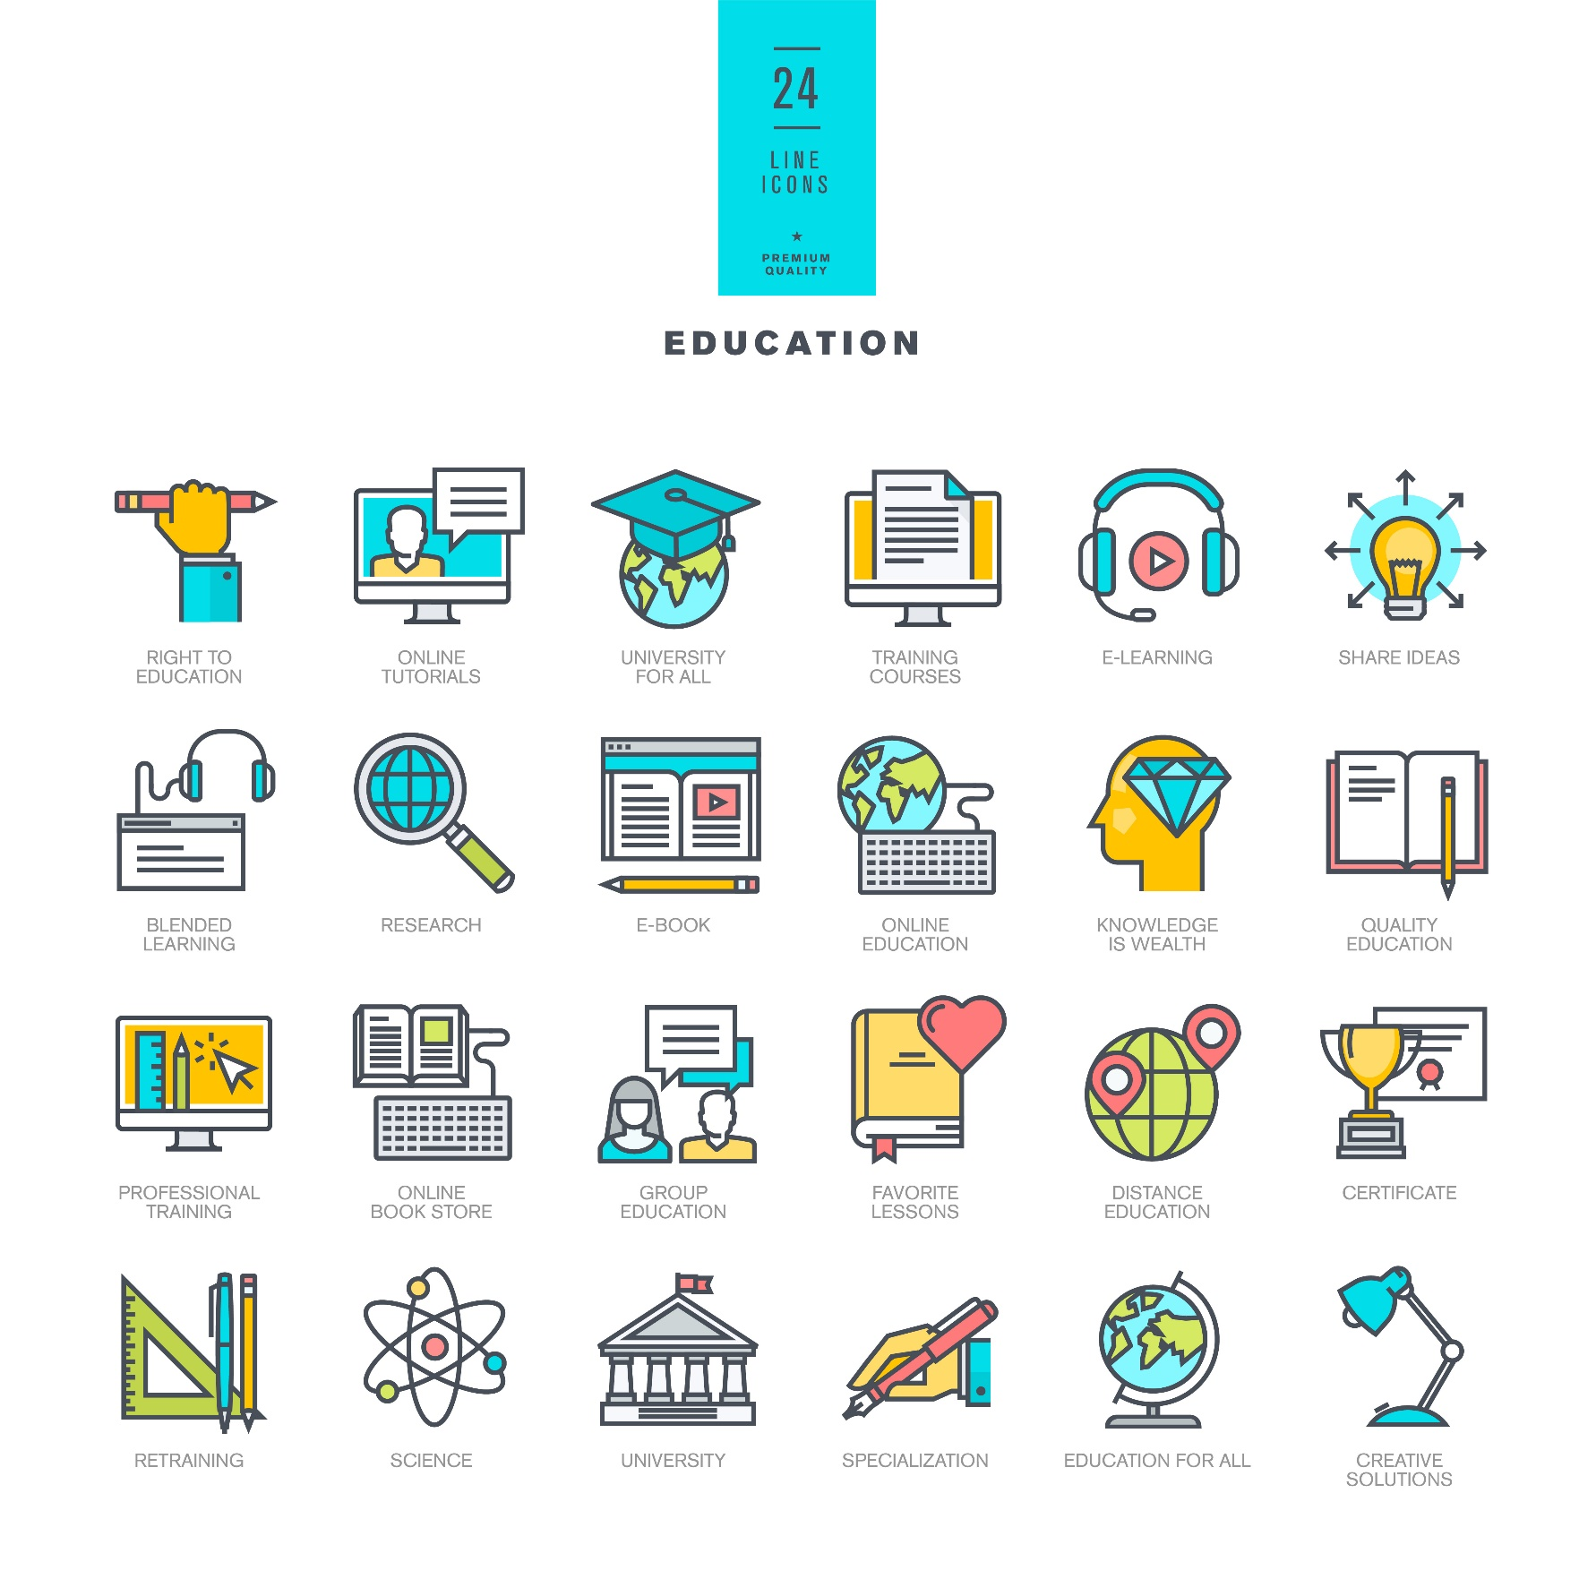 | Further Reading  You may refer to the Early Years Learning Framework (EYLF) to know more about Outcome 4: Children are Confident and Involved Learners (pages 36 to 40).  Early Years Learning Framework for Australia

National Quality Standard
The National Quality Standard (NQS) sets the standard for Australia’s quality of education and care services. The NQS establishes seven quality areas where education and care services are assessed and given a rating to determine compliance. These quality areas are important outcomes for children, especially in their early years.
The seven Quality Areas of the National Quality Standard are as follows:

This unit will focus on Quality Areas 1, 2, 3, and 5 of the National Quality Standard. It states the service standards, policies and procedures for children’s health and safety, educational program and practice, physical environment, and relationships with children. These quality areas will help you understand your role in nurturing creativity in children.

Quality Area 1: Educational Program and Practise
This Quality Area emphasises the importance of stimulating and engaging educational programs and practices to encourage children to participate in the learning process. It ensures that early childhood education and care programs and services exist to nurture the development of life skills and help children relate them to their experiences, opportunities, and relationships inside and outside the school.
Quality Area 1 outlines three standards for an educational program and practice. These standards and their elements are presented in the table below.

Standard 1.1 | Program | The educational program enhances each child’s learning and development.
Element 1.1.1 | Approved learning framework | Curriculum decision making contributes to each child’s learning and development outcomes in relation to their identity, connection with community, wellbeing, confidence as learners and effectiveness as communicators.
Element 1.1.2 | Child-centred | Each child’s current knowledge, strengths, ideas, culture, abilities, and interests are the foundation of the program.
Element 1.1.3 | Program learning opportunities | All aspects of the program, including routines, are organised in ways that maximise opportunities for each child’s learning.

Standard 1.2 | Practice | Educators facilitate and extend each child’s learning and development.
Element 1.2.1 | Intentional teaching | Educators are deliberate, purposeful, and thoughtful in their decisions and actions.
Element 1.2.2 | Responsive teaching and scaffolding | Educators respond to children’s ideas and play and extend children’s learning through open-ended questions, interactions and feedback.
Element 1.2.3 | Child-directed learning | Each child’s agency is promoted, enabling them to make choices and decisions that influence events and their world.
Standard 1.3 | Assessment and planning | Educators and coordinators take a planned and reflective approach to implementing the program for each child.
Element 1.3.1 | Assessment and planning cycle | Each child’s learning and development is assessed or evaluated as part of an ongoing cycle of observation, analysing learning, documentation, planning, implementation and reflection.
Element 1.3.2 | Critical reflection | Critical reflection on children’s learning and development, both as individuals and in groups, drives program planning and implementation.
Element 1.3.3 | Information for families | Families are informed about the program and their child’s progress.
Sourced from National Quality Standard, used under CC BY 4.0. © State of Victoria (Department of Education and Training)

Quality Area 2: Children’s Health and Safety
The objective of this Quality Area is to guarantee that children have access to quality education and care that makes their health and safety a priority, including minimising risks and protecting children from harm, injury, and infection. A child’s physical and psychological wellbeing should be given high importance by early childhood education and care service providers. It should support the child’s growing competence, independence, and confidence.
The standards outlined by Quality Area 2 and their elements are presented in the table below:
Standard 2.1 | Health | Each child’s health and physical activity is supported and promoted.
Element 2.1.1 | Wellbeing and comfort | Each child’s wellbeing and comfort is provided for, including appropriate opportunities to meet each child’s need for sleep, rest and relaxation.
Element 2.1.2 | Health practices and procedures | Effective illness and injury management and hygiene practices are promoted and implemented.
Element 2.1.3 | Healthy lifestyle | Healthy eating and physical activity are promoted and appropriate for each child.
Standard 2.2 | Safety | Each child is protected.
Element 2.2.1 | Supervision | At all times, reasonable precautions and adequate supervision ensure children are protected from harm and hazard.
Element 2.2.2 | Incident and emergency management | Plans to effectively manage incidents and emergencies are developed in consultation with relevant authorities, practised, and implemented.
Element 2.2.3 | Child protection | Management, educators, and staff are aware of their roles and responsibilities to identify and respond to every child at risk of abuse or neglect.
Sourced from National Quality Standard, used under CC BY 4.0. © State of Victoria (Department of Education and Training)
Quality Area 3: Physical Environment
The objective of this Quality Area is to ensure that the physical environment is safe, suitable and promotes the learning and development of children through a wide array of rich and diverse experiences. Early childhood education and care service providers must ensure that the environment promotes inclusive relationships and is designed, equipped, and organised to maximise children’s level of engagement, positive experience.
This Quality Area outlines two standards for the physical environment of children. The standards and their elements are presented in the table below.
Standard 3.1 | Design | The design of the facilities is appropriate for the operation of a service.
Element 3.1.1 | Fit for purpose | Outdoor and indoor spaces, buildings, fixtures, and fittings are suitable for their purpose, including supporting the access of every child.
Element 3.1.2 | Upkeep | Premises, furniture, and equipment are safe, clean, and well maintained.
Standard 3.2 | Use | The service environment is inclusive, promotes competence and supports exploration and play-based learning.
Element 3.2.1 | Inclusive environment | Outdoor and indoor spaces are organised and adapted to support every child’s participation and to engage every child in quality experiences in both built and natural environments.
Element 3.2.2 | Resources support play-based learning | Resources, materials, and equipment allow for multiple uses, are sufficient in number, and enable every child to engage in play-based learning.
Element 3.2.3 | Environmentally responsible | The service cares for the environment and supports children to become environmentally responsible.
Sourced from National Quality Standard, used under CC BY 4.0. © State of Victoria (Department of Education and Training)

Quality Area 5: Relationships with Children
The objective of this Quality Area is to ensure that early childhood education and care service providers build responsive and respectful relationships with children. It promotes a sense of security and belongingness to children and makes them feel free to explore their environment as they engage in play and learning.
This Quality Area outlines two standards for relationships with children. The standards and their elements are presented in the table below.
Standard 5.1 | Relationships between educators and children | Respectful and equitable relationships are maintained with each child.
Element 5.1.1 | Positive educator to child interactions | Responsive and meaningful interactions build trusting relationships which engage and support each child to feel secure, confident, and included.
Element 5.1.2 | Dignity and rights of the child | The dignity and rights of every child are maintained.
Standard 5.2 | Relationships between children | Each child is supported to build and maintain sensitive and responsive relationships.
Element 5.2.1 | Collaborative learning | Children are supported to collaborate, learn from, and help each other.
Element 5.2.2 | Self-regulation | Each child is supported to regulate their own behaviour, respond appropriately to the behaviour of others and communicate effectively to resolve conflicts.
Sourced from National Quality Standard, used under CC BY 4.0. © State of Victoria (Department of Education and Training)

When talking about nurturing creativity in children, Quality Areas 1, 2, 3, and 5 directly affect the practices you put into place to encourage children in their creative pursuits. To illustrate: When coming up with creative activities for children, you must make sure that they contribute to children’s learning and development (Quality Area 1) and arrange classrooms to provide stimulating environments (Quality Area 3). In addition, you must encourage them in their creative pursuits (Quality Area 5) and consider that the materials used are non-toxic or will not pose any harm to children (Quality Area 2).

National Quality Framework
In pursuit of better educational and developmental outcomes for children, all Australian governments created a standard for regulation, assessment, and quality improvement for early childhood education and care across long daycare, family daycare, preschool/kindergarten, and outside school hours care services.
The National Quality Framework (NQF) was established on 1st January 2012, and applied to most early years learning centres (EYLC) in Australia. In Western Australia, the National Quality Framework also extends to home-based care. The NQF aims to set a standard on the quality of childhood care and education services and monitor the improvement and consistency through:

The NQF operates under an applied law system consisting of the National Law and National Regulations. Essentially, the same is applied across Australia with some provisions to satisfy the different needs of each state/territory.
The law passed by Victoria, the Education and Care Services National Law Act 2010, essentially applied across Australia. The other jurisdictions adopted this law through the Application Act and passed corresponding legislation with some provisions to satisfy the needs of each state/territory.

The legislation followed in each state/territory are as follows:
State/Territory | Legislation | Application Act
Victoria | Education and Care Services National Law Act 2010
New South Wales |  | Children (Education and Care Services National Law Application) Act 2010
Australian Capital Territory |  | Education and Care Services National Law (ACT) Act 2011
Northern Territory |  | Education and Care Services (National Uniform Legislation) Act 2011
South Australia |  | Education and Early Childhood Services (Regulation and Standards) Act 2011
Tasmania |  | Education and Care Services National Law (Application) Act 2011
Queensland |  | Education and Care Services National Law (Queensland) Act 2011
Western Australia | Education and Care Services National Law (WA) Act 2012

Access the applicable law in your state/territory by clicking the link provided in the table above. Review and identify the legislations that apply to the Quality Areas mentioned earlier.
The underpinning regulations can be reviewed in the Education and Care Services National Law Act 2010. As an educator, you must be familiar with the different standards and regulations associated with these Quality Areas to satisfy the requirements of this unit.

You may access the regulations for Quality Areas 1, 2, 3, and 5 in the table below.
Underpinning Regulations of Each Quality Area
Quality Area 1: Educational program and practice
Quality Area 2: Children’s health and safety
Quality Area 3: Physical environment
Quality Area 5: Relationships with children

Further Reading
The Guide to the National Quality Framework summarises the corresponding laws and regulations that apply to each Quality Area. The NQF also includes the assessment and quality rating process and the approved learning frameworks. Read more about these topics through the links below.
Guide to the National Quality Framework
Approved Learning Frameworks
Assessment and Rating Process

I. Understand the Role of the Arts in Development and Learning
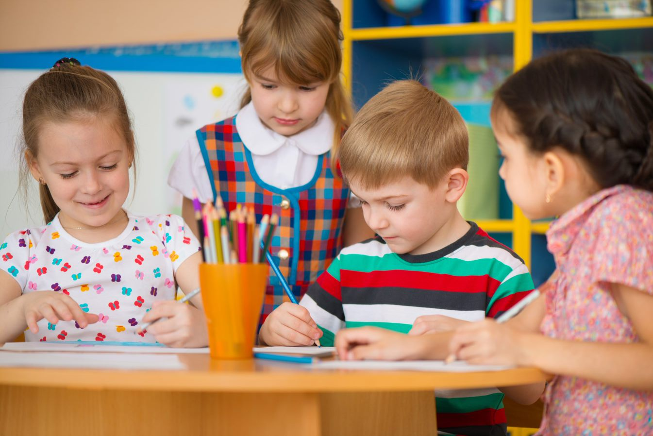
Most of the time, the arts is associated with a drawing or a painting on a piece of paper. It is usually expected to come with an output or a product. This thinking may be correct. However, the role of arts, especially in children’s development and learning, is way beyond the colourful pieces that children get to bring home from class.
You must understand the role of arts in the development and learning of children. By doing so, you can be more intentional in giving children opportunities to engage in art activities and processes. Studies prove that children are given more avenues to express themselves and communicate their thoughts and feelings when they are provided with opportunities to explore the arts. It is also linked to the development of other skills. One of these is the ability to create meaning in their daily experiences by expressing their creative thinking.

Further Reading
The following research papers discuss the relationship of arts in early childhood. You may read more about them by accessing the links below.
Arts-based Educational Research in the Early Years
Exploring Art in Early Childhood Education

1.1 Explore the Role of the Arts in Early Childhood Development and Learning
Art contains various advantages for a child’s learning and development, especially during the early years, which is proven to be the stage where their brains absorb information like sponges. Art can be used as a tool to express emotions, even with adults. The same is true for children whose thoughts, feelings, and interests can show by the way they engage in creating something and freely execute what is in their minds.
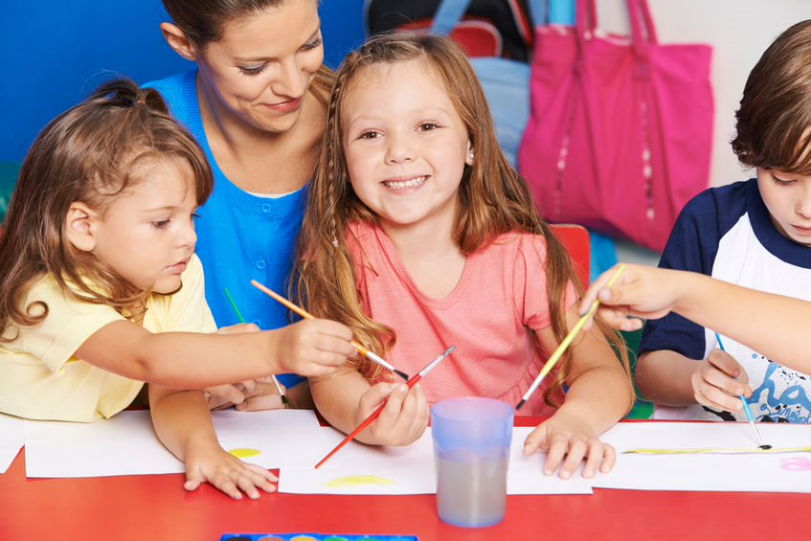
The artistic expression of a child refers to their ability to communicate with their minds. When they are allowed to explore their environment freely, they discover different ways to enhance this skill. Besides self-expression and creativity, children also develop the following skills:
- Communication skills
Arts is an effective tool that allows children to learn to communicate feelings they cannot verbalise yet. It can be through the use of bright colours, a portrait of the person they love, someone they miss, or a translation of their imagination.

- Problem-solving skills
Part of artistic expression is creativity. While artistic ability relates more to a child’s skills to demonstrate art expressions, creativity is more related to using the imagination to create and solve problems. Allowing children to be engaged in different art forms will open doors to learning and creating ways to solve problems.
- Physical skills
When children participate in art activities they are interested in, they are more likely to engage their whole bodies in the process. It includes using their fine and gross motor skills to manipulate objects and tools or move from one place to another to achieve a goal. Children will learn to use and move objects with their bodies properly.
- Social skills
Once children enjoy the different art processes, they can eventually be open to having someone else join them and learn about sharing, taking turns and appreciating others’ work. Art activities are also opportunities to learn and practise collaboration and to work together.
- Emotional skills
Since art activities can be venues for self-expression, children can learn to use them to regulate their feelings and soothe or calm themselves. It may be a form of redirection and an appropriate way of handling both pleasant and unpleasant feelings.

Further Reading
Read more about children’s developmental milestones and how arts play a role in the development of each domain. Access the link below.
Early Years Learning Framework Practice-Based Resources – Developmental Milestones

1.2 Understand the Concept of Creative Freedom and Its Positive Connection to Development and Learning
Creative freedom is about expressing thoughts and ideas through a limitless range of materials, methods, or techniques to create a tangible, abstract, or observable output. It refers to one’s ability, independence, and liberty to produce any kind of product without being contained in a specific instruction.
Creative freedom’s foundations are based on the idea of adopting an approach that is outside the usual practices. ‘Thinking outside the box,’ as some people may refer to it. It involves processes where children can freely move, combine, redesign, line up, take apart, put together materials, or use their senses to develop different ways of self-expression and problem-solving techniques.
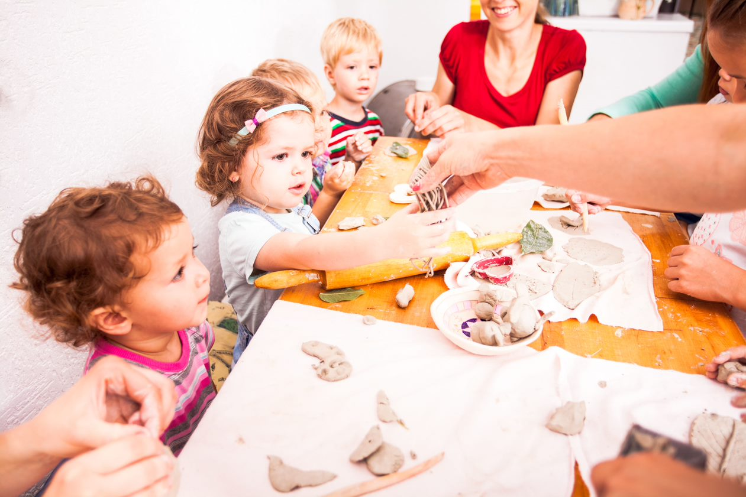
Current research shows that creativity provides children with a healthy opportunity to channel their uninhibited energies and communicate themselves. It also presents an opportunity for them to learn about themselves through expression. Multiple fields of study consider creativity valuable and something to be cultivated from a young age. You may access research studies about this in the Further Reading section found on the next page.

Creative freedom is critical in children’s learning and their exploration of various life processes. Creativity learnt through play promotes a fun and enjoyable experience for children. It helps develop a new perspective on situations and things, critical thinking skills, motor skills, communication skills, problem-solving, and individual expression.
When doing activities such as painting, drawing, or playing, allow children to use the materials however they see fit, as long as it is not destructive or harmful to themselves or the people around them. Instead of giving them an object to draw, hand them a sheet of paper and the materials needed to make markings on it. Let them scribble, draw, or doodle whatever they want. Once they are finished, ask them why they chose to draw what they did and find out the inspiration for their creations without downplaying their inspirations and references.
The freedom to express and manipulate materials in an unstructured way allows children to explore, experiment, and, most of all, have fun without restrictions. Additionally, allowing them to create freely teaches them accountability and responsibility, which helps in making them realise how their actions affect themselves, their work, and the people around them.
Most of the time, the focus of arts and creativity is on the result and does not give much importance to the process to reach it. However, the process is equally significant, especially in their creative goals, as it includes all the methods, choices, and procedures that children made to achieve the output.
The benefits of creativity to the learning and development of the child do not depend on the product alone. For example, children develop their fine motor skills during the actual process of painting or sculpting. The appearance of the final artwork has no bearing on motor skills development and is instead a product of their engagement in the process. You must also take into consideration the different rates at which children develop. By focusing on the creative process instead of comparing children’s results, you can ensure children’s needs for developing relevant skills are addressed.
Further Reading
Learn more about researches about the importance of creative freedom and how it helps in children’s learning and development by accessing the links below:
Children’s Creativity: A Theoretical Framework and Systematic Review
Developing Young Children’s Creativity: What Can We Learn From Research?
Creativity as a Stepping Stone towards Developing Other Competencies in Classrooms

1.3 Identify the Connection Between Creativity and Different Learning Dispositions
Creativity is your ability to express existing knowledge and skills in new ways and create something new from your personal feelings and experiences. Creativity is in every aspect of your life. It is in the way you think, enquire, make, and do.
Many people show their creativity when expressing their thoughts and feelings through drawing, painting, writing in a journal, combining ingredients to create a meal, or developing strategies to accomplish a task. Being creative involves nurturing interests, expressing ideas, and working towards solving everyday problems. It goes the same with children.
Creative experiences include:
- Self-expression (e.g. verbal and non-verbal)
- Sensory experiences (e.g. seeing, hearing, touching, tasting, smelling, moving through space)
- Play (e.g. exploration, manipulation, role-playing etc.)
Young children are naturally creative. If nurtured, creativity will grow and expand as children refine their skills, add to their life experience, and increase their understanding of the world. Children view their world and approach learning through these experiences, which is what learning dispositions are all about.

Learning Dispositions
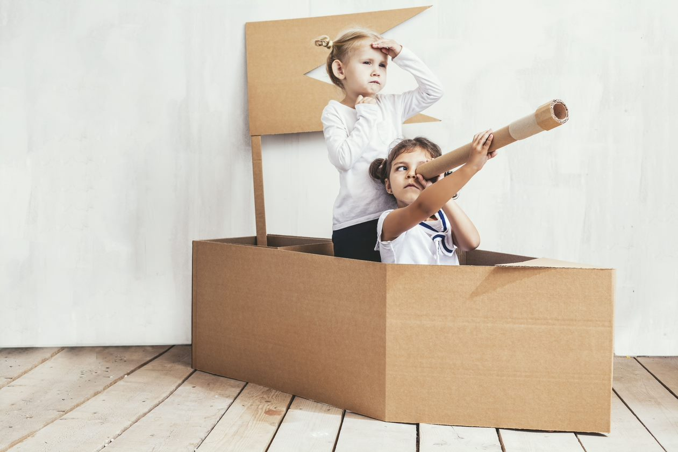
Children are more likely to be comfortable being in their natural state when they feel safe. This safety is not just about the physical aspect but also a safe place, free from judgment and restrictions. When children feel free to explore the environment, they are more likely to develop positive approaches to learning. It will also lead to uninterrupted play and a full engagement in activities that foster creativity.
Children develop confidence and problem-solving skills when they are given opportunities to make age-appropriate decisions. They can be flexible and use their imagination and creativity to solve problems when given access to a wide range of materials and allowed to execute their plans. Children are more likely to participate and engage in their environment when they know that they are free to explore and make discoveries. They tend to show persistence and develop a sense of independence in a supportive environment.
The NSW Government website describes learning dispositions as ‘habits of mind’ and refer to children’s ways of engaging with the learning process. These definitions indicate that children’s dispositions are observable behaviours that can be seen as they engage with different learning processes. Instead of the outcomes, learning dispositions, such as creativity, show the processes and how children approach learning.
Some of the common learning dispositions observed in children include:

- Persistence
Children’s drive to remain in a task and not easily give up until their goal is achieved. Persistence is a fundamental skill in developing resilience, which, on the other hand, develops children’s coping ability when facing challenges.
- Agility and flexibility
Children’s ability to reflect on new information and change their strategy and techniques as they approach tasks. They consider alternatives and different sources of information to decide which will work best in achieving their goal.
- Motivation and drive to learn
Children’s enthusiasm and engagement in new learning experiences. They show great interest in discoveries and can cope with the challenges in learning.

- Metacognition (thinking about thinking)
Children’s ability to reflect on the situation and respond to their thoughts while engaging in learning experiences and gathering new ideas and concepts. It involves children’s ability to think about achieving their goals with the correct strategies based on the information they have.
- Problem-solving and questioning
Children’s tendency to find problems to solve and ask relevant questions to further their knowledge and understanding. When children become effective problem-solvers, they learn to anticipate the possible outcomes of their strategies and ask problems characterised by ‘if’ questions that require further investigation.
Based on Learning dispositions, used under CC BY 4.0 © State of New South Wales (Department of Education), 2021

When educators such as yourself understand how children learn, you can provide appropriate learning opportunities to support children and develop their skills further. Planning activities that encourage creativity is a vital factor in developing learning dispositions.
For example, children can use creativity in trying out ways to put a broken wooden block together. Based on their previous experiences, they may use glue because they know that it sticks things together. Then, after an activity that allows children to peel stickers, for example, one of them realised that stickers are also materials for ‘sticking’ and may help ‘fix’ the wooden block. Remember that even if the solutions they consider may not make sense to you as an adult, you must allow children to try, experiment and prove if their ideas will work.
Through an unplanned situation like this, persistence is practised when children stay on task and find solutions to fix a broken wooden block. Metacognition and problem-solving skills can be observed when children reflect on past experiences and recall that glue can be used to stick things together and fix the broken wooden block when the same concept is applied. If that does not work, they can find other ways to continue with the task, such as using stickers, which reflects flexibility. Children show motivation when they encounter something new and are allowed to execute their plans, whether in building structures using wooden blocks or fixing them when they get broken.
When you observe how children use their creativity in learning opportunities, you will realise that creativity may appear in different means and learning dispositions. Do children show creativity by constantly asking questions on how things are done? Is it in the way they explore? Is it in how they create new ways to address old problems? You play an important role in the observation and analysis of these connections.

1.4 Provide Opportunities for Children to be Exposed to a Range of Art Forms and Artists from Diverse Cultures

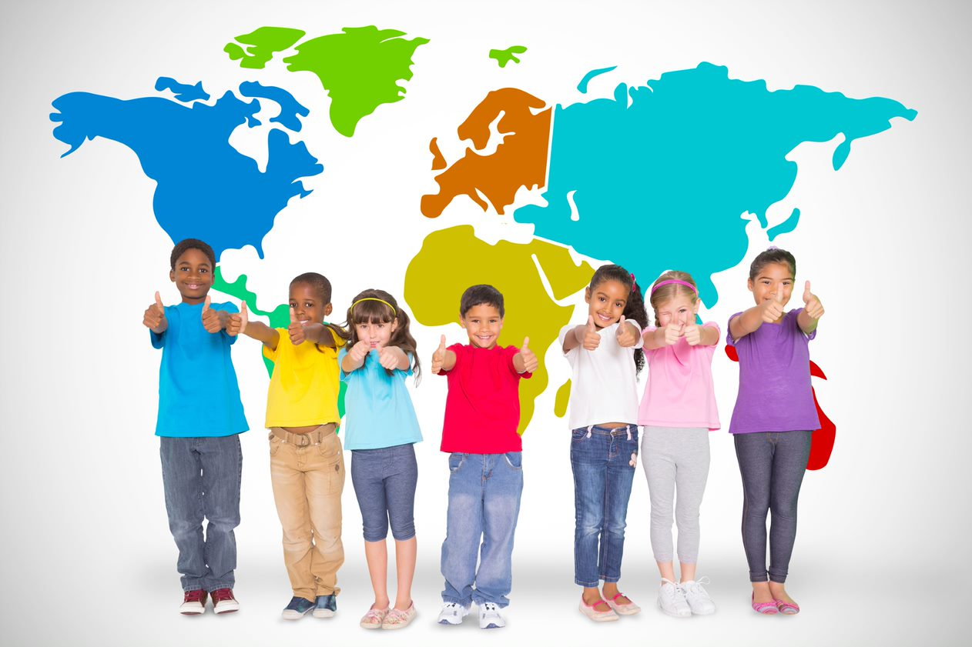
There are various opportunities that you can provide to allow children to be exposed to various art forms. Each art form includes different processes that children can explore and learn about each form’s components.
Arts is the artistic expression and a product of one’s skills and imagination intended to be shared with others, whether in objects, the environment, or experience. The Australian Government’s Office for the Arts supports the arts through the following:
- Cultural heritage
The national and international movable cultural heritage, including repatriation of Indigenous ancestral remains and cultural materials.
- Screen
The screen industry, including actors, writers, producers, and post-production workers.
- Indigenous Arts and Languages
The language and arts of the culture being essential and identification of Aboriginal and Torres Strait Islander peoples and communities.
- Literature
The work of writers to communicate culture through Australian stories.
- Performing arts
The contemporary music industry and performing arts training organisations.
- Regional arts
The arts and cultural development of regional and remote communities, including festivals.

- Museums, libraries and galleries
The collecting institutions that protect and celebrate Australia’s rich cultural heritage.
- Visual arts
The visual artists who receive support through a range of initiatives and schemes.
Sourced from Australian Government Department of Infrastructure, Transport, Regional Development and Communications Office for the Arts, used under CC BY 4.0 ©Commonwealth of Australia.

These art forms show the limitless potential of arts and how they can be developed further when given enough support. As an early childhood educator, your role is to observe and notice these potentials and give children opportunities to discover their abilities through artistic expression. When children engage in art activities, it is not just the final output that provides value to their experience but also how they come up with it. Engaging in art processes is the key to unlocking skills among children. These are relevant to the progress of their developmental milestones and the acquisition of new learning through their interests.
Aside from the various art forms, introducing artists to children is also one way of exposing them to artistic concepts. Artists are the people who perform art and create art, which means that children are artists themselves!
Some of the well-known artists that you can introduce to preschoolers are:
- Wassily Kandinsky
Kandinsky’s Squares with Concentric Circles is a perfect example to introduce abstract art to children. Kandinsky is a Russian artist who is known for his abstract paintings. Abstract art does not intend to represent a specific object but contains lines, shapes, and colours to express one’s ideas.
- Andy Warhol
Warhol is an American artist, film director, and producer who became well known for the pop art visual art movement. Pop art is a movement that includes the representation of objects, especially mass-produced and popular objects, using various contrasting colours.
- Gustav Klimt
The Austrian symbolist painter is known for incorporating gold colours in his artwork. He is known for his paintings, such as The Kiss and the Tree of Life.

The image below is an example of an illustration inspired by Andy Warhol’s pop art movement.


Some of the activities that you can do to expose children to various art forms and artists are:
- Going on educational trips to museums
- Watching movies that talk about the different forms of art
- Having various artworks of artists displayed and posted in the classroom

- Exploration of the art forms through improvised materials or provocations. Examples include:
  - Painting circles in different sizes and pasting them on square-shaped paper or cardboards to replicate Kandinsky’s work
  - Allowing children to take photographs, print and post them as pop-art posters and discuss the contrasting colours used. You may also involve children in choosing the contrasting colours before printing them. This activity can be an adaptation of Warhol’s work.
  - Introducing gold and silver colours to children by using markers in these colours for a drawing activity. You may also do a pasting activity using gold metallic paper in different shapes.
Culture is composed of the practices, arts, customs, traditions, and achievements of a group in their collective effort. It is part of a group of people’s identity, embedded in their everyday living. Integrating arts and creativity into one’s culture indicates their expression and ability to create ways to sustain their way of living. Through arts and creativity, people come up with methods and different strategies to fulfil their daily activities. These are possibly passed on to generations after them, which creates their unique identity.
Arts and creativity are complex and culture sensitive. Arts as an expression of oneself is heavily influenced by the culture embedded in a person. In the review of the paper How Does Culture Shape Creativity?, it was mentioned that culture influences creativity. It may be manifested as people from different cultures having distinct implicit and explicit concepts of creativity and the people from various contexts or cultures adopting or preferring to use different psychological processes in their creative endeavours. Culture, including language and the environment, may nurture creativity and also affect its assessment. It means that cultural differences may affect the different approaches to creativity, so as do multicultural experiences.
Shao Y, Zhang C, Zhou J, Gu T and Yuan Y (2019) How Does Culture Shape Creativity? A Mini-Review, used under CC BY 4.0. Front. Psychol. 10:1219. doi: 10.3389/fpsyg.2019.01219

Further Reading
Below are the links to access the full paper of Shao, Zhang, Zhou, Gu and Yuan, and a reference on how to talk to kids about art.
How to Talk to Kids about Art
How Does Culture Shape Creativity? A Mini-Review

1.5 Provide Experiences That Allow Children to be Exposed to Aboriginal and/or Torres Strait Islander People’s Art Forms and Artists
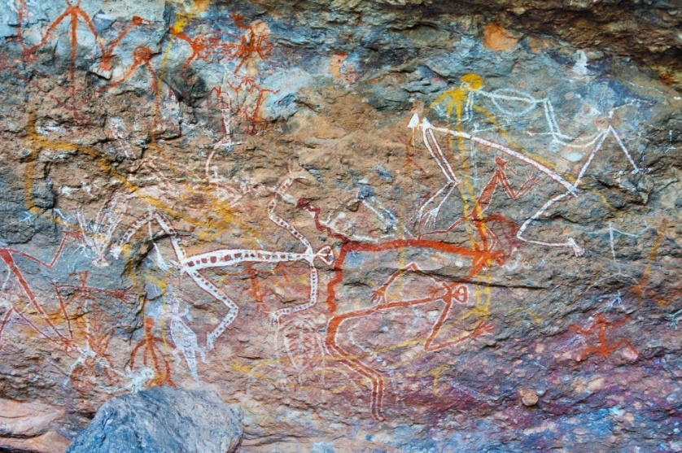
Australia has its own rich history of indigenous arts, including Aboriginal and Torres Strait Islander. To give you a brief history of Aboriginal Art, it started about 60,000 to 80,000 years ago, when the Aborigines first settled in Australia. They leave marks on rocks and used symbols to portray their artworks. The interpretations of these marks are not clear, and information was only passed on to preserve history and the story behind the indigenous art.
Aboriginal people communicate through arts. They use it in teaching and in ceremonial practices. In the table below are forms of Aboriginal art developed by Aboriginal artists that are known locally, nationally, and internationally.

2-D Media | 3-D Objects | Time-based Media
- Collage  - Drawing  - Painting  - Photographic  - Printmaking | - Ceramics  - Fibre art  - Installation  - Sculpture  - Wearable art and body adornment | - Electronic imaging  - Film and animation  - Sound art  - Performance art
Sourced from Visual Art and Aboriginal Knowledges, used under CC BY 4.0 ©State of Queensland (QCAA) 2019.

The Torres Strait Islanders are at the coast of the northernmost tip of Queensland. More than 200 islands with a busy intersection served as the trading ground for people coming from Europe and Asia.
Torres Strait Islander Art is developed by artists from the island. They took many forms and became well-known nationally and internationally. Some of these artworks are:
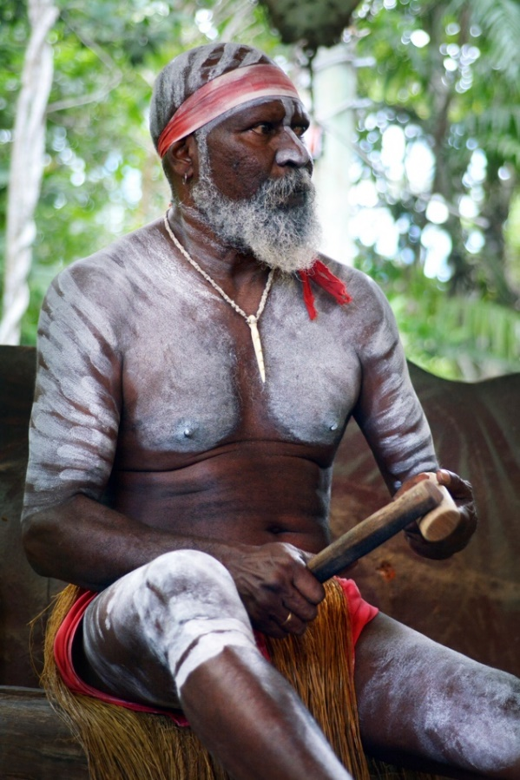
- paintings and drawings on boards, canvasses, paper, sculptures, and ornaments
- sculpture and carving in traditional materials such as stone, wood, bone and other plant-animal products, and contemporary materials such as metals, plaster, found objects, and synthetic textiles
- site-specific installations, including in caves and sand
- fabric arts including printmaking, lino-cuts, and weaving
- body art such as body scarring and painting, and wearable art such as ornaments, jewellery, headdresses, and costumes
- traditional and contemporary dance
- traditional and contemporary songs
- digital art and multimedia artworks that incorporate graphic arts, photography, motion film, computer-generated forms and more.

Some established Torres Strait Islander artists are:
- Ricardo Idagi – a sculptor from Mer (Murray Island) who now lives in Melbourne. His artworks are expressions of his interpretation of social issues.
- Ellen José – a female artist from Mer who uses various forms of media, such as printmaking, painting, installation, video, and photography. Her works show her exploration of the political aspects of Indigenous life and her islander heritage.
- Alick Tipoti – his works are focused on preserving his cultural heritage as a Badu Island Man. Some of his media are printmaking, bronze casting and carving.
Sourced from Visual Art and Aboriginal Knowledges, used under CC BY 4.0 ©State of Queensland (QCAA) 2019.
Checkpoint! Let’s Review
- Australia has its own rich history of arts, including Aboriginal Art and Torres Strait Islander Art.
- Creativity has a strong connection to children’s learning and development.
- Various forms of arts can be introduced to children to discover their creative skills and artistic expressions.

Further Reading
Read more about Aboriginal and Torres Strait Islander peoples, their history and their art through the links below:
Knowledge frameworks of Aboriginal and Torres Strait Islander peoples
Aboriginal and Torres Strait Islander Studies Handbook
Torres Strait Island Website
The Story of Aboriginal Art

 | Learning Activity for Chapter 1  Well done completing this chapter. You may now proceed to your Learning Activity Booklet (provided along with this Learner Guide) and complete the learning activities associated with this chapter.  Please coordinate with your trainer/training organisation for additional instructions and guidance in completing these practical activities.

II. Creating Experiences That Nurture Creativity
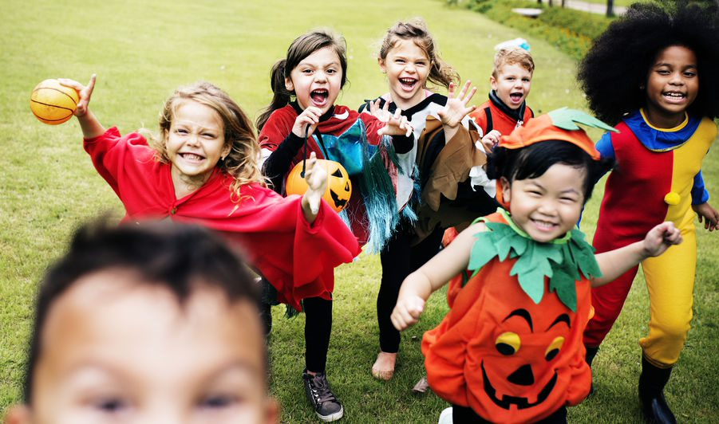
The previous chapter highlighted your role as an educator in providing opportunities so children can freely express their creativity through artistic expressions and develop learning dispositions by being exposed to different art forms and artists in diverse cultures.
This chapter will focus on how you can apply these concepts as an early childhood educator by creating experiences that nurture children’s creativity. To ‘nurture’ means to care for, train, or allow and encourage to thrive. It is how you, as an educator, should treat each child’s unique ways of showing creativity. You can do this by intentionally planning experiences that will provoke learning and inspire children to stay engaged. During that time of engagement, children invest their thinking into what they are doing and learn to explore, experiment, and be creative.

The adults that assist children in engaging activities at home and in school must provide the materials, equipment, and tools that children need to explore independently and develop their creativity. However, adults should be careful when it comes to the implementation of the activities. Directing a child's play or artwork by telling them what they should make (e.g. asking them to draw a dog or a frog after reading a book with those animals as characters), or how they should make objects appear in their artworks (e.g. use green for the car and red for the book just like in the story, or make a circle first then add lines on the side to draw a sun), will become more of a reflection of your interpretation of the story and those objects than the child’s. Doing this may only make the child feel incapable of executing their ideas on their own or that something about what they do is wrong or lacking. This may eventually affect their confidence and self-esteem.

Adults must encourage the children to express their own interpretation and how they think about these objects, books, or events by helping them process their thoughts and not directly influencing children how they should create them.
Avoid making children feel like their work is inadequate. A painting, for example, may seem unfinished to you, but it might already encompass the entirety of what the child wants to portray or express. Make an effort to understand the child’s thinking before passing judgment.
Children, acting out their curious minds, have many interests, all of which differ from every other child. As an educator, you must constantly plan and prepare for learning and exploring opportunities to nurture creativity based on the children’s interests and cultural backgrounds.

Further Reading
Learn more about the Victorian Curriculum on children’s critical and creative thinking through the link below.
Critical and Creative Thinking

2.1 Identify Opportunities That Nurture Creativity, Based on Children’s Interest and Cultural Backgrounds
Children’s cultural backgrounds are part of their individuality and surely influences their overall identity. They affect the way they see things, communicate, or make decisions. One’s cultural background includes the native language, traditions, and practices of each family. It is reflected in their daily living and can be observed in their lifestyle or preferences. Some examples can be seen in children’s food choices, artistic expression, religion, language, and interests. You may learn about this by checking children’s personal information, school records, observing them, or discussing them directly with the family.
As you identify opportunities to nurture children’s creativity, you must consider their cultural background because it gives value to their individuality and overall sense of self. Considering children’s cultural backgrounds will promote diversity and inclusion. It will help raise awareness of the cultural differences among children and train them to respect and accept those differences. These values are foundations in developing and nourishing creativity in children.

To identify opportunities that nurture children’s creativity based on cultural background, you must see to it that the opportunities:
- cater to children’s individual differences and treat them with value and respect
- welcome children’s preferences and not pressure them to participate
- encourage children’s creative freedom regardless of the cultural context of their artistic expressions and creative outputs
- make children feel comfortable to explore, investigate, and express themselves freely when using their native language or incorporating their traditions and practices.

Another basis for identifying opportunities that nurture creativity is children’s interests. In a play-based teaching approach, the activities and curriculum progress and rely heavily on children’s interests. It can be identified by observing and reflecting on children’s responses.
Observing children’s responses will help you understand their goals and why they persist on a task. These are your clues in finding their interest. Look into what the child enjoys doing, then guide and introduce them to activities that expound their interest. Below are some examples of the questions you may ask yourself as you observe:
- Does the child spend extended time engaging in messy art activities?
- Does the child enjoy creating a mixture of colours and how they change when mixed or is the child more interested in the art of mixing?
- Should I prepare activities that allow exploration of colours, or should the focus be on transferring and mixing?
- How does the child use the materials? What is the child trying to achieve?
- Does the child enjoy feeling the paint on their hands or watching how the movement of their fingers create images?
Answering these types of questions with your observations from the children’s responses will more likely help you get in the direction of each child’s interest. The opportunities you prepare to nurture creativity in children should not be limited to crayons and paint. Children’s creative abilities may be applied across all developmental domains and may be challenged and developed further through a play-based approach. Play allows children to explore, investigate, and experiment. Each experience you provide enables you to observe how children respond to it and gather the information necessary to plan your next goal.

Considering children’s interests is imperative because it creates opportunities for them to experiment with new concepts, try and prove the theories they form in their minds, work on their mistakes, and find solutions to their problems. Through this, they learn to create and develop new strategies to explore and acquire new knowledge. Children develop creativity and become responsible learners if they are allowed to explore freely.
Children’s interests may be categorised into nine learning areas. The discussions in the learning areas are descriptions of what creative opportunity must look like to nurture children’s creativity based on their interest and how children show their interest in each learning area.
- Construction
This learning area shows children’s interest in putting things together, building structures, or creating their imagination with the materials available. They may use building blocks, sticks, pipes, boxes, cardboards, and other items they see fit. Children might also see supporting props to complete what they built (e.g. construction tools, cars, dinosaurs, people and signs, etc.).
In construction, children may decide to change the structure and plan to achieve a new goal. Children can learn concepts such as sizes, shapes, numbers, order, area, length, and weight as they explore.
For example, a child may create and design a community using blocks and manipulatives to show interest in community helpers and matching vehicles and buildings. They may construct bridges and highways imitated from their daily experiences and assign specific areas to the police station, hospital, farm, fire station, school, or church.
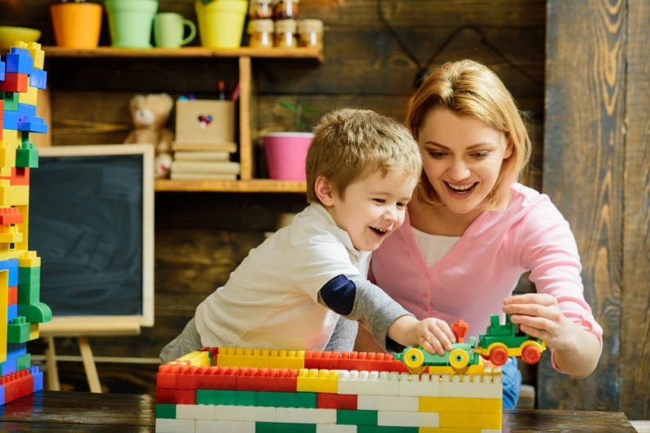
The child may also use manipulatives such as people and cars to construct a complete community setup. Through construction, children can explore their interests and execute their imagination by connecting them to their previous experiences. Reading books may also contribute to their knowledge in the construction project and add details, such as fire hydrants for the firefighters or bus stations and ferries.

Further Reading
You may refer to the activities below to get an idea from RaisingChildren.net.au about stacking and building games for children ages 3 to 6.
Stacking and Building Games

- Digital Technologies
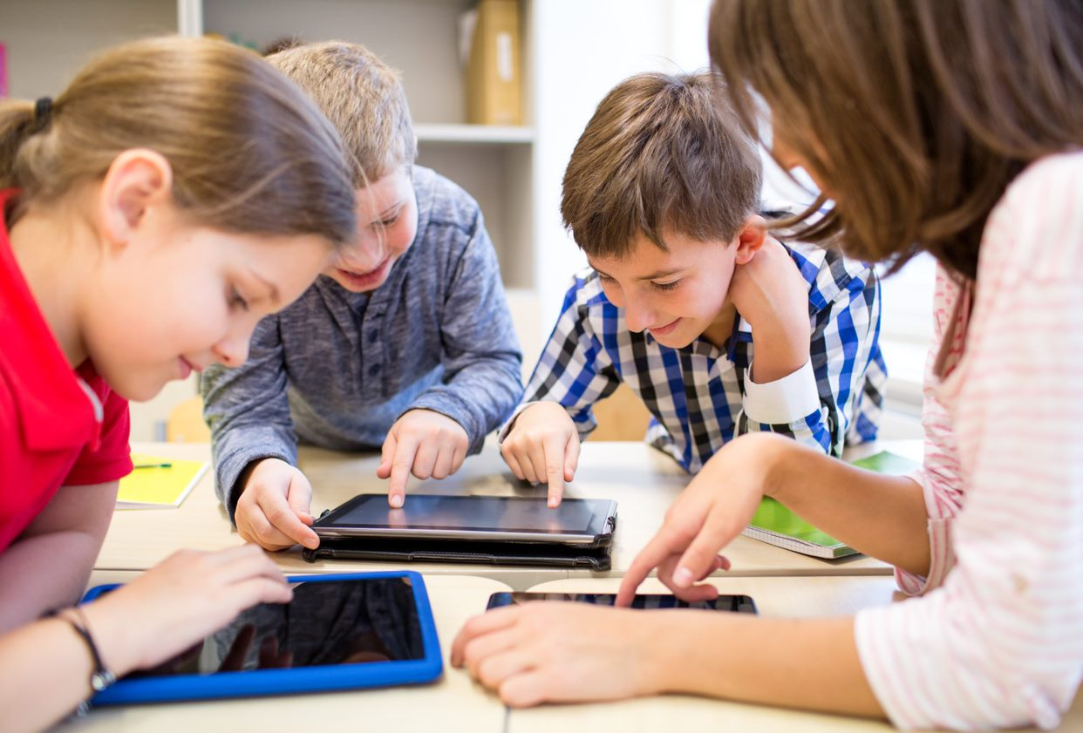
Regulated integration of digital technologies can open opportunities to children’s exposure to both learning and play through modern software and applications. With adult supervision and in the regulated amount of time, digital technologies can enhance children's cognitive development and creativity, especially through games and activities that encourage critical thinking, strategies, techniques, and exploration.
The use of digital technologies in the centre may depend on the resources available and used with close adult supervision. Digital technologies may be extended outside the school, especially when families are forced to stay at home, when resources are available and when an adult can oversee the child’s digital activities.
For example, a child may show interest in colours and may use educational applications that allow them to manipulate the colours by ‘spreading’ or ‘mixing’ them on the screen. It may enable the child to experiment with the different colour combinations and mix colours to produce a new one.

- Dramatic Play
Dramatic play is one of the most observable activities that clearly shows children’s creativity. They act out scenes and imitate actions, words, songs, or even costumes through props. These opportunities may be observed as children try to recreate scenarios from their previous experiences at home, in school, in the community, or even in the books they read or the movies they watch.
Dramatic play may also be a tool for children to develop empathy by putting themselves in someone else’s shoes. They would act as if they were someone else with a different personality and character.
For example, a child may be fond of superheroes because of a movie they recently watched and may recreate and imitate their favourite scenarios or even come to class in costume. The child shows creativity as they replay these scenes in their minds and translate them into actions. Some areas and materials for dramatic play in the classroom may include the kitchen corner, fruit and vegetable stand, grocery store, construction area, or medical tools and equipment.
- Imaginative Play
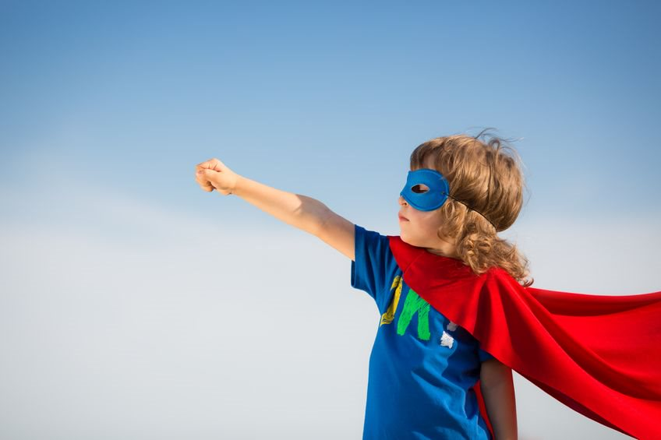
Imaginative play may somehow be similar to dramatic play. However, instead of imitating and recreating familiar events and situations, children engage in pretend play based on the scenarios they create out of their own ideas. Children may use objects to stand for something else in this type of play, such as using yarn as spaghetti noodles or multi-coloured cubes as fruits to serve as toppings on their cake. What children learn from books and their daily experiences are contributing factors in the development of this skill.
Imaginative play may also be a tool for children to express their creative minds, resourceful skills, feelings, emotions, and energy. As children engage in imaginative play, they explore endless possibilities of expressing their ideas.
For example, a group of children may discover that they enjoy being together as they start to have preferred friends. They may create scenarios where they pretend to go on a playdate at a park or a picnic and share their snacks. Children may also engage in fantasies and pretend they are mermaids, princesses, or pirates on an adventure.

- Language and Storytelling
Storytelling is one of the best forms to support and nurture creativity in children. It encourages them to imagine and play in their minds the scenarios they read or hear from the books. Language plays an important part in this area. As an educator, you must make sure that that all types of learners in your class can understand the language you use, and you can communicate properly in ways that children can relate to. You may use inclusive language to ask open-ended questions to encourage interaction during read-aloud and book conversations. Doing this gives children opportunities to develop their skills in identifying problems, recalling events, formulating resolutions, reconstructing the story through pictures or props, and learning to make assumptions and draw conclusions.
For example, one of the children prefers to read books during free play and asks you to read the same book repeatedly. This scenario clearly shows that the child is interested in the story and may also like how you deliver it. Take the chance to ask open-ended or ‘what-if’ questions to enhance the child’s critical thinking skills. The reading nook or reading corner in the classroom will be ideal for children with this interest. Make sure that the books in your class library are updated and related to children’s interests.
- Movement
When children are given opportunities to express their energy through dance and movement, they explore what their bodies can do. Creativity will develop as children learn to communicate their feelings and ideas through dance and movement. They will also be able to develop the following skills:
- Spatial awareness – where the body moves (e.g. location, direction, level, pathway)
- Effort awareness – how the body moves (e.g. speed, force, control)
- Relational awareness – relationships the body creates (e.g. body parts, body shapes and sizes, and space)
For example, children may show interest by dancing to the song of their favourite movie or an action song that tells about the animals they like. They may also enjoy outdoor activities and explore body movements in an open and wide space.

- Music
Researches support music’s contribution to the brain’s neurological processes to develop creativity. Music allows the brain to follow the patterns produced by sounds, melody, and the tune created by songs and musical instruments. Learning about music and participating in musical activities is a creative process itself. Children who can freely explore music and sounds are more likely to explore new ways to express and communicate their energy.
For example, children may show interest in playing musical instruments like maracas, tambourines, and drums to investigate the different sounds they create. They may also use other materials and try to create a melody or rhythm to accompany a song or simply explore the sounds they make, such as using pans and sticks as drums, listening to the sound of blocks hitting a cardboard box, or hearing two metal sticks clinking.

Further Reading
You can read more about how learning music fosters creativity through ForteMusic.com.au’s article linked below:
Learning Music Fosters Creativity

- Science, Technology, Engineering, Arts, and Maths (STEAM)
The concepts of science, technology, engineering, arts, and maths may be observed across the different areas discussed in this chapter. You will often see this as children:
- investigate and inquire about the properties of objects
- use tools and technology to explore them
- observe the changes in their environment
- express their ideas and communicate their observations
- measure these changes and the characteristics as they achieve a goal.
Children enjoy activities that allow them to investigate the properties of objects around them. You may introduce science and maths concepts through interesting activities, like sand and water play, transferring and scooping activities, and building and construction activities.

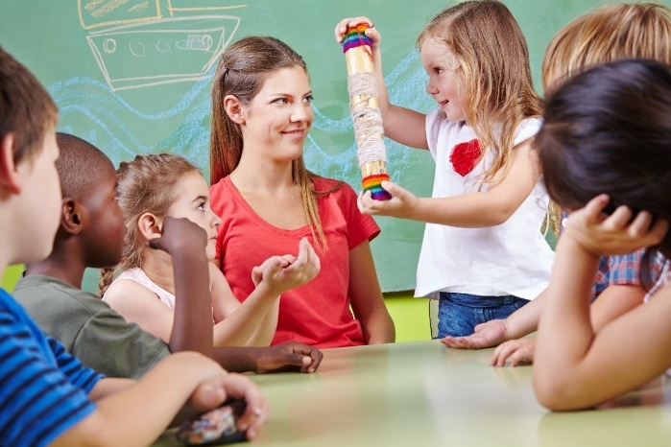
For example, sand and water play will enable the child to explore the properties of sand (i.e. loose and rough without water and intact when with water). This activity may integrate math concepts as the child thinks about how many buckets of sand they would need to build the sandcastle they want. The child may use tools such as a shovel and pail or a spoon and different sizes of cups. Establishing a strong foundation of the sandcastle will require exploration of engineering concepts such as using other materials as firm support or re-purposing broken toys or loose parts. Arts will involve the child’s expression and preference on the design and the actual engagement in the sandcastle building process.

Further Reading
Learn more about incorporating STEAM into your curriculum through the links below:
STEM in Early Childhood
Integrating STEAM into the ECE Classroom: Finding and Utilizing the Right Resources for Your Center
- Visual Art
Visual arts may usually be associated with the product of ‘arts and crafts’ activities. Although this may be true, visual arts is much more than the product itself. It involves the exploration of lines, colours, shapes, forms, designs, texture, and value as children engage in the different processes. In this area, children must be free to express their thoughts and execute their own interpretation of concepts and ideas instead of following a specific and structured direction. Below are some examples of learning opportunities for the visual arts:
- Drawing (e.g. dry media: pencils, chalks, crayons, charcoals; wet media: ink, textas)
- Painting (e.g. mixing of colours, create meaningful artworks to engage senses and verbal, visual and written expression)

- Sculpture and craft (e.g. clay, papier-mâché, play dough, re-cycled paper and cardboard materials, fabric offcuts, string and twine, pipe cleaners, etc.)
- Multimedia (e.g. photography, digital storybooks, storyboards, comic strips, videos, animation, etc.)
Sourced from Fine arts (emergent literacy), used under CC BY 4.0 ©State of Victoria (Department of Education and Training)
You may also provide loose parts or open-ended materials such as feathers, leaves, glitters, sticks, buttons, bottle caps that can be used in various ways. You can engage children in forming creative thoughts as they experiment with texture, space, and colours in their artwork. Having a free choice about the materials to use will encourage their ability to plan, make decisions, learn and practice new skills, and develop their creativity and appreciation for visual arts.
As you provide activities using the different forms of visual arts, you can observe which materials and types of exploration children are interested in. It may be demonstrated by how long they engage in the process or how they communicate their observations and appreciation of their work or others’ works.

Further Reading
Read the resources below to learn more about integrating arts into your curriculum and a study on visual art experiences in early childhood:
Visual Art and Creativity in Your Curriculum
Do Visual Art Experiences in Early Childhood Settings Foster Educative Growth or Stagnation?

You can plan and implement activities that integrate all the areas discussed in this section and make them available to children between the ages of birth to six years. When planning for creative experiences for children, make sure that you consider your resources, the age and developmentally appropriate materials, and children’s readiness or prior experiences. Remember that when preparing opportunities to nurture creativity in children, you have to let them experience problems, figure out solutions independently, collaborate, or change plans to achieve a goal.

You may review the examples below:
- Building Blocks Play
  - When planning for building blocks activities, you would want to prepare blocks that are appropriate for the developmental age of children. There are soft-edged styrofoam blocks that may be applicable to toddlers and babies. Preschoolers may use wooden blocks.
  - Set up the environment and materials in an attractive way to entice children and make them curious about the blocks. You may leave a small stack of blocks that they can observe to give them an idea of what they can do about it.
  - Encourage children to participate by joining them and asking open-ended questions to direct their play or inquire about their interests. Allow children to use the materials to build and construct buildings or structures. There can also be materials such as cars or people to use for dramatic or imaginative play. Children will use math and STEAM concepts while deciding, calculating, and building foundations for structures and the visual arts as they incorporate the design they prefer. You may play a song about building or the people in the community in the background to give inspiration to children. As children work on their projects, they will use language and communication skills to express their thoughts and ideas.
- Sensory Play
  - The materials you can prepare are smocks or aprons and a safe space for exploration, such as a long tub, non-toxic, and child-safe materials. Prepare age-appropriate tools for exploration, such as jelly-like materials, sticky and slimy items, or grainy and rough materials. You might want to consider having edible materials for toddlers and babies as some children this age are still prone to mouthing toys they are curious about.
  - Ensure that there is enough space for each child to join in and the number of adults in class is enough to watch over the children.
  - Allow children to engage and manipulate the items however they want. Encourage them to use their senses to touch, smell, feel, or even taste, if possible, to explore the materials and their properties. You may let them use a filter, chopping board and knife toy, moulder, may prepare tools for pounding, flattening, or moulding the items.

Exploring the characteristics of the materials fall under the area of STEAM and visual art. How children use their imagination to produce their ideas and use it to stand for something else also represents their dramatic and imaginative play. You may allow children to sing songs that relate to what they are doing, like making Five Little Butterflies with the materials and singing the song with them. You may also create the materials from scratch, such as making playdough and incorporate math concepts by allowing children to measure the ingredients needed. Children are also using their language and communication skills as they share what they created.
- Water and Sand Play
  - The materials you may prepare are tools for transferring, pouring, measuring, and filtering. Children are commonly fond of water exploration, and they enjoy outdoor water play. Take this chance to allow children to explore the properties of water and sand using different containers and objects.
  - Exploring the concept of sinking and floating, water-absorbent materials and waterproof items may all fall under the investigation of their properties, which are all concepts of STEAM. Adding water to sand and allowing children to discover how to make sandcastles are opportunities to use construction and imaginative play. They will also apply concepts of the visual arts as they design their castle.
When preparing for activities, you may adjust the materials and the environment’s set-up to make them appropriate to the developmental age of children under your care. Make sure that the area is safe and there are enough adults to supervise and watch over each child or group of children as they investigate the materials and the environment. Remember to observe and document children’s explorations as well.

2.2 Structure and Document Opportunities and Intentional Teaching Strategies That Assist Children to Explore the Arts
Educators such as yourself are encouraged to act spontaneously and respond to children’s needs as they arise. Developing the skills to know how to respond appropriately to a child without interrupting their exploration and giving them enough room to discover new ideas on their own are some things that improve through practice and experience.
To establish a process that effectively addresses the needs of each child, you must plan, structure, and document opportunities and your responses to analyse and reflect on how all these factors affect the child’s learning experience.
As you prepare for activities, you may consider the five learning outcomes from the Early Years Learning Framework (EYLF) as stated in the table below. The learning outcomes may serve as a guide in giving children creative learning opportunities.

Early Years Learning Framework (EYLF) Learning Outcomes
Outcome 1: Children have a strong sense of identity
Outcome 2: Children are connected with and contribute to their world
Outcome 3: Children have a strong sense of wellbeing
Outcome 4: Children are confident and involved learners
Outcome 5: Children are effective communicators
Sourced from The Early Years Learning Framework for Australia, used under CC BY 4.0. © Commonwealth of Australia

2.2.1 Structure Opportunities to Explore the Arts
Creative experiences promote imagination, experimentation, exploration, and investigation through the areas discussed in Subchapter 2.1. When planning for these opportunities, you must ensure that they encourage and support the following:

Active Learning
You may find this related to Outcome 4 of the EYLF, which states that children are confident and involved learners. As the name implies, active learning occurs when children become active participants in the learning process. They are encouraged to ask questions, give suggestions, or change the direction of the exploration based on the new knowledge they acquire. Children collaborate and contribute to the investigation and discovery.

Applying Aesthetic Values
Applying aesthetic values or the characteristics of visual arts is a form of communication. When children develop an appreciation for the different forms of arts, they can give interpretation and meaning to their works and the works of others. They will notice and will be able to describe, compare, and differentiate the colours, lines, textures, shapes, and characteristics that make an artwork. You may find this related to Outcome 5 of the EYLF, which describes children as effective communicators.
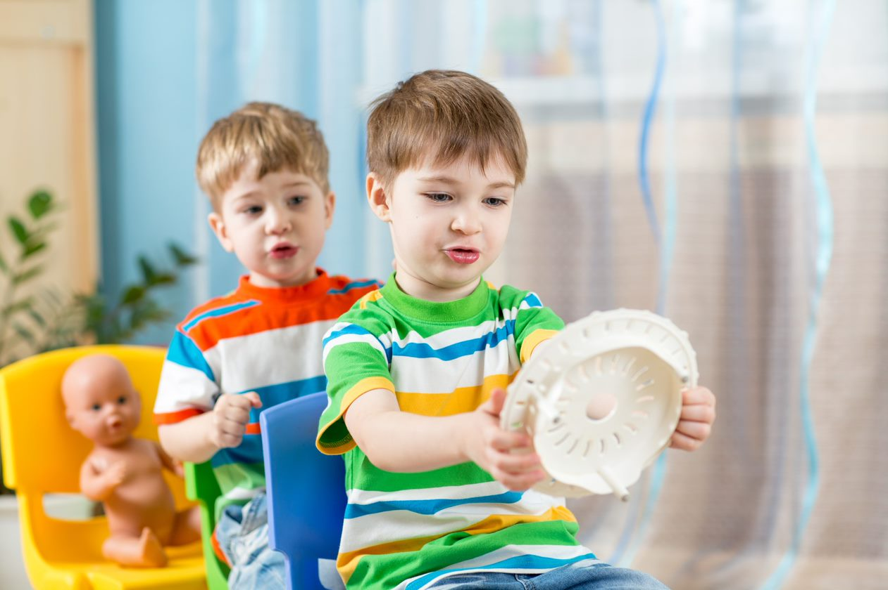
Fostering Children’s Agency
Giving children the chance to make age-appropriate decisions and allowing them to do things their way will develop their critical thinking skills and make safe choices. Creative opportunities that enable children to experiment and make independent choices will also build on their confidence in creating solutions to the problems they encounter. As the first learning outcome of the EYLF says, children have a strong sense of identity, which means that children can be responsible for their own learning and are capable of deciding what they want to do or how they want to do things.

Cultural Awareness and Sensitivity
Outcome 2 of the EYLF states that children are connected with and contribute to their world. Children have within them the values of their culture. Providing opportunities to explore their differences and embracing them will promote awareness and appreciation of different cultural backgrounds. Learning experiences like this will also develop children’s sensitivity to inclusion and treat everyone with value and equally.

Fostering Curiosity
Similar to how children are active learners, they are also naturally curious beings. They like asking questions and trying out new ways to see different results. They also like to experiment with how materials affect their environment when manipulated in various ways. Curiosity helps children build up their store of knowledge, which they can use in creative opportunities they engage in. You may find this related to EYLF’s fourth learning outcome.

Developing Literacy
Literature is essential in nurturing creativity. It develops children’s ability to communicate and connect words and terms to the concepts they discover. Literacy is also necessary for building children’s vocabulary, which they need as they engage in different learning processes. Books are also effective tools to encourage and develop children’s imagination. Through the illustrations and pictures, children can create an image in their minds and animate them based on the actions and events in the story. Developing literacy, such as the visual arts, is also related to Outcome 5 of the EYLF.

Ensuring Safety
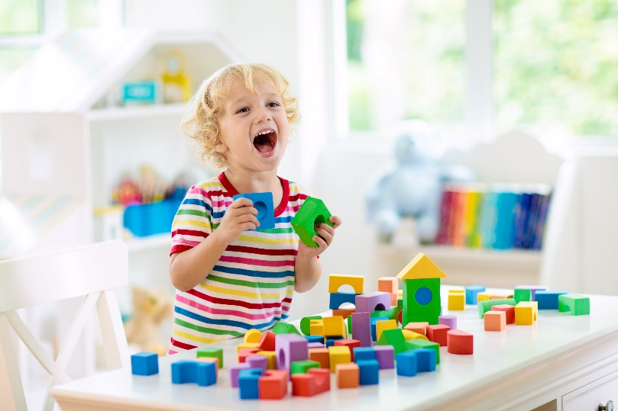
Ensuring children’s safety is as crucial as encouraging and supporting their exploration of the world. Throughout the learning process, safety should always be a top priority. Learning outcome 3 of the EYLF states that children have a strong sense of wellbeing. As children participate in the activities, they develop an increasing responsibility for their own health and physical wellbeing. Their knowledge about safety hazards (e.g. choking hazards) and their awareness of possible danger in their environment also increases. Even then, as an educator, you must ensure that children are ready and equipped with this knowledge before you allow them to engage in certain activities. Plan and provide age-appropriate and developmentally appropriate activities and materials (e.g. child-safe and non-toxic materials).

The Early Years Learning Framework supports a play-based approach for children’s learning. Although it requires spontaneity and flexibility, especially from your end, it is also important to add structure to your methods and techniques. A structure will serve as your guide in making sure that you are on the right track in achieving your goals and objectives for the activity. It is also your reminder to keep in mind the full creative experience and the areas and factors contributing to that.
The following tables in the succeeding pages will show some ways to structure creative experiences in each learning area in Subchapter 2.1, considering each aspect discussed at the beginning of this section.

Area of Learning | Ways to Structure Experience
Construction | Active Learning  - Provide conditions that will pose a problem they need to solve, such as irregular shapes of blocks, different quality of available materials, or dividing the materials into children interested in building and construction. Situations like this one will give children the opportunity to negotiate and collaborate, ask questions, or figure out how to build a firm foundation with the materials they have. You may help children solve each problem they encounter by assisting them in breaking down big problems into smaller items that are easier to solve.  Applying Aesthetic Values  - Use different materials and observe how children will plan and layout to express their imagination through their construction. Providing materials with varying colours, sizes, or shapes will encourage children to create a design they have in mind. You may ask open-ended questions to encourage the child to execute their plans using the materials they have.  Fostering Children’s Agency  - Give children the opportunity to make choices by allowing them to decide what object to put and where to place them as they construct and build structures or tools. Allowing them to execute their ideas without correcting them will help develop their confidence in making choices. Let children discover if there are errors and give them the chance to find a way that works better.  Cultural Awareness and Sensitivity  - Encourage children to share or divide the materials, such as building blocks, pipes, and magnetic tiles, equally if they prefer to work independently. Construction activities will also allow children to connect to the world as they integrate their experiences into their creation and eventually let others participate. You may invite two to three children to the same area to encourage collaborative play, acknowledging their different learning styles and preferences.

Area of Learning | Ways to Structure Experience
Construction | Fostering Curiosity  - Provide open-ended materials that can be manipulated in different ways to allow children to explore various methods of constructing and building to get similar or new results. If possible, focus on one concept to explore by asking open-ended questions so the child can have a full understanding and have enough time to explore a single concept.  Developing Literacy  - Provide new materials or new processes that children may encounter as they construct and build their ideas. It will be an addition to their vocabulary and allow them to learn new concepts. Collaborative building activities will also help children communicate their ideas and negotiate with each other. Facilitate negotiating and collaboration by making sure that each child understands what the other is trying to say. You may have to repeat or explain it in a way that each child will understand. You may limit participants per group to two to three children or based on their interpersonal skills.  Ensuring Safety  - Ensure that the area is safe and secured. If you are using wooden materials, make sure that you have a mat that can support the blocks that may fall on the floor. Ensure that the type of blocks and building materials are age and developmentally appropriate.
Digital Technologies | Active Learning  - Observe children’s interests and choose specific topics that may be explored using digital technologies. For example, during the Christmas season, you may allow the toddlers to watch a video of Frosty, The Snowman or The Grinch for older children and facilitate the discussion and sharing of their ideas about the Christmas Story.

Area of Learning | Ways to Structure Experience
Digital Technologies | Applying Aesthetic Values  - Using digital applications, children can make designs and drawings or practice writing and tracing. They can also explore the art of photography using mobile phones or discover how camera filters change the natural colours of the image they captured. You may allow children to focus on exploring one aspect to maximise the opportunity to expand their ideas.  Fostering Children’s Agency  - Give children enough time to explore the device and choose the type of activity they want to do during the allotted time. Communicate to children the limits and the setting and conditions of using the device based on their chosen activity. For example, children can only walk around the classroom if they choose to take pictures using the device. They have to stay on the table if they prefer drawing or writing applications.  Cultural Awareness and Sensitivity  - Allow children to take turns using digital technologies. You may use a virtual timer or count verbally to serve as cues for children that they would need to share the device with others. It fosters sensitivity to other’s needs and recognising that everyone is part of the big group and should be given a chance.  Fostering Curiosity  - Introduce age-appropriate activities based on children’s interests. You may add structure to their exploration by ensuring that they only have access to the applications and software they are intended to use or that there will be close adult supervision during the task.  Developing Literacy  - Create conversations with children as they engage in activities using digital technologies. These are also opportunities to help them process their thoughts and express their ideas. You may look at what they are doing and ask questions based on your detailed observation of their output.

Area of Learning | Ways to Structure Experience
Digital Technologies | Ensuring Safety  - Ensure that the materials can be used and are functioning appropriately. Prepare the area where children have no access to outlets you will use when, for example, watching a movie. Set a limit when using devices with digital screens and inviting displays and use them solely to explore age-appropriate and educational applications, like mobile photography, watching movies, etc.
Dramatic Play | Active Learning  - Encourage children’s participation by providing materials based on your observation of their interest in dramatic play activities. Limit the materials by providing two to three of each kind or based on how many children want to participate in the same activity. You may also offer other items that may be part of expanding their interest, but limit to a few and then gradually increase or replace them as you observe children’s engagement. It will ensure that children’s participation is driven by interest and not by the overwhelming stimulus caused by the classroom environment.  Applying Aesthetic Values  - Create an environment that strategically places materials for sharing and is conducive for learning and collaboration, especially in dramatic play scenarios. For example, place the kitchen area near the table or provide an empty shelf near the vegetables. That way, children are prompted to organise their play and use resourcefulness to fill in the missing materials they may need.  Fostering Children’s Agency  - Allow children to choose their ways of manipulating objects, but you may communicate rules on the appropriate materials they can mix or use in their pretend play. It will avoid hoarding of materials, resulting in other children not having objects to play with anymore. Regulations will keep an organised way of using materials and maximise children’s creative potential rather than making them an ingredient for chaos.

Area of Learning | Ways to Structure Experience
Dramatic Play | Cultural Awareness and Sensitivity  - Encourage children to hold inclusive pretend play by acknowledging that each class member can be a participant in their play. You can do this by facilitating sharing materials and demonstrating assigning of roles by asking permission from children. Provide materials that promote cultural development or shows their physical or cultural differences.  Fostering Curiosity  - Add new materials that children can explore or include a representation of the objects they previously experiences, which they can now use as props in their play. You may limit the materials or ask open-ended questions further to probe their goal and interest in their dramatic play. You may use situations like this to inquire and confirm their interests or the scenarios they are trying to re-enact.  Developing Literacy  - Allow children to express their ideas and negotiate roles. You may encourage them to identify the roles and say something about them to gather information about the characters involved in their dramatic play.  Ensuring Safety  - Make sure that the materials children use are age and developmentally appropriate. Check items that may be posed as hazards and potentially harm children and need to be removed. Consider children who enjoy climbing, going up on tables and chairs or those who mouth toys. Make sure that materials and the classroom setup cater for those types of children.

Area of Learning | Ways to Structure Experience
Imaginative Play | Active Learning  - Provide open-ended materials that will spark children’s imagination and create scenarios and roles they can dramatise. Limit materials by adding two to three of each kind or based on children’s participation and their interest. Give children enough time to explore and use the materials in multiple ways or until you see that you need to add in new items to expand their imaginative play.  Applying Aesthetic Values  - Add materials that have different physical characteristics, such as texture, colour, size, lines, or print and let children discover what they can do and how they will appreciate them. You may add in two new sets of items at a time to avoid getting children overwhelmed with unfamiliar materials.  Fostering Children’s Agency  - Allow children to execute their plans and imagination by how they manipulate the materials provided. Communicate rules on the use of materials in their imaginative play. It will help them understand the concept of getting only the materials they need and saving others who also need them. Regulations will keep an organised way of using materials and maximise children’s creative potential.  Cultural Awareness and Sensitivity  - Facilitate sharing of materials through modelling and give examples of ideas that may spark and contribute to their imaginative play. Provide materials that promote cultural development or shows their physical or cultural differences. Encourage children to accept everyone and acknowledge that each of them belongs in the group. Help children realise how they are connected by describing how well they work together and sharing their interests make them perfect playmates.

Area of Learning | Ways to Structure Experience
Imaginative Play | Fostering Curiosity  - Allow children to investigate the characters they portray and the items they use as props. Provide materials that will give them more information about the characters and help them discover new ways to implement their ideas. Ask open-ended questions to probe children’s interests and preferences.  Developing Literacy  - Encourage children to communicate their ideas and express their thoughts by asking questions or narrating what they are doing. Consider their communication skills and provide vocabulary that they can use, as necessary. You may also encourage children to write print as props and directions to their play.  Ensuring Safety  - Provide age and developmentally appropriate materials and ensure that they are safe from hazards that may lead to potentially harmful incidents. Consider children who enjoy climbing, going up on tables and chairs or those who mouth toys. Make sure that materials and the classroom setup cater for those types of play.
Language and Storytelling | Active Learning  - Encourage children to express their thoughts and ideas by asking open-ended questions during their play or storytime. Ensure that you highlight important parts of the story that will capture children’s interest. Inquire further to continue children’s participation and sharing.  Applying Aesthetic Values  - Facilitate a discussion that will bring children’s ideas and personalities as they share their insights. You may ask ‘what if’ questions or probe on what they will do in certain situations or refer to the scenario in the book.

Area of Learning | Ways to Structure Experience
Language and Storytelling | Fostering Children’s Agency  - Help children build their confidence in communicating their thoughts by establishing an environment that is free from judgment. Give children enough time to sort out their thoughts, process their ideas from the questions in the book, or provide language and vocabulary as necessary.  Cultural Awareness and Sensitivity  - Read books that promote cultural diversity and spark an idea of the different races, traditions, and cultures across the world. Introduce the distinct characteristics of people from various cultures through the books that you read in class.  Fostering Curiosity  - Provide opportunities for investigation of the book’s different characters or discuss the actions and scenarios by asking open-ended questions. Facilitate a discussion to probe children’s knowledge and perception of the story.  Developing Literacy  - Create a safe environment that can tell children that they are free to say what is in their minds or ask questions about things they do not understand, especially when they encounter new words or concepts in a story.  Ensuring Safety  - Choose books and reading materials that are appropriate to children and considers their developmental skills and knowledge. For example, you may read books about potty training to help toddlers and preschoolers relate to the character who is also experiencing the transition they are doing.

Area of Learning | Ways to Structure Experience
Movement | Active Learning  - Provide slow, moderate, and active physical activities that may be integrated into children’s interests or do together as a group. You may assign a day for yoga and mindfulness exercises, stretching, balancing activities, and more. That way, you can also prepare appropriate materials to use for each activity.  Applying Aesthetic Values  - Allow children to explore and express their energy through their movements by free active or outdoor play where they can run around, jump, hop, or do balancing activities as they like. As they learn about their bodies, they will develop spatial and effort awareness, distance and other concepts that involve their movement.  Fostering Children’s Agency  - Encourage children to engage in activities that cater for their preferences by providing options on the physical exercises to explore. Some may prefer to use materials as props for dancing, and some may enjoy collaborative materials like hopscotch or playing catch. Others may like to explore the environment with their bodies alone and not using materials for play.  Cultural Awareness and Sensitivity  - Create activities that allow children to share body actions and physical activities, perform a dance together, and consider others’ space and movement. These are opportunities that promote inclusion and teach children to acknowledge each other’s individuality.

Area of Learning | Ways to Structure Experience
Movement | Fostering Curiosity  - Prepare activities that will challenge children’s physical skills, such as obstacle courses and balancing activities. Their curiosity towards unfamiliar and challenging actions that require effort will develop persistence and perseverance.  Developing Literacy  - Provide opportunities where children can express their energy through their actions and movement. You may also introduce new vocabulary to associate the words used to describe actions, location, and distance, such as forward, backward, turn around, behind, under, over, straight line, zigzag, and more. You may introduce these words as you demonstrate the actions that children can imitate or create pathways that they can experience.  Ensuring Safety  - Make sure that the materials are age and developmentally appropriate and there is enough support to assist children as they explore their movements. Plan activities and assign roles to the adults who will supervise.
Music | Active Learning  - Allow children to explore music and its components by giving them access to music with various tempos, beats, or rhythms. You may set a time in your class routine where children get to choose songs they like or assign a ‘class DJ’ for the job. This way, you can also observe which type of songs they are interested in. You may also provide musical instruments that are accessible for children’s exploration. You may prepare activities that use those materials and sing songs with the class.  Applying Aesthetic Values  - Provide opportunities for children to explore the different components of songs and music and let them execute their ideas or imitation of those elements. Listen as they play a beat or as them what song they want to sing and do it in acapella and encourage children to play the accompaniment.

Area of Learning | Ways to Structure Experience
Music | Fostering Children’s Agency  - Allow children to discover their musical skills and interest by providing activities that encourage spontaneous singing or just enjoying the music in the background. Spend a few minutes in a day learning about songs or the sounds of musical instruments in the accompaniment. Create an environment where children will feel safe exploring and building on their confidence as they learn about their growing interest in music and its expressions.  Cultural Awareness and Sensitivity  - Play songs that promote cultural diversity and inclusion. It may be from songbooks that show the different cultures and traditions or those with lyrics from other languages. These are good opportunities to learn about other cultures and promote the awareness of the rich and varying cultures worldwide.  Fostering Curiosity  - Expose children to new sounds and music categories to expand their knowledge of the different combinations that sounds can create. Allow them to explore the sound produced by natural or found materials in the classroom or other improvised items. You may use them to create new music with children.  Developing Literacy  - Explore song lyrics by incorporating the words into actions or showing pictures of what they are singing. It will help in expanding children’s vocabulary and allow their language and communication skills to grow.  Ensuring Safety  - Prepare age and developmentally appropriate materials and consider children who still mouth toys or for younger children, for example, who like to shake or throw items as part of their exploration. Ensure that the quality of materials used is also appropriate for their level of investigation and developing skills.

Area of Learning | Ways to Structure Experience
Science, Technology, Engineering, Arts and Maths (STEAM) | Active Learning  - Provide opportunities where children will question the quantity, measurement, alignment, properties, or characteristics of the materials they use. Situations like this will encourage children to ask questions, give suggestions, or use other techniques to change the direction of their play.  Applying Aesthetic Values  - Allow children to execute their ideas through the designs and layout they imagine as they explore STEAM concepts. It may also be about the structure of their creation. Provide a good number of materials that children can use and observe how they come up with ways to improve the physical layout of their project.  Fostering Children’s Agency  - Encourage children to make choices and let them discover the advantages and disadvantages of the decisions they make. Let children experiment and probe the effectiveness of their actions, the tools they use, and the science or math concepts they explore and allow them to correct mistakes and misconceptions.  Cultural Awareness and Sensitivity  - Provide activities that will inspire children to get concepts from different cultures. Expose children to activities that will encourage inclusion and belongingness as they explore STEAM concepts. These are activities for collaboration, sharing of ideas and negotiating of roles.  Fostering Curiosity  - Prepare new activities or place new materials that children can investigate using math and science concepts. Encourage children to participate by trying out different methods or exploring their theories and presumptions by applying STEAM concepts. You may allot time to conduct experiments as a group.

Area of Learning | Ways to Structure Experience
Science, Technology, Engineering, Arts and Maths (STEAM) | Developing Literacy  - Encourage children to communicate their ideas or make inquiries by using expanding vocabulary related to measurement and the changes in their environment or the discoveries they make. Help them use appropriate language and develop an understanding of more words for collaboration and negotiation.  Ensuring Safety  - Provide age and developmentally appropriate materials that are safe and functional for children when exploring STEAM concepts. Consider children who enjoy tinkering and assembling or disassembling materials to understand their properties and composition.
Visual Art | Active Learning  - Encourage children to participate in art activities to express their ideas and thoughts through their artwork. Use materials that they can manipulate based on their interest and give options for them to choose from. Allot a time in a day to explore the materials for visual arts.  Applying Aesthetic Values  - Demonstrate the appreciation of the elements of the visual arts, including the colours, lines, shapes or texture of the materials used. Create a safe space for exploration where they are free to execute their ideas through their artwork.  Fostering Children’s Agency  - Help children build their self-esteem and confidence in creating and speaking their minds by choosing the form of visual arts they want to explore. Provide materials to support their exploration and continuous direction to further their investigation.  Cultural Awareness and Sensitivity  - Expose children to various forms of visual arts from different cultures by spending time to talk about the history and experiencing practical applications of the methods used by artists in the past.
Area of Learning | Ways to Structure Experience
Visual Art | Fostering Curiosity  - Introduce new materials and tools for exploring the arts. Allow children to manipulate and discover the different properties and characteristics of the materials. Provide two to three materials at a time until children can explore them completely. Then, observe how they engage with the tools and provide support for further investigation.  Developing Literacy  - Encourage children to express their appreciation of the visual arts and notice the different components, such as shapes, colours, lines, textures, and more. Model the appreciation of the work of others and use appropriate vocabulary to express admiration of their work. You may also ask open-ended questions to confirm the meaning and interpretation of children’s artworks.  Ensuring Safety  - Make sure that the materials you use are child-friendly and non-toxic, safe for exploration, even to children who tend to mouth toys as part of their exploration. Prepare for safety hazards and ensure that you are equipped to address possible harmful situations and that your classroom environment is also strategically designed for it.

2.2.2. Intentional Teaching Strategies
The Queensland Curriculum & Assessment Authority (QCAA) describes intentional teaching as an active process and a way of relating to children that embrace and builds on their strengths, interests, ideas, and needs. It is deliberate and purposeful teaching where the educator has carefully thought into the why behind their actions. For example, the educator has a specific reason for choosing a certain activity over the other options, even if this might not be immediately obvious. The point of intentional teaching is to make relevant programs and practices relevant to the needs of children. There must be a goal and objective behind the approach and methods chosen.

In a situation where two children are trying to figure out how to share art materials, you may decide to step back and not intervene because you want them to learn how to negotiate and collaborate. Though you have taken no action in this specific scenario, there is a valid reason behind your inaction.
Some relevant strategies that can be used in intentional teaching are:

Sourced from Intentional Teaching Practices used under CC BY 4.0 ©State of Queensland (QCAA) 2019.

Intentional teaching strategies rely on an educator’s knowledge of current educational theories and research regarding children’s play, leisure, and learning. Educators who practise intentional teaching recognise that learning experiences may be observed in social contexts or solitary explorations. For learning to occur, social interactions and conversations must assist and not interrupt children as they explore the arts. Exploration, uninterrupted play, and activities that give children the time to process information and experiment with their thinking promote creativity among children.

Another way to use intentional teaching to assist children in exploring the arts is by planning provocations and anticipating the different ways that children may respond but leaving room for unexpected reactions. Planning and structuring the intentional teaching strategies will help identify which methods work for each child, considering their responses and personalities. From your observations of the children’s responses, you can then act flexibly and spontaneously to take their art experience in a direction that will leave the most impact and value.
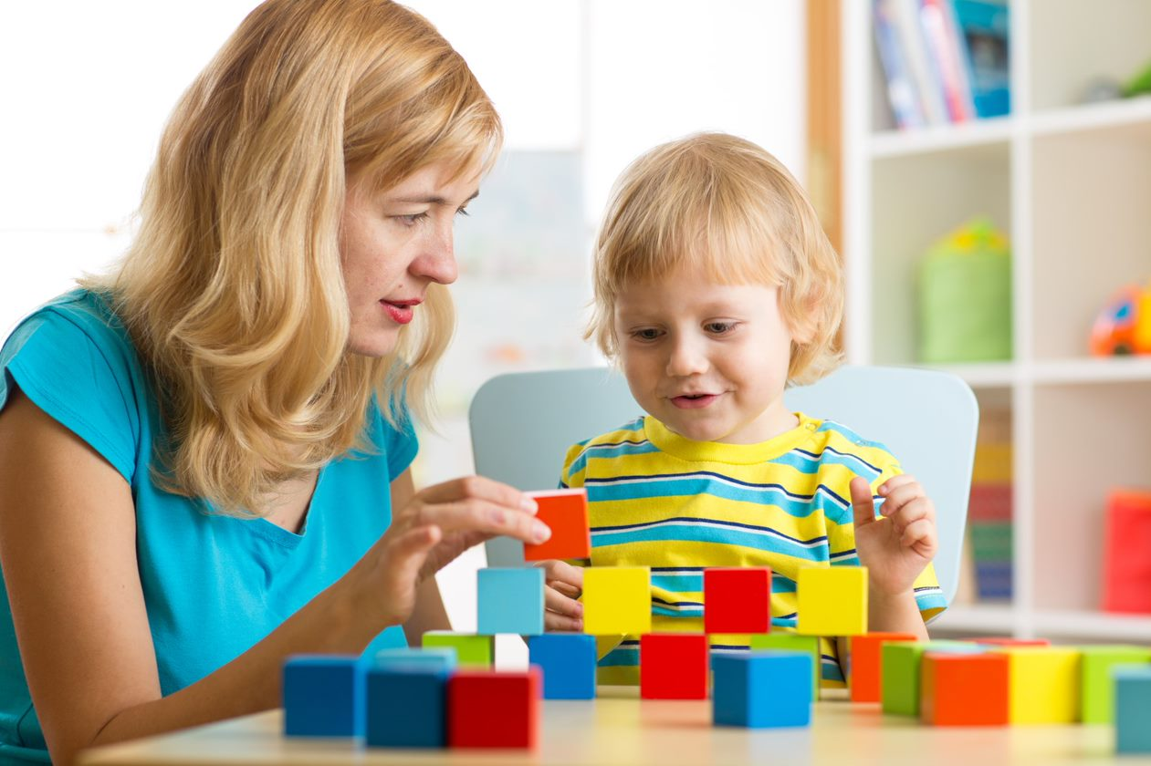
These strategies are not only about spontaneous approaches you may use as children’s responses arise. Adding structure as you assist children to explore the arts is also imperative to keep things organised. Structuring intentional teaching strategies may include planning your classroom environment, strategically placing materials and grouping them according to their use or children’s interest, and establishing rules and regulations.
For example, you may communicate to children that they are free to use and read books during free playtime, but they should take care of them (e.g. avoid writing or drawing on them, tearing or throwing them).and put them back on the shelf after using. If you notice that children prefer exploring the properties of paper, you can prepare a separate table with writing materials (e.g. crayons, pencils, and sheets of paper). There can also be an area with different types of paper (e.g. varying texture, thickness, and colour) that they can further explore by tearing, crumpling, or cutting.

Integrating these structures as you naturally develop intentional teaching strategies when responding to children’s exploration and play will make a good combination in creating an effective and efficient teaching method.

Further Reading
Read more about intentional teaching practices from Queensland Curriculum & Assessment Authority.
Intentional Teaching Practices

2.2.3. Document Opportunities and Intentional Teaching Strategies
One way to know whether your methods are working or not is by keeping everything documented. You may coordinate with your centre and check if they have forms and templates you may use to record children’s behaviours and responses, but you can also come up with your own template to maximise the areas you want to include. This may be used as you assist children in exploring the arts or in other domains.
First, you must document the learning opportunities that you are planning and preparing to do. This may include the following:
- Write your goals and objectives for a large group activity.
  - e.g. Feet painting – encourage children to use the same materials or work in the same space; introduce taking turns and sharing; explore painting using their feet (or other body parts).
- Write your goals and objectives for a small group activity.
  - e.g. Pasting activity(using assorted shape cutouts) – encourage children to express their imagination and thinking or remember events and experiences by putting together shape cutouts to create images and scenarios.
- Plan the structure of the furniture and equipment.
  - e.g. Classroom design and routine – place two tables near the sink so children who finish early can proceed to wash their hands; prepare a vacant table or space to allow artworks to dry.

- Prepare the instructions in an organised way that children can easily understand.
- Prepare the materials, equipment, or other furniture needed.
You may also add a section to note children who require close supervision during the activity and strategically assign them where adults can provide the assistance they need.

Second, during the execution of the activity, make sure that you have everything you need to document how children engaged in the learning opportunities and the intentional teaching strategies you executed in response to children’s exploration.
You may consider the following:
- Ensure that you have a clear view of each child assigned to your group if it is a small group activity, or enough adults can watch over each child if it is a group, outdoor, or active play activity.
- Assign a person to take pictures or video clips of children’s exploration and make sure that each child is included in the documentation.

- Record children’s responses to the opportunities, how they approached new learning experiences, and how they reacted to unfamiliar situations.
  - e.g. a child used hands for the painting activity instead of feet during the first few minutes and eventually tried using feet after seeing it from peers
  - e.g. a child dipped feet in paint and made marks on the allowed areas other than the paper on the floor then watched over the trail or footprints)
- Take note of your responses and how children reacted to them.
  - e.g. Modelling – you dipped your feet in paint and showed how to enjoy and explore the activity to encourage a child who is hesitant to participate; the child eventually tried to join using one foot and kept asking to hold an adult’s hand while participating in the activity.
  - e.g. Encouraging – you encouraged a child by noticing and describing what you see on their artwork by saying, ‘Oh, I can see that you put two squares together and stick them at the bottom of your paper. I wonder what you are trying to make.’
- Observe how the classroom setup, including the materials, furniture, and equipment available, contribute to the activity or the overall energy that the classroom portrays, and note if there are items that may be removed or regulated.
Lastly, after the activity or the class, allot time to review your notes and observations. You will see how the children responded and whether they are ready to explore new materials or provide more opportunities to familiarise them with using the same materials. Reflect on your observations for the day and use them as your guide in planning for the next activities by following the same process.

2.3 Research and Organise Resources Required for Creative Activities
Researching for resources as you prepare creative activities is necessary to ensure that they are relevant, current, and appropriate to the age and development of children. You may use the same activity for children of varying ages, but you need to know which adjustments you will make to make them fit the learning goals of your class. Consider children’s age, readiness, skills, personality, interest, and background when doing your research. It would be best to do research based on these factors.
Having relevant resources will help you address children’s learning needs appropriately. Previous studies will also provide evidence-based data to help you identify the approaches you might consider when responding to children’s inquiries and actions as they explore the creative activities you prepare. These are useful concepts you will learn as you continuously make yourself informed about creative activities for early years learning.
After researching, you would have to prepare and gather the materials you need based on your references, modified to the needs of children. Keeping your materials and resources organised will help you save time and bring a light mood that will help you think straight and focus on more relevant aspects of planning for your class.
When organising resources for creative activities, you may consider the following:

2.4 Select and Promote the Use of Diverse Natural and Found Materials and Make Them Available to Children
Educational materials that can be bought from stores, such as cars, animal toys, dinosaurs, people, manipulatives, puzzles, are without a doubt helpful in your child’s vocabulary and recognition as they engage in play. However, these materials may only provide limited ways because a child can use them based on how the creator intended them.
There are also open-ended materials readily available, such as wooden blocks, building blocks, magnetic tiles, pegboards, pipes, and more. These materials can surely enhance children’s creativity through construction and building, creating tools for play, or assemble and disassemble the materials for different purposes.
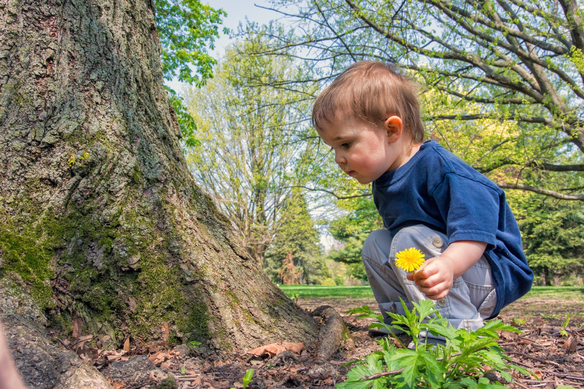
Aside from the ones that you can easily find in educational stores, a richer source of diverse materials can sometimes be found just right where you are. These are natural and found materials. Natural materials are basically anything you can see in your backyard. Some of these include twigs, branches, pine cones, stones, leaves, soil, sand, flowers, pebbles, water, dirt, nuts, and seeds. Found materials are the other materials you may find at home or in school that you would not need to buy. Some examples are pieces of fabric, handlebars, loose buttons, bottle caps, cereal boxes, old squeeze bottles, jars, lids, straw, string, empty tissue and tape rolls, and more. These materials may also be called loose parts.

You must expose children to materials they can use in a hundred, or even a thousand, different ways to train them to think creatively. By doing this, you help children see and use materials in unlimited possibilities, which they can only do when they are trained to be inventive and think creatively by making the most of the materials available.
Parents and families tend to provide their children’s wants, especially when selecting a toy, which is understandable. However, as an educator, you must understand that giving in to all children’s requests when choosing materials may also hinder creative learning opportunities. Instead, promote the use of diverse natural and found materials to encourage creativity and inventiveness.

Selecting Diverse Natural and Found Materials
When selecting materials, the first thing that you must consider is safety. You must always check if the materials are clean, considering that children will touch them explicitly, put them in their faces, or may accidentally put them in their mouth. Although exploration in the outdoor and natural environment will, of course, include getting messy and dirty, you must still make sure that children’s encounters with the surroundings and the materials in it are safe for exploration. Another thing that you must look out for are objects with sharp or pointy objects. There are times where children will walk or run around barefoot or roll on the floor or grass. It would be best to check if the area is safe from those hazards.
Diverse natural and found materials will create an effective combination in a natural environment. This may include:
- gardens where children can grow their own plants
- sandpits for sensory, symbolic, and physical play
- sensory tubs with loose parts and materials with varying textures
- small pits of pebbles, gravel, coarse sand, and smooth river rocks
- trees, branches, flowers, stones, and bark.
Once children develop and build a good experience in exploring their environment, they are most likely to look forward to it and crave more encounters with it. This means that there will be more venues for creative play and learning.
Sourced from Natural environments, used under CC BY 4.0 © State of Victoria (Department of Education and Training)

Promoting the Use of Diverse and Found Natural Materials
Educators’ ways of selecting materials for creative experiences are crucial in giving children access to diverse materials. You must understand how the environment plays a big role in the learning and development of children. To promote the use of these materials, you may consider:

Sourced from Natural environments, used under CC BY 4.0 © State of Victoria (Department of Education and Training)

Your goal in selecting diverse natural and found materials will affect their accessibility to children and how they can use them as they explore and play. Observing children’s interests will help you limit and pick specific materials that are relevant to what they are currently investigating. Making these materials available to children according to the topic they are exploring will supplement their learning and enhance creativity as they can use them as materials for exploration, props for play based on their uses, or represent something else.

Further Reading
Learn more about loose parts and how they help nurture children’s creativity by reading the resources below.
Loose Parts Toolkit
The Power of Loose Parts Play

2.5 Identify and Use Opportunities to Make Sustainable Resources
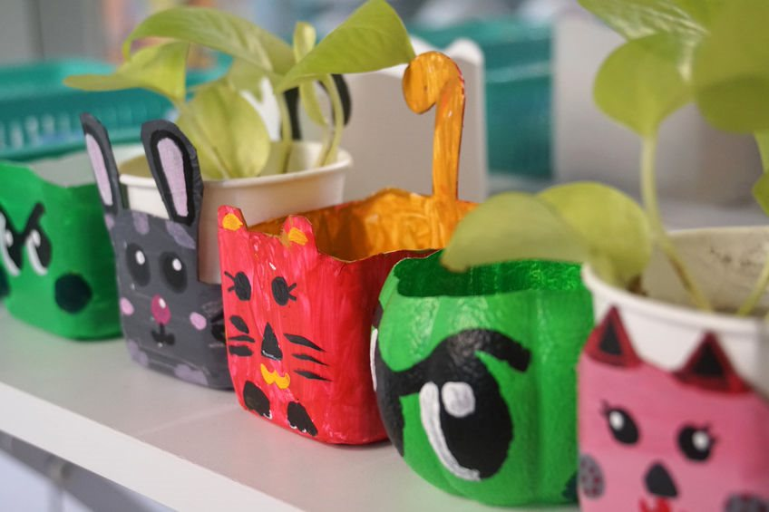
The use of diverse natural and found materials may somehow be related to making sustainable resources. Sustainability means resources will be consumed or used responsibly in a way that they can be used multiple times. Making sustainable resources for children could mean that these materials can be used by different age groups for various purposes and may still be functional to the new batches of children in the centre. These are the resources that can be used over and over again.
Sustainable resources are often made with the environment’s best interests in mind. Some processes that you may consider in making sustainable resources are re-cycling, re-purposing, and re-using. Re-cycling means giving a new life to an object that may be intended for disposal. For example, old newspapers that are outdated and not functional may still be used as a mat for a painting activity. Re-purposing materials means using an object for another purpose other than what it is intended for. For example, old tissue boxes may be used as containers for collected natural materials. On the other hand, re-using means old, functional materials are kept and used repeatedly for the same purpose. For example, old Halloween costumes and masks, musical instruments, art materials and tools.

As an educator, you must also train your mind to look for learning opportunities to nurture creativity among children spontaneously. It is also a challenge for you to be creative and maximise the use of different materials through provocations. You may identify opportunities to use them to make sustainable resources as you observe how children engage with their environment. For example, making animal masks for children to use as they play pretend may still be functional to other age groups and providing coloured pieces of cloth may be used as capes or ribbon wands that can be used as props for dancing or imaginative play.
It will also be helpful to review the different learning areas discussed in the first subchapter of this chapter and brainstorm which re-cycled, re-purposed, and re-used materials you may use to support children’s creative learning. You may check the examples below.

Re-cycled Materials
- Construction – scoops, spoon, shovel, funnels made from plastic bottles to explore sand play
- Digital Technologies – parts of a used calculator, clock, or cellular phone may be disassembled and used for tinkering activities
- Dramatic and Imaginative Play – create costumes using old pieces of cloth or painted paper plates as masks
- Language and Storytelling – gather pictures from old magazines or charts to form a storyline
- Movement – thick strings or cables may be used as jump ropes
- Music – metal bottle caps collected to make a tambourine or a shaker, cardboard boxes as drums
- Science, Technology, Engineering, Arts and Maths (STEAM) – using bottle caps, empty tissue rolls, and yarn to create objects like cars, robots, or a character figure
- Visual Art – wooden scraps for sculpting or scraping or vegetable scraps as stamps

Re-purposed Materials
- Construction – cake pans, spatula, plates to explore sand play
- Digital Technologies – old calculators, alarm clocks, or mobile phones used as props in classroom dramatic and imaginative play
- Dramatic and Imaginative Play – cardboard boxes may be used as houses or cars, shelves may act as a supermarket store or a vegetable stand
- Language and Storytelling – use writing materials to write words or draw images that can create a story
- Movement – beach balls may be used as a yoga ball or massage ball for exercises, old newspaper may be crumpled to form a ball to play catch
- Music – windchimes, kitchen pans and pots, metal ladles used to make sounds
- Science, Technology, Engineering, Arts and Maths (STEAM) – using a string or a tape to measure distance, a long stick to measure the height of an object
- Visual Art – old combs, sponges, plastic forks as tools for painting

Re-used Materials
- Construction – old sandcastle moulders, buckets, and shovels
- Digital Technologies – hand-me-down iPad, tablet or smartphones
- Dramatic and Imaginative Play – old Halloween costumes, old masks, old fireman’s helmets
- Language and Storytelling – old books passed on to younger children
- Movement – old jump ropes, chalks to make marks on the
- Music – old maracas, drums, or tambourines
- Science, Technology, Engineering, Arts and Maths (STEAM) – measuring spoons, cups, meter stick
- Visual Art – used paintbrushes or palettes

Checkpoint! Let’s Review
- There are nine areas of learning that can help you plan creative learning experiences that nurture creativity.
- Intentional teaching strategies will help you identify the appropriate responses in supporting children’s creative experiences.
- You may re-cycle, re-purpose, and re-use learning materials to promote sustainable education.

Further Reading
Learn more about sustainability in early childhood education by reading the article from The Spoke.
Education for Sustainability in Practice

Learning Activity for Chapter 2
Well done completing this chapter. You may now proceed to your Learning Activity Booklet (provided along with this Learner Guide) and complete the learning activities associated with this chapter.
Please coordinate with your trainer/training organisation for additional instructions and guidance in completing these practical activities.

III. Nurture Creativity Through Teaching and Learning
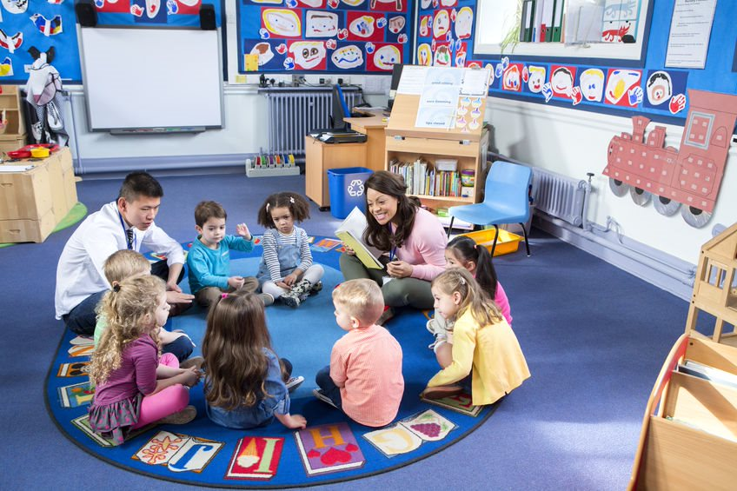
Teaching is the process of passing on the knowledge and skills to someone else, while learning refers to the acquisition of this knowledge. As an educator, you play a major role in nurturing children’s creativity by being part of these processes.
In this chapter, you will learn the following: the importance of giving children time and feedback in stretching out possibilities for creativity through extended exploration, to value the process and product of creative opportunities, to teach children to appreciate the materials and equipment they use, to prepare opportunities for collaboration, to encourage children to use creativity to overcome challenges, and to use flexibility to respond to children’s interests and needs.
These teaching and learning methods will help you identify opportunities to nurture children’s creativity and respond to them appropriately.

3.1 Provide Time for Children to be Creative and Encourage Efforts to Extend Over Days or Weeks
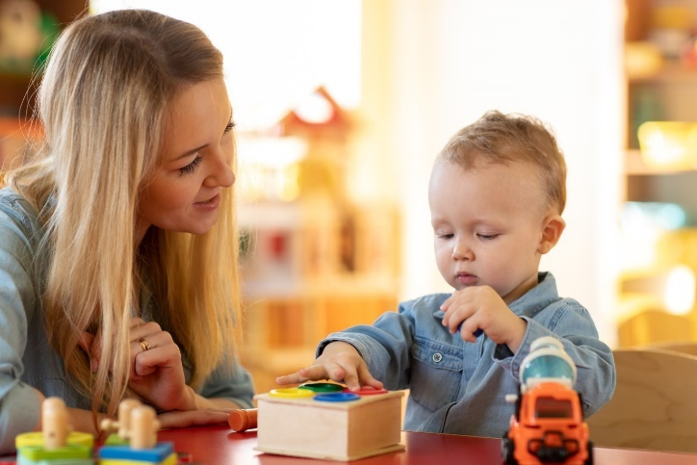
Young children are not automatically aware of their creative potential, although that is innate to them. As an educator, you must help children see them and discover them as they engage in the creative activities you prepare. Learning about creative skills and the realisation of having them involves building children’s confidence, which all take time to develop. Children need time to make mistakes and correct them or try another method that might work better. This learning curve may go for extended periods. Consider the following as you provide time for children to be creative:
- Observe how children engage with the materials.
- Avoid putting pressure on children to figure out the ‘correct’ way to finish the task.
- Allow them to explore the different ways to make something work.
- Help them reflect on mistakes and motivate them to try again.
- Ask open-ended questions to encourage communication and expression of their own observations and realisations.
As you provide time for children to engage in creative experiences, you must remember that you are not looking for a ‘right answer’ when you allow them to investigate. The time you give them to immerse in the processes of their interest is itself the highlight of your activity; it is where most learnings take place.
When children do not feel the pressure of time constraints when experimenting and investigating, it will help them build persistence and continue to work on a task repeatedly until their goal is achieved. You may consider the following when encouraging children’s efforts to extend over days or weeks through the following:

Through this, you can help children realise that they get different results as they change their methods and their actions affect the results directly or indirectly. Developing this kind of thinking is essential to nurturing creativity among children.
Product-oriented and process-oriented creativity are two different elements of creativity which both include various art processes within them. Product-oriented creative processes are those that have the final output in mind. These are detailed methods and techniques that aim to achieve the desired outcome. On the other hand, process-oriented creativity is all about immersing in spontaneous and flexible ways without a specific output in mind.
As you help children discover their interests and skills, process-oriented creative opportunities will help encourage them to participate and engage in various processes. Once they become aware and familiar with those processes, they can eventually create with a product in mind.
Further Reading
Below are some links to researches about the creative process and product:
Children’s Creativity: A Theoretical Framework and Systematic Review
Componential Model of Creativity

3.2 Teach Children How to Use and Care for Materials and Equipment According to the Nature of the Activity
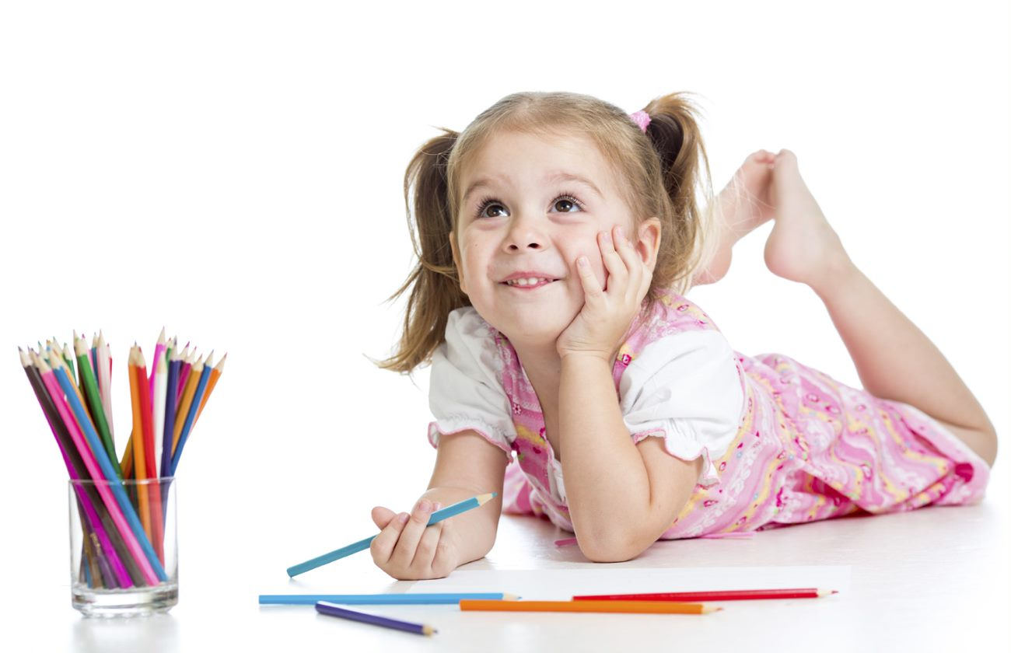
Fostering creativity among children involves countless exploration opportunities, which also means an equal amount of time in using different materials and equipment to support learning processes. In every activity, it is vital to educate children about the materials and equipment they will use. You may give them information such as the object’s name, what they are made of, and how they are commonly used. At the same time, you may encourage them to discover new ways of using the objects.
Introducing materials and equipment to children will help them acknowledge and value the existence and functions of the objects. Knowing more information will help them understand that the objects do not just exist for their benefit but also need to be taken care of. Caring for materials and equipment would consider their composition, properties, and characteristics. For example, fragile materials that would require adult supervision when using or those that might break when thrown, jabbed, or used with too much force.

You may teach children how to use and care for materials and equipment through the following:
- Model safe use and care
Demonstrate some ways of using the materials and cleaning and taking care of them. Be careful not to be too suggestive that you give structured directions on what children should do during the activity.
- Label items and processes
Introduce the names of materials and equipment and the processes involved in caring for them. For example, you may say that to clean paintbrushes, you use soap and water to remove paint, or when paint gets on the table, you would need a sponge to scrub off the stain.

- Give instructions/reminders
Although you want to encourage children to explore freely, there will be times that limitations on the use of materials will get along the way. Establishing rules and giving reminders will help children proceed with caution and be mindful of their actions. For example, you want to introduce the use of child-friendly paper scissors to children. You would want to train them to hold the paper and scissors properly by reminding them to place their fingers far from the scissor blades, even if the scissors are child-friendly. You must also ensure that children understand when you give important reminders about materials used with adult supervision.
- Organise flow of activity
Part of giving instructions is establishing a routine or flow. It will guide children on the steps that they need to do when using and caring for materials. Give children brief and simple steps to remember. Assign tasks to care for the materials and equipment that are appropriate to children’s age. You may think of a pasting activity using shape cutouts as an example:
  - Do the activity. Put back the shapes you did not use.
  - Set aside your work to let it dry.
  - Wipe your area on the table.
  - Wash the glue brush on the sink.
You may demonstrate these steps the first time you introduce them and then give reminders on the next opportunities. You may also tell them to use soap, for example, which they would need when washing the glue brush and point out the container prepared for the clean brushes.
Early years learning centres have protocols in maintaining the cleanliness and safe use of resources and equipment in creative experiences. They will be washed and sanitised regularly, giving special attention to materials mouthed by a child or after being handed by a child who is sick. The cleanliness of common areas and surfaces should also be maintained.

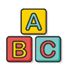 | Sparkling Stars Early Years Learning Centre  Sparkling Stars is the simulated early years learning centre environment referenced in our learning resources.  Their maintenance and upkeep procedures are published on their site. You can access them through the link below.  Facilities and Environment  (username: newusername password: new password)

3.3 Plan and Create Opportunities for Children to Collaborate Creatively With Each Other
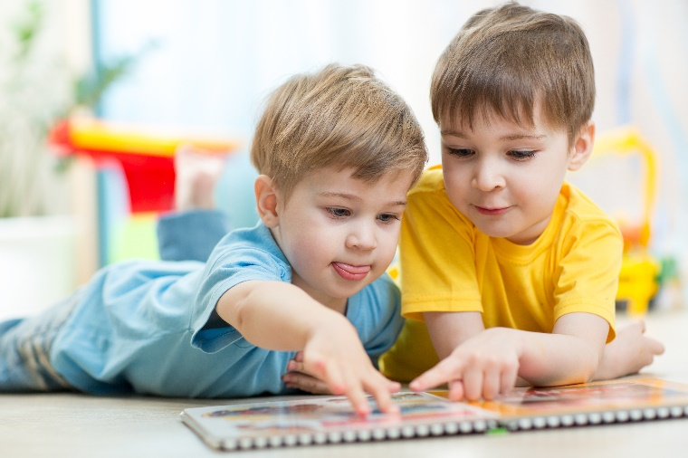
Shared interests among children are doorways to build positive relationships and bonds. These are good opportunities for creative collaborations to build on their strengths, work together, and use them to achieve a goal.
The Early Years Learning Framework principles and practices explicitly discuss how children can learn to appreciate their connectedness and interdependence as learners and value collaboration and teamwork when educators prioritise nurturing relationships among children. It sets the foundation when thinking about activities to foster collaboration.
Sourced from The Early Years Learning Framework for Australia, used under CC BY 4.0. © Commonwealth of Australia

When planning and creating opportunities for children to collaborate creatively, you may: consider the following:
- Consider children’s personalities and responses.
Knowing how children respond to activities and certain materials will help you anticipate how they will probably manipulate shared materials and areas for collaborative activities. It will help you watch out for teaching opportunities or give reminders as necessary. Observing how children with contrasting personalities work together is also something worth taking note of.
- Prepare open-ended activities.
Open-ended activities put children in unpredictable situations that they need to respond to without exact directions from adults. Instances like these are opportunities to encourage children to negotiate, compromise, and communicate their thoughts and ideas to each other.

- Use opportunities in forms of social play and interaction.
Play-based learning experiences are proven to be most effective in teaching children about relationships and working together. Engaging children in play creates a safe space and makes them feel comfortable interacting with each other. This type of environment and a play-based approach encourage children to respond to each other’s needs and communicate their needs as well.
- Create a natural environment with provocations for collaboration.
Provocations act as invitations for children to engage in the activity without giving direct instructions. Setting up your classroom environment that will invite children to engage in the materials you prepare will naturally invite them to work together towards a common goal. It is also a good opportunity to observe how children will act naturally and respond to each other without prompts from adults.
- Allow situations that children may see as problems or challenges.
Materials may be intended to be lacking or incomplete if you have a clear objective in doing so. Children’s responses are the most important aspect of collaborative and creative opportunities, including their responses to problems, mistakes, and challenges. Observe how children react to problems and how they will work together and use creativity to solve them.
- Provide shared activities among children.
Other than the activity you intend for creative collaboration, shared activities facilitated by the educator, such as storytelling and group discussions, will allow children to discover each other’s interests. Having shared interests will contribute as children communicate verbally and non-verbally and work towards a common goal.

Further Reading
Page 36 of the Early Years Learning Framework discusses how children are confident and involved learners, including their natural capacity to learn to collaborate. Review the framework through the link below.
The Early Years Learning Framework for Australia

3.4 Encourage Children to Use Creativity to Overcome Challenges
The previous subchapter briefly mentioned how children could use creativity to solve problems. Using creativity to overcome challenges is not different. Challenges are situations children encounter when working towards a goal they may struggle to accomplish. Some factors that may contribute to these challenges are limited skills and abilities, lack of or use of inappropriate materials, the limitations caused by the properties and characteristics of materials used, and more.
Challenges are unavoidable and should not be removed from children’s paths to learning. It is necessary to teach children learning dispositions such as persistence and resilience. Your role as an educator is not to provide solutions so children can overcome the challenges. It is your job to help children to persist and continue moving forward until they achieve their goals. You may consider the following as you encourage children to use creativity to overcome challenges:
- Help children realise that a challenge is not a dead-end. They may feel frustrated and upset, but you can support and encourage them to try again. You can do this by:
  - acknowledging the challenges they are experiencing
  - asking questions to identify or clarify their goals
  - offering other options and alternatives considered to achieve their goal
  - letting children choose which strategy or technique they want to use to try again.
- Boost children’s confidence. They need to feel that they are capable of accomplishing their goals or making progress as they practise. You can do this by:
  - praising their efforts and describing the specific actions they took (e.g. ‘Looks like the first piece you put in there did not work. Are you trying a different shape this time?’)
  - noticing observable behaviours that contribute to achieving their goal (e.g. ‘You are working on building your castle since you arrive. You really do not give up easily.’)
  - expressing your appreciation of their work or give comments on how they can be related to personal experiences (e.g. ‘The car on top makes me want to go on a fun adventure!’).

- Ask them questions and lead them to reflect on why it did not work. Help children identify the cause of the challenges and analyse what could be done differently or used differently to make it work. Use follow-up questions to inquire further and understand their thought processes and help children realise the challenges present. Some questions you may ask are:
  - What did you use to do that? What do you think went wrong?
  - What happens if you do this? What do you think will happen if you do that?
  - Where did it go wrong? Why do you think it is not working? Do you think you need to change anything?

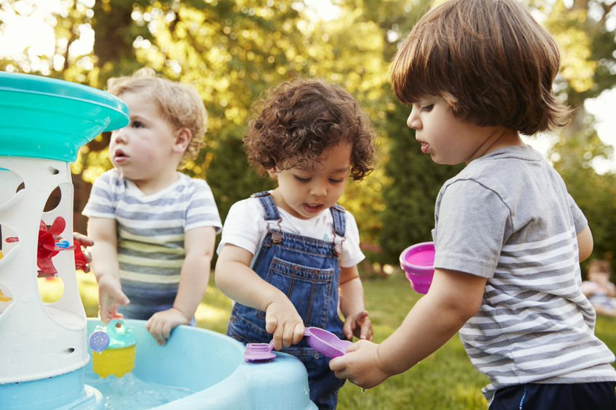

3.5 Use Flexibility to Respond to Children’s Interest and Needs
Acknowledging children’s differences will help you embrace their individual needs and accept that they have different interests. There will be several times when things will not go as planned because children respond differently, or some plans will not push through because of unexpected situations. Like how you encourage children, you must also see these as opportunities to teach children new knowledge and skills that are timely and relevant, instead of seeing them as mistakes.
Children’s interests may include the topics they explore, what they enjoy doing, activities that are related to their past experiences, or new activities that spark their curiosity. Some of their needs involve the materials and equipment that will supplement their exploration, support, and encouragement, or the activities and experiences for exploration.
Flexibility is the ability and willingness to compromise, adjust, or change methods and approaches in response to a more urgent matter. You may use flexibility when responding to children’s interests and needs by:
- changing activities or adjusting schedule because children responded differently during play
- responding based on children’s reaction and interaction to new activities
- elaborating discussion on topics spontaneously that children relate to because of previous events to develop their ability to connect experiences
- observing how children interact and engage with the activities and gauging if more materials need to be provided to supplement the current exploration or transition to a new topic is needed
- providing materials and improvising equipment on the spot based on the availability to support children’s interests
- giving support and encouragement suitable to the present situation and based on the observable behaviour of children.

Example:
You initially planned to do messy art exploration after free play. However, you noticed that several children in your class were invested in building a community together using chairs, tables, and shelves. They assigned roles and divided the room into areas with a fire station, a police station, and a grocery store. It seems like everyone participated in dramatic play.
You noticed that free playtime is almost over, and you have prepared an activity for art exploration. Instead of stopping and interrupting children’s play, you may use flexibility to respond to children’s interests by allowing them to use the time for art exploration and extend their play. You may continue observing children’s dialogue as they play or how they represent each community helper. Flexibility will help you focus on the more important matters, such as allowing children to spend more time in an activity they are invested in and discovering new concepts in their play.

When attending to children’s needs, educators like you must use flexibility to gauge and weigh the situation and decide what would be best for the child. Examples are indicated below.
- One way to comfort a child may not be effective to another. Not all children would prefer hugs as a way to comfort them. Some children may choose to do quiet activities by themselves, sit down alone or beside an adult, or play with friends.
- One strategy to show support to a child when facing challenges, such as going up the wall climber, may not work for the others. Some may be okay with verbal encouragements and directions, some may need gestures as a guide, and others may require full physical prompts to motivate them. Knowing children, including their skills and abilities, will help you change strategies and techniques necessary to address and respond to their needs.

Checkpoint! Let’s Review
- Give children enough time to extend their play and expand their ideas and interests through creative opportunities.
- Prepare activities that help children use creativity to solve problems and overcome challenges.
- Educators need to be flexible to address children’s needs and support their learning appropriately.

Further Reading
You may read the reference below to help you understand how to respond to the varying learning styles of children.
Examples of learning styles

Learning Activity for Chapter 3

Well done completing this chapter. You may now proceed to your Learning Activity Booklet (provided along with this Learner Guide) and complete the learning activities associated with this chapter.
Please coordinate with your trainer/training organisation for additional instructions and guidance in completing these practical activities.

IV. Nurture Creativity Through Engagement With Children
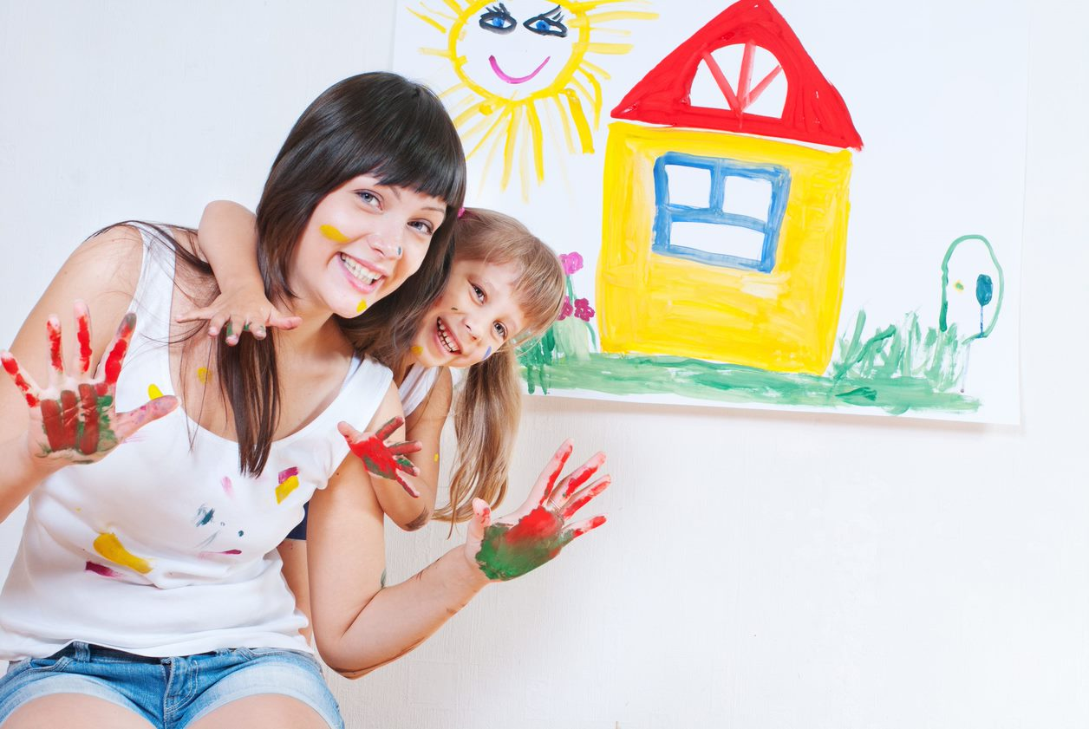
The Early Years Learning Framework principles and practices emphasise the role of educators like you in assisting children towards achieving the five learning outcomes. Establishing positive relationships with children and having an adult that makes a safe and nurturing environment make a difference in promoting children’s learning.
Your engagement with children means being involved and taking part in their learning. Although you encourage children’s independence and agency, some learning processes occur in social contexts and through your help and facilitation. You must be involved as children engage in various learning processes because only then will you realise their interests and needs. By participating and experiencing first-hand what the children go through, including their successes, frustrations, questions, and queries, you will understand how they learn best.
This chapter will suggest different ways of engaging with children to nurture creativity: supporting children to have a sense of responsibility for materials and equipment through modelling; using strategies to improvise equipment and materials; encouraging children to pursue original ideas and interpretations; inviting them to ask questions, engaging in conversations to talk about their creations; modelling enthusiasm for and showing respect to their creative work and encouraging children to respect and appreciate the work of others.

4.1 Support Children to Feel a Sense of Value and Responsibility for Equipment and Materials Through Encouragement and Modelling
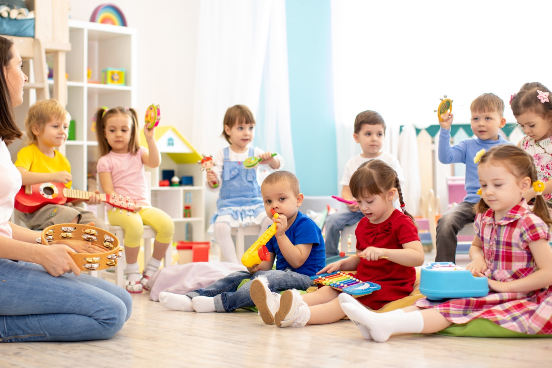
Having a sense of value for materials and equipment means recognising their importance and use. It also means acknowledging that there are ways to take care of them and prolong their shelf life. Developing a sense of responsibility, on the other hand, integrates the awareness of obligation and action in response to having a sense of value for the materials and equipment. It means that a person knows they need to respond to their awareness of the value of something.
As you previously encountered, encouragement means giving someone support, confidence, hope, or the persuasion to push someone forward, believing that they can accomplish and succeed on their goal. On the other hand, modelling simply demonstrates knowledge or skill or provides an example to copy. Through encouragement and modelling, you can support children to feel a sense of value and responsibility for the equipment and materials they are using.

Supporting children to feel a sense of value and responsibility for equipment and materials through modelling may include:
- Demonstrating your awareness of the function and uses of materials.
  - e.g. express verbally how you like that scissors make opening or cutting things faster and easier.
- Emphasising how materials and equipment are helpful and why they are needed.
  - e.g. communicate how you like that books help give information about a lot of things.
- Appreciating when materials are put back in the right places and are safe from being broken or damaged.
  - e.g. mention how having all colours of crayons inside the crayon bucket are helpful when looking for a preferred colour, or acknowledge how you feel safe walking around knowing that there are no loose parts or tiny objects scattered on the floor that might break or hurt someone.
- Cleaning the equipment and materials as part of your routine.
  - e.g. wipe the tables regularly after an art activity, set aside used art tools for washing, use soap to remove all paint stains and make sure they dry up nicely, use a clean cloth and sanitiser to clean used equipment, and set aside mouthed toys.
- Putting back the materials in an organised manner and inviting children to participate in sorting them out.
  - e.g. take the time to sort out blocks, manipulatives, puzzles, or books and put them back in the correct location during pack away time.
- Fixing broken materials and equipment.
  - e.g. use glue and tape to put back a piece together temporarily. You may also ask for input from children and demonstrate how it is possible to fix broken toys based on their ideas. It can also be an opportunity to help them understand how taking care of the materials and equipment is important because it is not all the time that things can be fixed with glue or tape.

Supporting children to feel a sense of value and responsibility for equipment and materials through encouragement may include the following:

- Notice careful manipulation of materials and use of equipment.
  - e.g. ‘Thank you for getting just the right amount of glue and sharing the excess with your friends. Now we have extra glue for next time.’
- Observe how children show knowledge on using materials and equipment.
  - e.g. ‘Wow! You can easily put the pipes together now and make them go in different directions.’
- Acknowledge when children enjoy using the materials and give reminders on how to take care of them.
  - e.g. ‘I can see how you are enjoying using the balance board and wooden blocks! We have to make sure the blocks fall on the mat, and only two children will use the balance board at a time so we can keep using them, and we can avoid breaking things.’

4.2 Use Strategies That Model Creativity by Improvising with Equipment and Materials
There will be times that you will notice how children are actively participating in a project, and you have to think of materials and equipment to bring in class on the spot to support the topic or encourage continuous participation while children are still at it.
However, materials and equipment may not always be available when you need them, and there are times that it is best to have them ‘now.’ As an educator, you must also be prepared in situations like this and make the most of what you have. When you do this, you also demonstrate to children how to use creative strategies in improvising materials and equipment.
A research study on the ‘Improvisation in Teaching and Education’ considers ‘improvisation’ as a professional skill for teacher educators. This skill is developed based on the need to act and respond in accordance with the needs and requirements of various pedagogical situations.
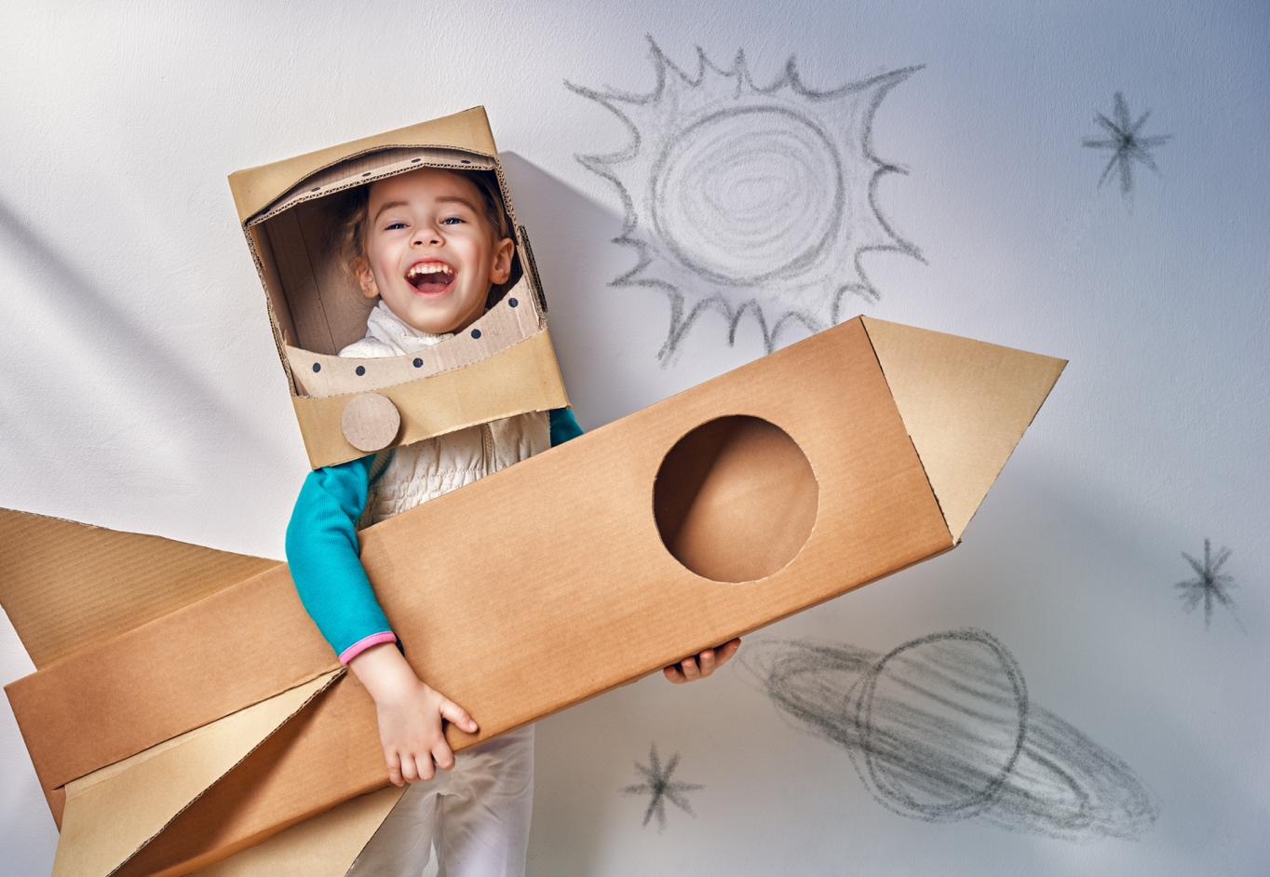

The following are the four aspects of improvisation identified in the study that are significant in forming strategies in modelling creativity:

- Communication and dialogues
Emphasises the effect on the audience or the process of exploration.
- Structure and design
Awareness of and skills in planning and structural thinking.
- Repertoire
Learnable skills, subject knowledge, and the knowledge of learning and good teaching.
- Context
Strategies used to model creativity by improvisational practices are based on context.
Kari Holdhus, Sissel Høisæter, Kjellfrid Mæland, Vigdis Vangsnes, Knut Steinar Engelsen, Magne Espeland & Åsmund Espeland | Mark Boylan (Reviewing Editor) (2016) Improvisation in teaching and education—roots and applications, used under CC BY 4.0. Cogent Education, 3:1, DOI: 10.1080/2331186X.2016.1204142

The four aspects of improvisation show that educators like you should have a goal when engaging in conversations or giving instructions. You must consider whether the target of the language and the direction of the activity is focused on exploration processes or children’s responses. Prior knowledge on structure and design is also important when selecting improvised materials, whether they are efficient, safe, and effective. Your knowledge of the topic and standards of teaching and learning are also big influences on your choice of materials and equipment to improvise. Finally, context will decide whether the improvised materials are current and effective.
Below are some strategies that you may use when improvising equipment and materials:
- Identify your goal
You must know your objective and have a clear reason why you will improvise. Identify the function of the materials or equipment. It may be encouraging children to participate in storytelling and invite them to recreate or retell the story with the props you improvised. Another example is using and connecting long wooden blocks on the floor and using them as balance beams.
- Describe the characteristics of the materials you need
You must know what you need to find replacements or substitutes. Consider the quality of the improvised materials, their safe use and caution as necessary. For example, you need something green to represent the frog in the story and something brown and big to represent the bear.
- Look for available materials in the centre or at home
Part of sustainable teaching is using re-cycled, re-purposed, and re-used materials. Maximise the scraps, old items, and functional objects that you have and use them for the same or different purposes.
- Use your imagination and have fun!
Recreate and use the materials based on your goal and invite children to join you in ‘pretending’ or representing improvised objects as new materials and equipment.
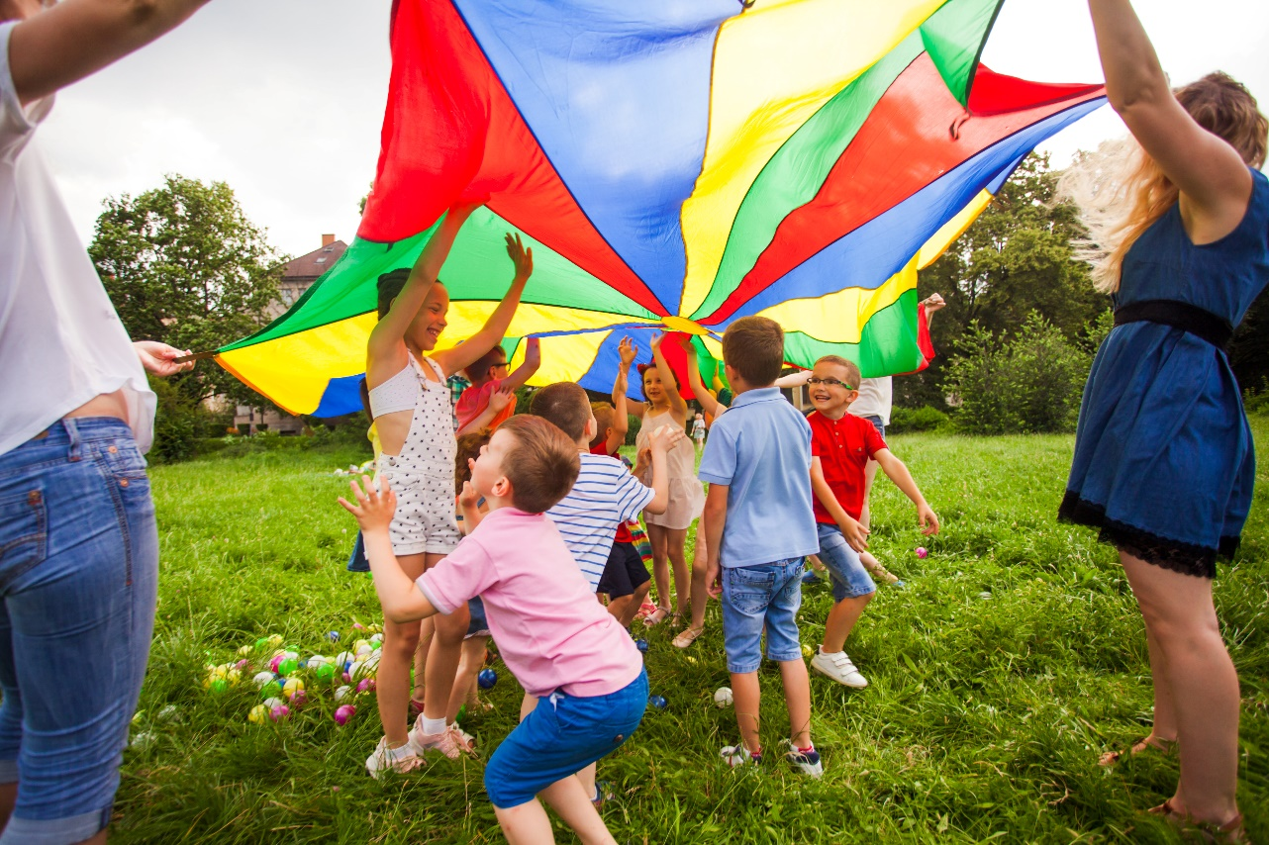

4.3 Encourage Children to Pursue Their Own Original Ideas, Interpretations and Expressions
Part of acknowledging children’s differences is to keep in mind that no two children are alike. Even twins do not have the same personalities, needs, and interests. In the same way, children’s ideas and thoughts will surely be different from each other. As an educator, you must support children in their explorations and in pursuing their unique ideas. It also means that you have to observe how they communicate their interpretations and expressions. You must help children build their confidence in exploring and expressing their discoveries, foster independence and critical thinking, and create a safe space for learning that is free from judgment and see mistakes as learning opportunities.
Your skills and techniques in creative areas will also help assist children in implementing their ideas. Skills refer to your ability and proficiency in performing a specific task, including your communication skills, reflective skills, dealing with conflict, flexibility and spontaneity, motivating others, organisational skills, and teamwork. On the other hand, technique refers to the methods that you may apply in addition to your skills to assist children in implementing their ideas in more efficient ways.

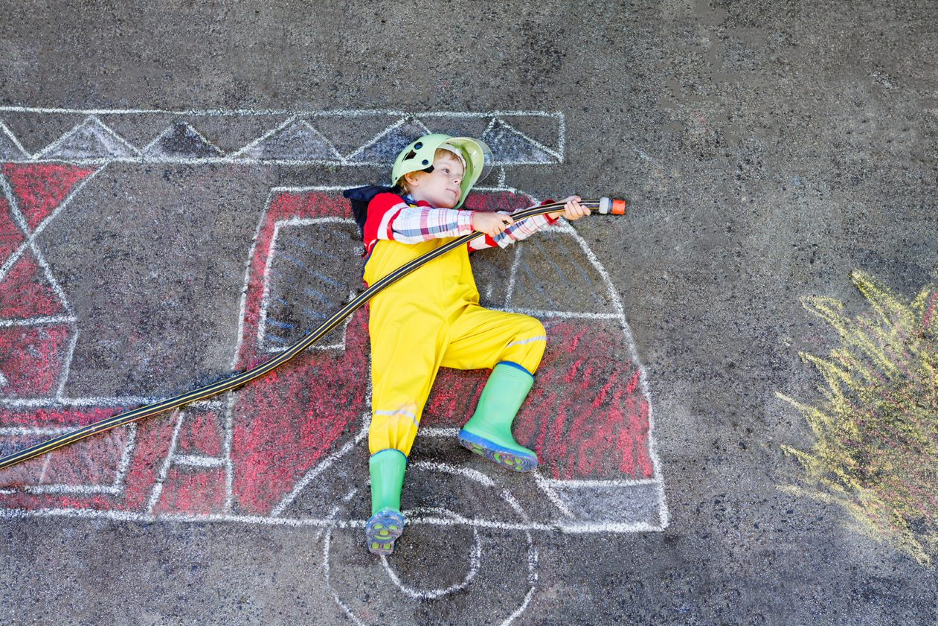

You may consider the following techniques:
- Prepare activities and materials that provoke children’s thoughts and ideas.
- Ask open-ended questions.
- Provide appropriate and open-ended materials.
- Use imagination and brainstorming to solve problems.
- Show dramatisation of events and situations to encourage creativity.
- Engage in children’s learning.
- Accommodate all types of questions and responses.
For example, you have the skill to read a book and facilitate storytelling. You may use techniques such as creating a drama or act out the character’s expressions to invite children to participate in the read aloud. After that, you may ask the children to draw what they remember or how they understood the story. To help children recall, you may re-enact a scenario or a line as necessary and use drama as a more creative technique.
Encourage children to pursue their own original ideas by observing their interests, providing creative opportunities to explore them, and allowing them to investigate and experiment.
As they progress, you may ask them about their goals and the reason behind their plans of action. When children observe the work of others, or if you see them looking curious about a process or a structure, asking open-ended questions will encourage them to share their interpretation of what they see. Children’s interpretations may not always make sense to adults. Their ideas will be based on their present knowledge, which may include misconceptions and inaccurate information. Even then, continue to ask questions without judgment and encourage children to try out their ideas and see if they will work based on their present knowledge.
Children’s expressions may not always be verbal. It may reflect on their creation, movements, energy, gestures, play, and artwork. Observe which method allows them to express themselves completely. Encourage them by reinforcing their means to express their ideas and energy.

Further Reading
Read through Scholastic’s article to learn more about promoting creative thinking among children.
How to Promote Creative Thinking

4.4 Invite Children to Ask Questions and Assist Them to Find Their Own Answers

Asking questions is a fundamental part of the learning process. Children ask questions when they encounter a gap in their knowledge, a situation that they do not know how to resolve, and new concepts in unfamiliar situations. It is a part of children’s cognitive development. As an educator, you must respond not only to provide answers to children’s questions. When children make inquiries, they gather facts and collect additional information to integrate into what they observe or explore. These are their attempts to fill in the missing parts in their current knowledge or verify their assumptions. Therefore, you must treat them as part of a process.
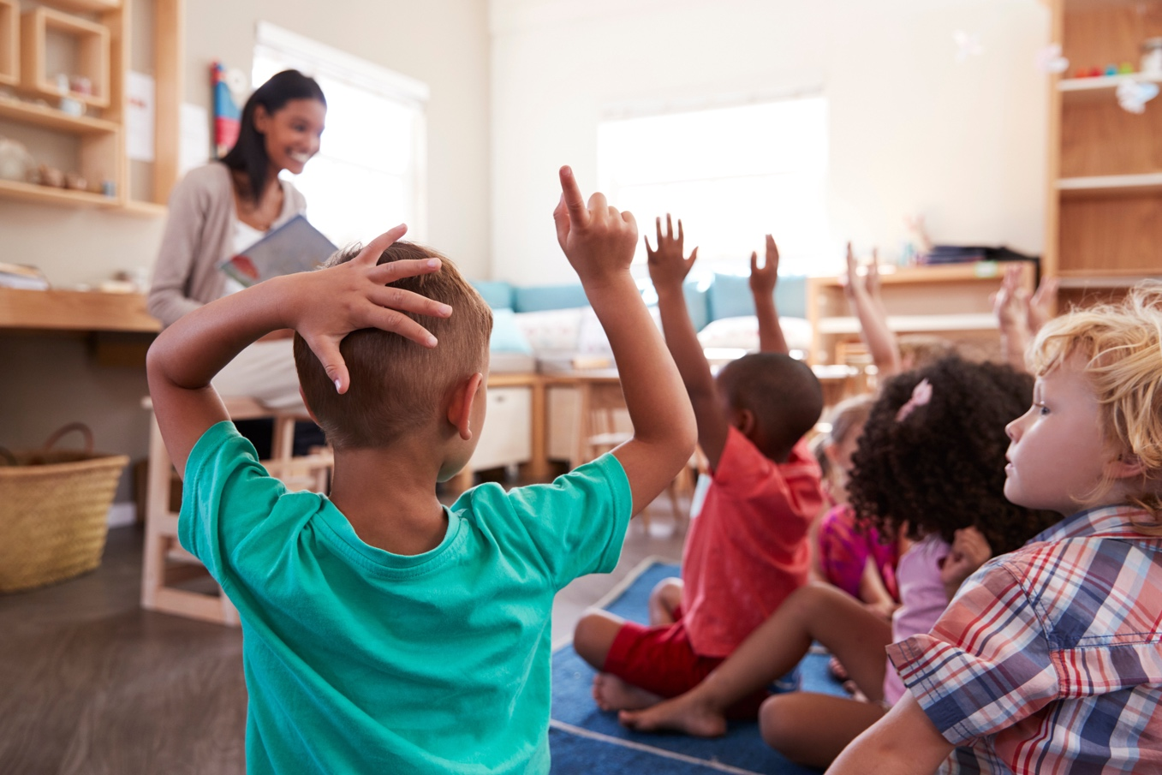

Consider the following before you think about providing an answer to children’s questions:

Children usually ask questions to gather information, validate or confirm assumptions, and request help or permission on their exploration and play conditions. Understanding that these inquiries are attached to their learning dispositions would make you consider them as part of children’s explorations and investigations rather than solve or answer them.
Setting up an environment that engages children in materials to make them curious and wonder about various processes is the best invitation for questions. These are the objects or experiences that provoke thoughts, ideas, and actions. These materials could be prepared to respond to children’s interests and ideas, which pose an invitation for inquiries and investigation. For example, you may put flashlights and coloured transparent sheets on a table, allow children to manipulate the materials and observe how they explore or ask questions among themselves or an adult about the new experience.
Conducting experiments in class is also another way to invite children to ask questions. Allowing them to see the changes in an object’s state and properties or how things transform or turn differently are some of the opportunities that encourage them to ask. You may also consider taking care of plants or observing a caterpillar evolve into a butterfly. Storytelling is also another activity that can invite children to ask questions. Try to give children hanging or incomplete information and observe how they find a way to answer it.

Another critical aspect of learning is how you respond to children’s inquiries. Giving answers is a quick way to end the learning process and take away further opportunities for experimentation and investigation. You can encourage and assist children in finding their own answers by:
- Asking the right questions.
Responding to a question with another question may sound pointless. However, your goal in asking should be to assist the child break down a big thought into smaller questions that they can answer based on their current knowledge or past experiences.
- Looking for relevant and appropriate resources.
Books and video clips are some resources you may use to help children find answers to their questions. You do not need to answer their question explicitly, but allow children to discover them through the new information they get.
- Setting up opportunities for investigation.
This unit has emphasised the importance of exploration throughout the previous chapters. Responding to children’s questions is no different. You may prepare an activity with appropriate materials that will allow children to experiment and probe it themselves.
There will be instances that even after further investigation, questions, and review of resources are stretched out, you still need to confirm new information by directly discussing them with children. You may do this at the end of the learning process by gathering information from children based on what they have learnt.

Further Reading
Learn about provocations and how they help set up a classroom environment that invites children to explore, inquire, and wonder by accessing the resources linked below.
What is a provocation?
The Compass School – What is a Provocation?
The Importance of Kids Asking Questions

4.5 Engage Children in Talking About Their Creations and Ask Them Open-Ended Questions
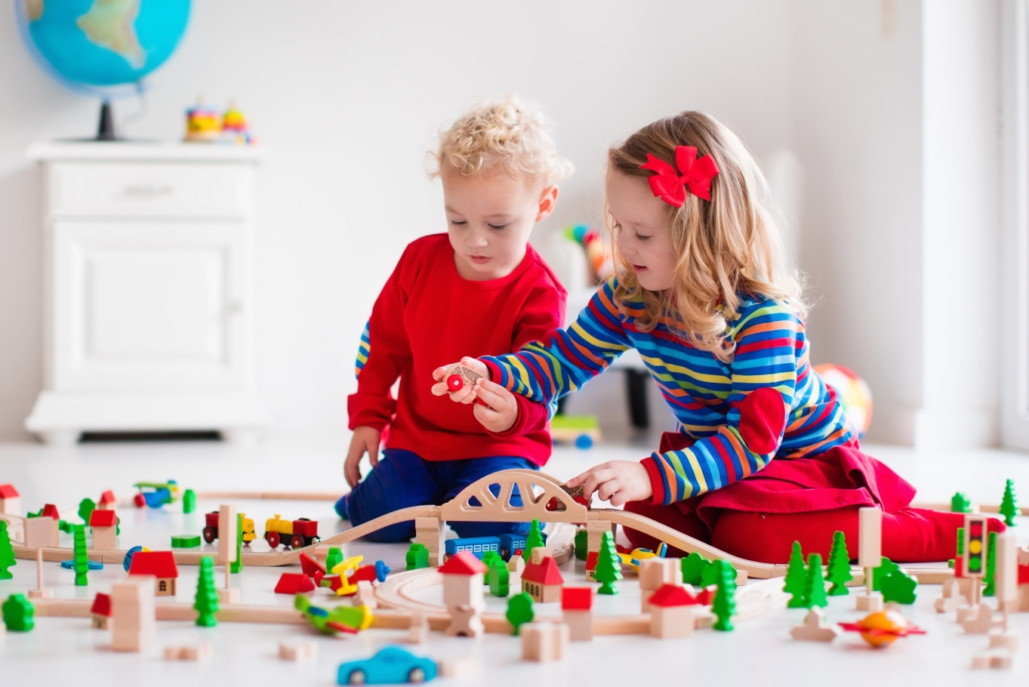
Open-ended questions require critical thinking and observation. They cannot be answered with one-word responses such as ‘yes’ or ‘no.’ These types of questions invite children to give a more detailed response, be creative, and express their thoughts and ideas. They can do this by making meaningful conversations when sharing their observations, recalling events, remembering past experiences, or making assumptions. These are all contributors to the development of their cognitive and communication skills.
When you ask open-ended questions, it will show that you pay attention and observe children’s actions. It demonstrates participation and involvement in the child’s learning process. You can engage children in talking about their creations by showing interest in what they are doing and wanting to know how they plan, execute, and direct their play or exploration. This way, you give children the chance to share information and take ownership of what they are doing.

Below are examples of open-ended questions.
- What are you planning to do next?
- Why is this here? What will this do?
- Why did you use this instead of this?
- Why did you bring this here?
- How did you do that? How did that happen?
- How did you assemble those pieces?
- How are they the same/different?
- Is there another way to do it?
- What will happen if you do this?
- What will you do next?
- Can you tell me about it?
- Tell me about the colours you used.
- Show me what it looks like.
Paying attention to children’s answers to the open-ended questions will help you understand their goals, intentions, and the ideas they want to confirm, resolve, or probe. Children will be encouraged to communicate their plans. As you observe, you may also notice some things that the child need to improve or work on to help them achieve their goal. Instead of giving direct answers, try to form open-ended questions that will lead children into trying more effective methods and approaches.

Further Reading
Read the references below to know about the benefits of using open-ended questions and how conversations with children deepen their understanding.
Using Open-Ended Questions with Children
Conversations with Children! Questions that Spark Conversations and Deepen Understanding

4.6 Model and Share Enthusiasm for Creative Work with Children

Children are naturally curious and creative. As an early childhood educator, preparing activities to nurture learning dispositions will surely allow children to have more opportunities for investigation. However, other than the materials, equipment, and activities, you must also show children that you are interested and excited to make discoveries with them. Showing enthusiasm for creative work will add to children’s motivation and convince them that activities will be fun. You can model this by:

Some of these may sound silly, as you may already know what to expect most of the time. Remember that your goal is to encourage children and demonstrate how you are invested in your creative work. When you develop an honest desire to join children in the learning process, your enthusiasm towards it will show naturally, and children will see it as they observe how you interact with them and your environment.
Enthusiasm is contagious. Demonstrating a passion for learning and creative work will surely motivate children to be interested in the activity. However, remember that the spotlight is theirs and not yours. You are not a performer, and your goal is to encourage and share the enthusiasm with them. Your actions must help them appreciate the passion for learning and aim to develop the same energy they see in you as they participate in creative opportunities. By allowing children to absorb the positive energy you give towards creative works and apply how you demonstrate them, you become successful in sharing the same passion and enthusiasm for learning.

4.7 Show Respect and Seek Permission from Children Regarding Their Creative Work

When you prepare activities that encourage children to engage in creative work, it is better to give them a blank slate where they are free to decide what to do and choose what to include in their work. Allowing children to select materials and execute their plans however they like is a way of respecting their ideas and choices in the processes they want to engage in. In addition, you give them a sense of responsibility and accountability when they feel that they ‘own’ what they are creating.
Showing respect to children’s work can be demonstrated through the simplest gestures. Below are some examples:

Seeking permission from children is also a way of acknowledging their ownership of their work. As an educator, you also model this by not adding or removing items on their work without asking them first or making decisions on their behalf, including where to put their name or which colours should go first. These are not restrictions on your participation because you have learnt that your involvement and engagement provides vital support in children’s learning. Seeking permission is a way to communicate to children that their work is important and reflects their individuality and expression, which should be treated with respect just like their own personalities.

You may ask simple questions, such as:

As you seek permission, children may not always respond with a ‘yes’ or something that agrees with your suggestion. It is imperative to show respect to their responses as much as you show it to their work. If the child is not ready or does not want to make any changes in their work or remove or add anything to it, accept and acknowledge their choices. They will also recognise the ownership of each other’s work and be involved in caring for them. Consistent demonstration of respect and seeking permission from children will also help them develop these values among each other.

4.8 Encourage Children to Respect and Appreciate the Creative Effort of Their Peers
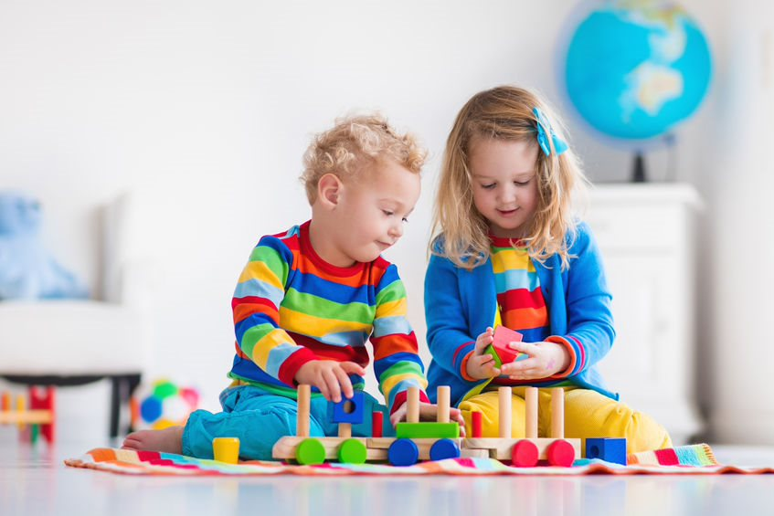
When you show respect to and appreciate children’s efforts and works, you establish a classroom environment that values children’s learning. Celebrating everyone’s achievements, no matter how small, is a way to make them feel seen and show respect to their work. You can review the examples in Subchapter 4.7 on how to model respect to children.
Each child has their own personality and individual preferences, strategies, ideas, and thoughts. Each of them is a unique individual, and their efforts may appear in different ways. When they feel valued and realise that you treat their accomplishments as equally important, they are most likely to hold on to those values and pass them on to their peers, including respect.
Appreciating children’s effort may sometimes be hard to identify right away if you do not pay close attention to what they are doing and are not aware of their developmental progress. If you know enough information about children, their personalities, the level of their skills and abilities, it will be easy for you to spot how they put effort into what they do. You can also show a genuine appreciation and give detailed observations on their progress.

Example:
A child who is still working on their fine motor skills engages in a drawing activity for an extended time. Because you understand the child’s challenges, you can give a more personal appreciation of what they do. You may say, ‘I can see how you are spending longer time drawing using crayons!’ As this naturally comes out to you, children will eventually notice and be inspired to copy what you are doing and share among each other what you are making them feel.

You may consider the following languages and examples to encourage children to notice the effort of their peers and show appreciation and respect:
- ‘Wow! Look at that, Olivia. Can you see how Adrian carefully stacks up the blocks to build his tower? Let us be careful not to shake the ground so it will not collapse.’
- ‘I think Lucas is trying a different way to knock off the animal figures he lined up. He was using a thin string a while ago and standing far from the line. Now, he has decided to put something heavy on it. Let us watch and see if it works this time!’
- ‘Amanda is working hard to go up the wall climber. She was trying to do big steps before. Now, she decided to take smaller steps. Let us give her a cheer!’
- ‘Look, Stephen. Ali is choosing the colour of the beads and buttons and carefully sticking them in his artwork. I like the colours she picked! What do you think?’
Checkpoint! Let’s Review
- Your participation and engagement in children’s creative exploration will serve as support for further learning and inquiries.
- Provide activities that will motivate children to create and execute their own ideas, interpretations and expressions.
- Give respect to children’s creative work by asking permission about it and model how they can show appreciation to each other’s creative efforts.

Further Reading
The references below are some articles from schools that tell you how to encourage respect and appreciation.
Five Ways to Teach and Encourage Respect
How to Teach Your Child Appreciation

Learning Activity for Chapter 4

Well done completing this chapter. You may now proceed to your Learning Activity Booklet (provided along with this Learner Guide) and complete the learning activities associated with this chapter.
Please coordinate with your trainer/training organisation for additional instructions and guidance in completing these practical activities.

V. Evaluate Experiences

Evaluation is the process of reviewing an activity, event, or experience to check its effectiveness, relevance, appropriateness, and value. It involves methods to measure student learning, development, and the skills they acquired through the activities. Evaluation is focused on forming feedback to children’s approach to learning. It is part of the assessment of children’s learning together with planning and documentation.
This chapter will discuss the methods and processes involved in evaluating children’s experiences: monitoring children’s participation through observation and critical reflection; identifying and using opportunities to gather feedback; using and expanding on children’s creative ideas; collaborating with others to evaluate and document outcomes according to policies and procedures and using outcomes as future reference.

Further Reading
The links below will give you an idea of the assessment for learning and development in early childhood education from the Victoria State Government Education and Training website.
Assessment for Learning
Effective Assessment

5.1 Monitor Children’s Role in Creativity Through Observation and Critical Reflection
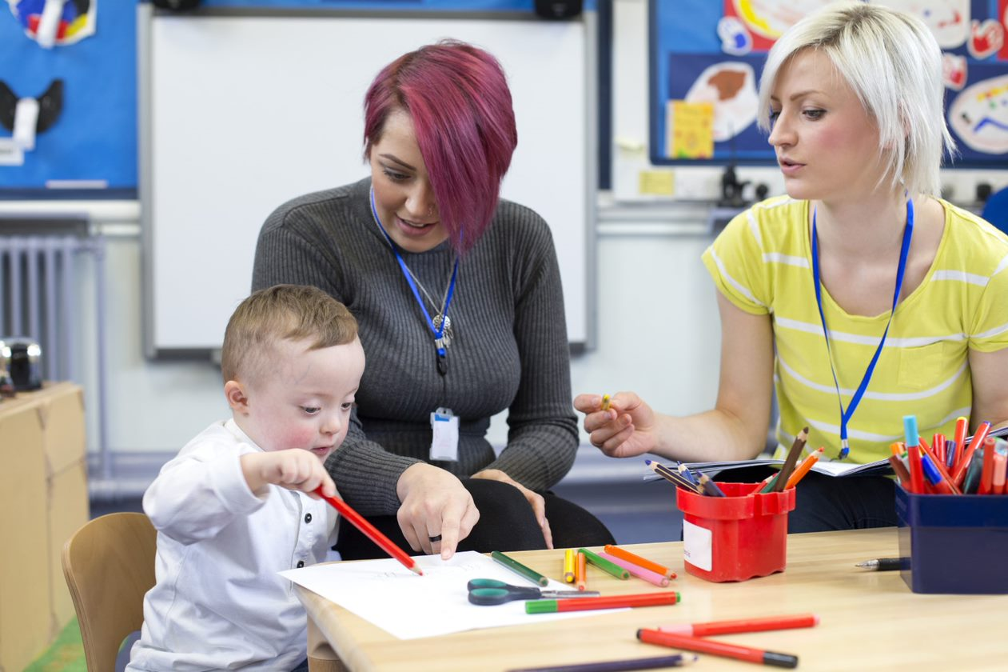
Observation is about paying attention to the different ways that a child does as they engage in the activity. It uses inclusive language, accurate descriptions, or a record of children’s attempts and what they do differently on each attempt. Observation is used to describe in detail or narrate a learning experience. Critical reflection, on the other hand, aims to understand the meaning of an experience. Below are some statements that describe critical reflection.
- It refers to the observation and attempt to interpret the child’s actions, goals, and intentions.
- It is used by educators to analyse and connect children’s actions to the guidelines and evidence-based standards of children development.
- It is a close examination of the different factors contributing to the learning experience.
- It also includes the educator’s reflection of their own experience, including the educator’s contribution to children’s learning, feelings towards the observation, or reaction to children’s responses.

- It is an analysis of children’s behaviours as they engage in creative opportunities.
- It creates a resolution and acts as evidence-based observation for future reference in expanding children’s learning.
Observation and critical reflection can be used to monitor children’s role in creativity. Children play the biggest role in a creative experience. Although the accessibility to materials and equipment is also crucial in nurturing creativity, children are the ones who make something happen out of them. Some examples of children’s role in creativity include:

To monitor children’s role in creativity, you must pay attention to what they are trying to achieve. You must look into the processes they engage in and changes that occur in their environment to see how children react to them. By doing that, you can identify their interests and what sparks their curiosity.
When using observation and critical reflection to monitor children’s role in creativity, you must:
- identify the child’s goals and pay attention to their actions
- analyse and reflect on the child’s participation in an activity

- ask questions to expand your analysis on the child’s role
Examples:
  - Does the child learn by observing or by looking at their peers from afar?
  - Does the child enjoy facilitating and leading their peers to an interactive activity, such as dramatic play?
  - Does the child enjoy quiet independent explorations?
  - Does the child enjoy communicating and expressing their discoveries and ideas verbally or through drawings?
- remember to look at a child as a unique individual who engages in various creative roles and may change their mind when something else catches their attention
- take note of your observations, reflections, and analysis of the child’s actions and use them to expand on children’s ideas and interests.

Further Reading
You may read the reference below from an early childhood educator who shares her expertise in analysis, reflection and evaluation in Early Childhood Programming and a paper on applying critical reflection to the experiences of educators and professionals.
The Empowered Educator – Analysis, Reflection and Evaluation in Early Childhood Programming
Critical Reflection
What is critical reflection?

5.2 Identify and Use Opportunities to Gather Feedback from Colleagues, Families and Children
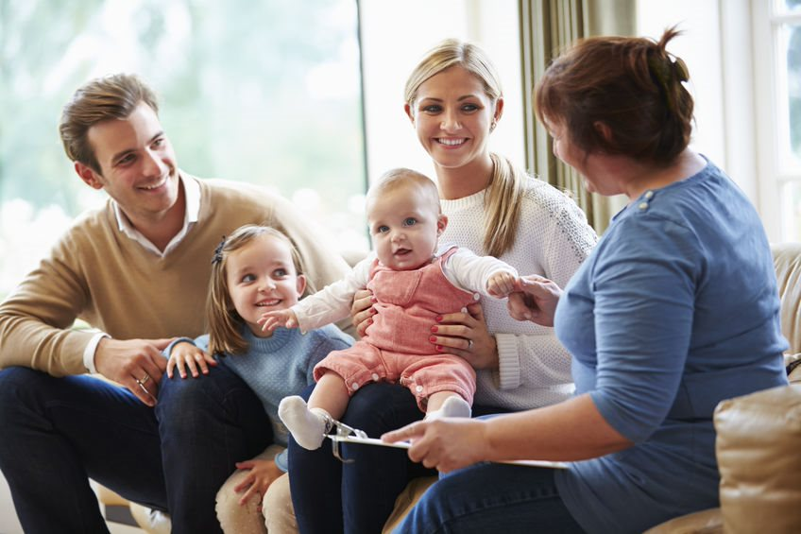
Feedback is one of the necessary tools for improvement. Getting them from relevant people who directly influence and know what you are trying to improve in your program or approach, or maybe about a child’s development, would help you evaluate children’s experience. Some of these people are your colleagues, children, and their families.
Gathering feedback from colleagues will help you get a different perspective on children’s experiences from a person with an educational background and who would most likely understand the context of your concern. They can also respond considering the policies and standards and the culture of the centre. These opportunities may be a casual conversation after classes or a scheduled meeting. You may also ask a colleague to observe your class and take notes from a third person’s perspective.
Information from families is also significant in evaluating children’s experiences. It shows an extension of children’s learning or what they remember from their classroom activities.
Some examples of these opportunities are:
- starting a quick and casual conversation with parents as children leave the centre
- sharing activities the children did for the day and sending pictures on email, social media, or messaging applications
- posting photos in centralised locations at the centre such as a bulletin board, which may spark a conversation with parents
- asking about children’s interest and play behaviours at home and relate them to the skills you are working on at the centre; ask parents whether they see the same improvement at home
- telling parents the kinds of activities you are doing at the centre and sharing with them your target goals.
Other than your colleagues and children’s families, you must know that the best source of feedback is the children. Your observation of children’s participation, how they engage in the activities you prepare, the questions they ask, or their expression of their discoveries are examples of the opportunities you can use to inquire further, probe their skills, and ask open-ended questions to gather feedback.

5.3 Use and Expand on Children’s Ideas in Relation to Creativity

Children who are invested in working on a project tend to discover new concepts and ideas. They like to experiment and execute what they think or try new ways and see what happens next. As an educator, you must pay attention to situations like this as you observe children’s explorations. When you analyse what children are trying to achieve, even if they do not seem obvious at first, you can use these opportunities to expand on children’s ideas and creativity.
You can start by taking note of your observations, including the topics related to the concepts they are exploring. One way to use and expand on children’s ideas is to create a mindmap. A mindmap is basically a dump of your thoughts and observations of children’s exploration. Make it your own and treat it as a projection of your thoughts. You can throw in concepts and topics that may be related and children’s behaviours and responses. Concepts may overlap, some may be unrelated to the original topic you initially started, but a mindmap will surely be helpful for planning and expanding children’s ideas.
Below is an example of a mindmap:
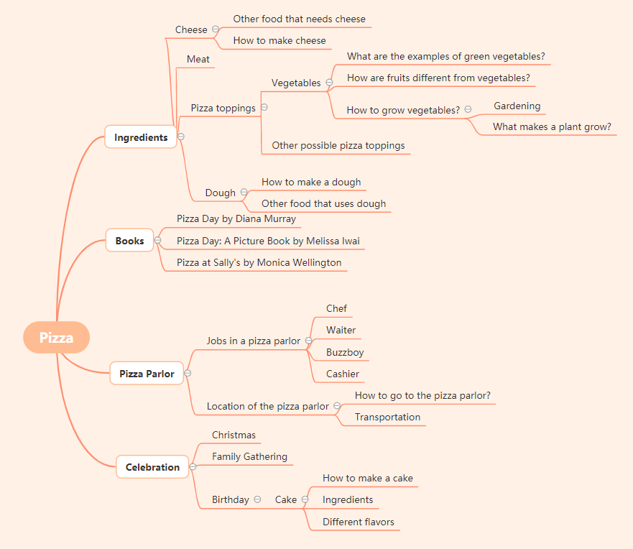

You may use a mindmap like this, for example, if you noticed that children are engaging in dramatic play and pretending to make pizza because of a recent experience at a birthday party. As you ask children open-ended questions to confirm information, you may find out their goals and interest. Is it in preparing pizza? Is it about serving food to their friends as an act of a love language? Do they enjoy eating together? Are they paying attention to the vegetables they put as toppings? Or are they in a setting of a restaurant and pretending to play different roles to serve pizza? These are only some of the questions that you can ask as you make your observation.
Expand your mind map as you observe children’s responses and actions by adding more items to it. You can plan and anticipate the direction of children’s exploration by analysing what they are trying to discover. You can use these opportunities to provide further investigations through activities, probing their interest, and preparing activities to support and answer their inquiries. When you use your mind map as a guide, you can then prepare for the next exploration through the following:
- Plan for the next topic of exploration
- Look for appropriate materials to use
- Prepare large and small group activities
- Take note of children who need close supervision and group them strategically
- Identify the creative processes that children may engage in
- Encourage children to participate through provocations

To expand on children’s ideas and creativity, you must observe and analyse how they manipulate the materials and their environment. That way, you can plan according to their interests and create a direction for their exploration.

Further Reading
The links below show resources and videos of how intentional teaching can extend children’s ideas and an article from TheSpoke about extending learning.
Extending Learning – more than activities
Intentional teaching resources
Intentional teaching practices

5.4 Collaborate with Others to Regularly Evaluate Children’s Participation in Experiences and Document Outcomes According to Service Policies and Procedures

You are not alone in nurturing children’s creativity, helping them achieve their full potential, and fostering independence and development. You work in a team, together with families, carers, and your partners in class. To fully evaluate and document children’s participation in experiences, you must collaborate with the persons involved in the creative processes. Planning, documenting, and evaluating are all included in the ongoing cycle of children’s assessment for learning.

Evaluating Children’s Participation and Experiences
The introduction of this chapter explicitly described what evaluation means and how it helps analyse children’s participation by paying attention to the effectiveness of the methods, approaches, and creative activities conducted. To plan for the continuity and give direction to children’s interests and exploration, evaluating their experiences is fundamental in moving forward to the next part of your curriculum.

Below are some of the methods you may consider when evaluating children’s experiences:
- Observe and document children’s participation in creative activities.
- Distinguish the different processes they are interested in.
- Identify the materials and equipment they enjoy investigating.
- Describe how they are manipulating the materials and equipment.
- Relate children’s explorations to the developmental milestones.

Observing and evaluating children’s experiences are usually affected by various factors. It is important to get to know the child, their skills and abilities, present developmental milestones, personalities, background, and learning dispositions. You may consider:
- the context and background, such as cultural background, tradition, race, and practices of the family
- the child’s interests, abilities, and strengths
- the classroom environment, such as the design, arrangement of furniture, availability of materials, and strategic placement of materials
- the child’s routines, such as sleep time or mealtime
- the child’s relationships, such as attachment to preferred adults, the adjustment in separation with family members or carers
- the expectations and goals of the family.

As you consider these factors, you can present accurate data and collaborate with your co-educators, supervisors, family members, including nannies and carers at home. Gathering data on children’s participation at the centre and confirming them with the observations at home will help identify if the activities are helping the child generalise the skills and apply them across different settings and around other people.
Getting insight from your co-educators and supervisor through regular meetings and discussions will give you a different perspective on your observations. It will also help ensure that your observations are objective and focused on the child’s learning experience. You may also collaborate with professionals to consult the data you gathered from your observation. Professionals will help you identify if children need further assistance or are at par with the developmental milestones.

Reviewing Educator’s Practices

Children’s experiences are not only affected by their learning dispositions and interest. Your practices and approaches also play a big role in children’s participation.
The State of Victoria published the actions and indicators of assessment practices and feedback for teaching and learning practices to achieve student engagement. Below are two out of nine principles and the action items that reflect educator’s teaching practices and their assessment and improvement:

Principle 6: Rigorous assessment practices and feedback inform teaching and learning
- Action 6.1 – Teachers design authentic, fit for purpose assessments to reflect the learning program and objectives.
- Action 6.2 – Teachers moderate student assessment and use data to diagnose student learning needs and plan for learning.
- Action 6.3 – Teachers provide regular feedback to students on their progress against individual learning goals and curriculum standards.
- Action 6.4 – Teachers analyse student achievement data to improve their practice.

Principle 7: Evidence-based strategies drive professional practice improvement
- Action 7.1 – Teachers evaluate the impact of teaching on learning by analysing multiple sources of data.
- Action 7.2 – Teachers identify and target areas for professional learning.
- Action 7.3 – Teachers draw on current research and use an inquiry improvement cycle.
- Action 7.4 – Teachers challenge and support each other to improve practice.
Sourced from Practice Principles for Excellence in Teaching and Learning, used under CC BY 4.0 © State of Victoria (Department of Education and Training)

The actions items under Principle 6 can be applied to your approaches and methods in planning for creative experiences. It emphasises the need to review and ensure that the assessment tools, program, and objectives are appropriate. It also highlights the importance of diagnosing and planning for children’s needs through the gathered data and providing regular feedback to children regarding the goals and standards. Finally, educators like you must analyse children’s development and set new goals for improvement.
Principle 7, on the other hand, focuses on the evidence-based methods that can help evaluate the impact of the teaching practices. It also highlights professional development, especially in aspects that need improvement and the importance of studying other evidence-based resources as a reference. Additionally, it emphasises how your collaboration with other educators will help in enhancing and revisiting the overall teaching practices.
You may access the full document, together with the indicators of each action item, in the further reading section below. Through the indicators stated in the document, the effectiveness of your practices as an educator can be evaluated further.
Collaborating with your co-educators and supervisors by observing your classroom practices will help you get an ‘outsider’s perspective’ and provide constructive feedback on the effectiveness of your strategies. When addressing the needs of children with special conditions, you may also collaborate with professionals to give you recommendations to properly attend to the child’s needs through evidence-based practices.

Further Reading
Learn more about collaboration, evaluating children’s experience and educator’s practices, and the reference for children’s developmental milestones through the links below:
Working as a Team
Developmental milestones and the Early Years Learning Framework and the National Quality Standards
Practice Principles for Excellence in Teaching and Learning
The Essential Guide to Professional Learning: Evaluation
Understand your Impact on Student Learning Growth

Documenting Outcomes
You must keep track of children’s progress, explorations, and investigations through documentation to support your evaluation and plan. It will help you review scenarios, backtrack events, and support your observations as you conduct an in-depth analysis of children’s experiences. Without documentation, you cannot plan further activities and will have no basis for expanding on children’s interests and ideas.
Review the activities in Subchapter 2.1 as an example and consider the following when documenting evaluation outcomes and observations:

Play Behaviours | Outline the observable behaviours you see, such as how the child prefers independent exploration or collaborative activities.
Positive Language | Use positive language. Avoid judgemental language that indirectly states that the child’s actions are right or wrong or compare the child’s progress to another child. For example: better, wrong, silly, etc.
Be Factual | Only use words that describe what is actually happening and can be characterised using neutral words. For example, ‘using the right hand to grab the crayon and made marks in a circular motion through hand and arm movements.’
Be Relevant | Include only details of direct quotes and information about the factual observation. For example, ‘prefers using a paintbrush with a bigger handle during an art activity, refused when offered a paintbrush with a smaller grip, moves paintbrush in a circular motion or jabs on the paper.’
Be Objective | Avoid subjective remarks that reflect your personal opinion or feelings towards the child’s exploration. For example, ‘did not like the activity today and only used one colour of paint’ or ‘did not have fun and engaged only for a short period, does not like painting activity.’

When documenting children’s experiences, they must be aligned with the service policies and procedures of the school, and most importantly, the Australian Government. According to the EYLF, when educators collaborate with families and the community, reflect on and analyse children’s experiences and learning and their teaching practices, they can focus on the following:
- the experiences and environments they provide and how they link to the intended learning outcomes
- the extent to which they know and value the culturally specific knowledge about children and learning that is embedded within the community in which they are working
- the each child’s learning in the context of their families, drawing family perspectives, understandings, experiences and expectations
- the learning opportunities which build on what children already know and what they bring to the early childhood setting
- the evidence that the learning experiences offered are inclusive of all children and culturally appropriate
- the importance of not making assumptions about children’s learning or setting lower expectations for some children because of unacknowledged biases
- the incorporation of pedagogical practices that reflect knowledge of diverse perspectives and contribute to children’s wellbeing and successful learning
- the sufficiently challenging experiences provided for all children
- the evidence that demonstrates children’s learning
- the ways to expand the assessment methods to make assessment richer and more useful.
Sourced from The Early Years Learning Framework for Australia, used under CC BY 4.0. © Commonwealth of Australia

Further Reading
Read through the references linked below to know more about documenting children’s learning.
Guidelines for Documenting Children’s Learning
Documenting and Reflecting for Children’s Learning

5.5 Use Evaluation Outcomes to Inform Future Practices


Your analysis of your observation will serve as your guide and give you a direction for the next steps to take in supporting children’s creativity and explorations. The result of your evaluation will be your basis in planning for future activities. Without the evaluation outcomes, there will be no continuity in children’s learning. Before you achieve the evaluation outcomes you need to reflect on, you need to plan your activities. Planning involves the setting of goals and preparation of activities based on children’s interests. These can all be supported by your evaluation outcomes.
Early years learning centres typically use a ‘planning cycle’ to prepare a quality program that best suits both the child and the centre's needs. The programming and planning cycle is an ongoing process that has four main steps.
Step 1: Question
This process involves your observation as an educator and the information and data you gather from children’s families and the communities in which they live. Below are some techniques under this step.
- Identify their individual and group strengths, interests, and goals in conjunction with the Framework’s Learning Outcomes and creativity.
- Observe children’s participation to determine their developmental progress and establish whether any goals and objectives (Learning Outcomes) have been achieved through creative opportunities in their home, community, and school.
- Observe children during their regular daily activities as they engage in various creative opportunities. Their use of language, social interactions with others, and work samples will demonstrate learning.
- Ask questions and analyse what has been observed. Analyse the observation considering child development theory and knowledge in relation to creativity and artistic expressions.
Below are some examples of questions you may ask:
- What learning is taking place here?
- How is this meant for us as educators, the child and their family?
- What are their strengths and interests?
- What do I see?
- What do others see?
- What do children recognise about themselves?
- What do families recognise?
- How does this meet the learning outcomes?
Step 2: Plan
Plan and design learning experiences considering what other learning activities or extensions of learning are possible. Planning includes:
- collaborating with children and families
- learning against the EYLF Learning Outcomes, especially creative learning experiences
- supporting the pedagogy, including individual and group plans, routines, experiences, and interactions inside and outside.
Step 3: Act/Do
Acting is to respond by implementing the plan for the children (i.e. putting the plan into action). As an educator, you need to present the experience in inviting ways to encourage children’s participation that provoke thoughts and ideas. It is important to remember to actively participate in the experience to guide and support children’s learning.
Step 4: Reflect
Reflecting on children’s learning is about analysing what you have noticed, understood, planned for, or how you and the children have interacted and participated. You may also review the strategies that worked or what modifications are needed.
Evaluation and reflection involve your review as an educator and discussion with colleagues, children, and families. Each person will have unique thoughts and observations to draw upon and offer meaningful and important reflection. You will also need to reflect on how the experience links to the EYLF practises, principles, and learning outcomes. Through the evaluation outcomes, you can expand on children’s interests, provide more creative experiences, and use them to reference future practice.

Checkpoint! Let’s Review
- Observation and critical reflection are important processes in evaluating children’s experiences.
- Feedback from and collaboration with families, colleagues, and children provide relevant information in evaluating children’s experiences and educator’s practices.
- Objective documentation and evaluation will help in planning for future activities and practices.

Further Reading
The following links tell about early education experiences and the framework in measuring outcomes. Access the references to get an idea of how to evaluate outcomes from children’s experiences.
Effective Early Education Experiences – E4Kids Study
Evaluating Programs
NQF Evaluation Framework – Key evaluation Questions and Sub Questions

Learning Activity for Chapter 5
Well done completing this chapter. You may now proceed to your Learning Activity Booklet (provided along with this Learner Guide) and complete the learning activities associated with this chapter.
Please coordinate with your trainer/training organisation for additional instructions and guidance in completing these practical activities.

References
Aboriginal and Torres Strait Islander studies handbook. (2018, March 19). Queensland Government - Queensland Curriculum & Assessment Authority. https://find.search.qld.gov.au/s/search.html?query=Aboriginal+and+Torres+Strait+Islander+Studies+Handbook&num_ranks=10&tiers=off&collection=qld-gov&profile=qcaa&form=simple
Ahmadi, N., & Besançon, M. (2017, August 1). Creativity as a stepping stone towards developing other competencies in classrooms. Education Research International. https://www.hindawi.com/journals/edri/2017/1357456/
Analysis, reflection and evaluation in early childhood programming. (2014, October 25). The Empowered Educator. https://www.theempowerededucatoronline.com/2014/10/analysis-reflection-and-evaluation-in.html/
Approved learning frameworks. (2019). ACECQA. https://www.acecqa.gov.au/nqf/national-law-regulations/approved-learning-frameworks
Artlandish Aboriginal art gallery. (2019, March 28). Artlandish Aboriginal Art Gallery. https://www.aboriginal-art-australia.com/
Assessment and rating process. (n.d.). ACECQA. https://www.acecqa.gov.au/assessment/assessment-and-rating-process
Assessment for learning. (n.d.). Victoria State Government - Department of Education and Training. https://www.education.vic.gov.au/childhood/professionals/learning/Pages/Assessment-for-learning-.aspx
Barton, G. (2015). Arts-based educational research in the early years. International Research in Early Childhood Education (IRECE), 6(1), 62–78. https://research-repository.griffith.edu.au/handle/10072/131736
Being a learner - Examples of learning styles. (n.d.). Victoria State Government - Department of Education and Training. Retrieved July 1, 2021, from https://www.education.vic.gov.au/childhood/professionals/profdev/Pages/settinglearnscene.aspx
Belonging, being & becoming - the early years learning framework for australia - department of education, skills and employment, australian government. (2009). Department of Education, Skills and Employment; Australian Government. https://www.dese.gov.au/national-quality-framework-early-childhood-education-and-care/resources/belonging-being-becoming-early-years-learning-framework-australia
Brunk, S. (2018, March 12). 5 ways to teach and encourage respect. Stepping Stone School. https://www.steppingstoneschool.com/5-ways-to-teach-and-encourage-respect/
Children (Education and care services national law application) act 2010. (n.d.). NSW Government. https://legislation.nsw.gov.au/view/html/inforce/current/act-2010-104
Componential model of creativity - An overview. (n.d.). Science Direct. Retrieved July 1, 2021, from https://www.sciencedirect.com/topics/psychology/componential-model-of-creativity
Critical and creative thinking. (n.d.). Victorian Curriculum. https://victoriancurriculum.vcaa.vic.edu.au/critical-and-creative-thinking/curriculum/f-10
Developmental milestones and the EYLF and NQS. (2015, May). Australian Government Department of Social Services. https://www.dss.gov.au/our-responsibilities/families-and-children/publications-articles/developmental-milestones-and-the-eylf-and-nqs
Documenting and reflecting for children’s learning. (2016). Queensland Government. https://www.foundationsforsuccess.qld.edu.au/decision-making-process/documenting-and-reflecting-children%E2%80%99s-learning
Education and care services (national uniform legislation) act 2011. (n.d.). Northern Territory Government. https://legislation.nt.gov.au/Legislation/EDUCATION-AND-CARE-SERVICES-NATIONAL-UNIFORM-LEGISLATION-ACT-2011
Education and care services national law (ACT) act 2011. (n.d.). ACT Government. https://www.legislation.act.gov.au/a/2011-42/
Education and care services national law (application) act 2011. (n.d.). Tasmanian Government - Tasmanian Legislation. https://www.legislation.tas.gov.au/view/html/inforce/current/act-2011-048
Education and care services national law (Queensland) Act 2011. (n.d.). Queensland Government - Queensland Legislation. https://www.legislation.qld.gov.au/view/html/inforce/current/act-2011-038?query=((Repealed%3DN+AND+PrintType%3D%22act.reprint%22+AND+PitValid%3D%40pointInTime(20210701000000))+OR+(Repealed%3DN+AND+PrintType%3D%22reprint%22+AND+PitValid%3D%40pointInTime(20210701000000)))+AND+Content%3D(%22education%22+AND+%22and%22+AND+%22care%22+AND+%22services%22+AND+%22national%22+AND+%22law%22+AND+%22act%22+AND+%222011%22)&q-collection%5B%5D=inforceActs&q-collection%5B%5D=inforceSLs&q-documentTitle=&q-prefixCcl=&q-searchfor=education+and+care+services+national+law+act+2011&q-searchin=Content&q-searchusing=allwords&q-year=&q-no=&q-point-in-time=01%2F07%2F2021&q-searchform=basic
Education and care services national law (WA) act 2012. (n.d.). Government of Western Australia - Western Australian Legislation. https://www.legislation.wa.gov.au/legislation/statutes.nsf/main_mrtitle_12929_homepage.html
Education and care services national law act 2010. (n.d.). Victorian Legislation. https://www.legislation.vic.gov.au/in-force/acts/education-and-care-services-national-law-act-2010/013
Education and care services national regulations. (2011). NSW Government - NSW Legislation. https://www.legislation.nsw.gov.au/view/html/inforce/current/sl-2011-0653#ch.4-pt.4.1
Education and early childhood services (regulation and standards) act 2011. (n.d.). Government of South Australia - South Australian Legislation. https://www.legislation.sa.gov.au/LZ/C/A/EDUCATION
Effective assessment. (n.d.). Victoria State Government - Department of Education and Training. https://www.education.vic.gov.au/school/teachers/teachingresources/practice/Pages/insight-effective.aspx
Effective early education experiences. (2020, October 2). Victoria State Government - Department of Education and Training. https://www.education.vic.gov.au/about/research/Pages/E4kids.aspx
Elliott, S. (2019, June 11). Education for sustainability in practice. The Spoke – Early Childhood Australia’s Blog. http://thespoke.earlychildhoodaustralia.org.au/education-sustainability-practice/
Extending learning—more than activities. (2015, February 20). The Spoke – Early Childhood Australia’s Blog. http://thespoke.earlychildhoodaustralia.org.au/extending-learning-activities/
Facilities and environment. (n.d.). Sparkling Stars Childcare Centre. Retrieved July 20, 2021, from https://compliantlearningresources.com.au/network/sparkling-stars/policies-procedures/facilities-and-environment/
Fine arts (emergent literacy). (2019). Victoria State Government - Department of Education and Training; https://www.education.vic.gov.au/childhood/professionals/learning/ecliteracy/emergentliteracy/Pages/finearts.aspx
Guide to the NQF. (2018). ACECQA. https://www.acecqa.gov.au/nqf/about/guide
Guidelines for documenting children’s learning. (n.d.). ACECQA. https://www.acecqa.gov.au/search?s=guidelines%20for%20documenting%20children%27s%20learning&f%5B0%5D=bundle%3Adocument
Holdhus, K., Høisæter, S., Mæland, K., Vangsnes, V., Engelsen, K. S., Espeland, M., Espeland, Å., & Boylan, M. (2016). Improvisation in teaching and education—roots and applications. Cogent Education, 3(1),. https://doi.org/10.1080/2331186x.2016.1204142
Honig, A. S. (n.d.). How to promote creative thinking. Scholastic. Retrieved July 20, 2021, from https://www.scholastic.com/teachers/articles/teaching-content/how-promote-creative-thinking/
How to teach your child appreciation. (2019, July 26). Children’s Bureau. https://www.all4kids.org/news/blog/how-to-teach-your-child-appreciation/
Intentional teaching practices. (2019). Queensland Government - Queensland Curriculum & Assessment Authority. https://www.qcaa.qld.edu.au/kindergarten/qklg/practice/intentional-teaching-practices
Intentional teaching resources. (2021). Queensland Government - Queensland Curriculum & Assessment Authority. https://www.qcaa.qld.edu.au/kindergarten/qklg/learning-development-areas/intentional-teaching-resources
Knowledge frameworks of Aboriginal and Torres Strait Islander peoples. (2019). Queensland Government - Queensland Curriculum & Assessment Authority. https://www.qcaa.qld.edu.au/about/k-12-policies/aboriginal-torres-strait-islander-perspectives/resources/frameworks
Koester, A. (2014, April 9). Integrating STEAM into the ECE classroom: Finding and utilizing the right resources for your center. Early Childhood Webinars. https://www.earlychildhoodwebinars.com/webinars/integrating-steam-into-the-ece-classroom-finding-and-utilizing-the-right-resources-for-your-center-by-amy-koester/
Kupers, E., Lehmann-Wermser, A., McPherson, G., & van Geert, P. (2018). Children’s creativity: A theoretical framework and systematic review. Review of Educational Research, 89(1), 93–124. SAGE Journals. https://doi.org/10.3102/0034654318815707
Learning dispositions. (2021, June 23). NSW Government. https://education.nsw.gov.au/teaching-and-learning/school-learning-environments-and-change/future-focused-learning-and-teaching/learning-dispositions
Learning music fosters creativity. (n.d.). Forte School of Music. https://fortemusic.com.au/joondalup/blog/learning-music-fosters-creativity
Lesser, C. (2018, November 23). How to talk to kids about art. Artsy. https://www.artsy.net/article/artsy-editorial-talk-kids-art
Lindsay, G. (2016). Do visual art experiences in early childhood settings foster educative growth or stagnation? Faculty of Social Sciences - Papers (Archive), 1–14. University of Wollongong Australia Research Online. https://ro.uow.edu.au/sspapers/2558/
Loose parts toolkit. (n.d.). Play Australia. Retrieved July 1, 2021, from https://www.playaustralia.org.au/node/674
Lorina. (2015, May 15). Using open-ended questions with children. Aussie Childcare Network. https://aussiechildcarenetwork.com.au/articles/teaching-children/using-open-ended-questions-with-children
Miller, M. (2011). Critical reflection. Reflections Magazine. https://eprints.qut.edu.au/79260/
National quality standard. (n.d.). Victoria State Government (Department of Education and Training). Retrieved July 1, 2021, from https://www.education.vic.gov.au/childhood/providers/regulation/Pages/natqualstandardlinks.aspx#link42
Natural environments. (2019). Victoria State Government - Department of Education and Training; https://www.education.vic.gov.au/childhood/providers/regulation/Pages/naturalenvironments.aspx
NQF evaluation framework - key evaluation questions and sub questions. (n.d.). ACECQA. https://www.acecqa.gov.au/search?s=nqf%20evaluation%20framework&f%5B0%5D=bundle%3Adocument
Parker, R., & Lamont, A. (2010, September 7). Evaluating programs. Australian Institute of Family Studies - Child Family Community Australia. https://aifs.gov.au/cfca/publications/evaluating-programs
Practice principles for excellence in teaching and learning. (2019). Victoria State Government - Department of Education and Training; https://www.education.vic.gov.au/school/teachers/teachingresources/practice/improve/Pages/principlesexcellence.aspx
Sally. (2016, September 26). What is a provocation? Fairy Dust Teaching. https://fairydustteaching.com/2016/09/what-is-a-provocation/
Shao, Y., Zhang, C., Zhou, J., Gu, T., & Yuan, Y. (2019). How does culture shape creativity? A mini-review. Frontiers in Psychology, 10, 7–8. https://doi.org/10.3389/fpsyg.2019.01219
Sharp, C. (2004). Developing young children’s creativity: What can we learn from research? National Foundation for Educational Research, 32, 10–12. https://www.nfer.ac.uk/developing-young-childrens-creativity-what-can-we-learn-from-research/
Stacking and building games: children 3-6 years. (n.d.). Raising Children Network. https://raisingchildren.net.au/guides/activity-guides/stacking-and-building-games#stacking-and-building-games-why-theyre-good-for-children-nav-title
STEM in early childhood. (2020, February 13). Victoria State Government - Department of Education and Training. https://www.education.vic.gov.au/about/programs/learningdev/vicstem/Pages/ec.aspx
Strasser, J. (n.d.). Conversations with children! Questions that spark conversations and deepen understanding. NAEYC. https://www.naeyc.org/resources/pubs/tyc/apr2018/conversations-with-children
The essential guide to professional learning: Evaluation. (n.d.). Australian Institute for Teaching and School Leadership. https://www.aitsl.edu.au/tools-resources/resource/the-essential-guide-to-professional-learning-evaluation
The importance of kids asking questions. (2020, March 25). InformED. https://www.opencolleges.edu.au/informed/features/importance-kids-asking-questions/
The power of loose parts play. (n.d.). Department of Education South Australia. https://www.education.sa.gov.au/funnelback/search?query=the%20power%20of%20loose%20parts%20play
Torres Strait Island regional council. (2016). Torres Strait Island Regional Council. http://www.tsirc.qld.gov.au/
Twigg, D., & Garvis, S. (2010). Exploring art in early childhood education. International Journal of Arts in Society, 5(2), 193–204. https://research-repository.griffith.edu.au/handle/10072/34998
Understand your impact on student learning growth. (2019). Victoria State Government - Department of Education and Training; https://www.education.vic.gov.au/school/teachers/teachingresources/practice/improve/Pages/eitimpact.aspx
Visual art and Aboriginal knowledges. (2019). Queensland Government - Queensland Curriculum & Assessment Authority. https://www.qcaa.qld.edu.au/about/k-12-policies/aboriginal-torres-strait-islander-perspectives/resources/a-visual-art-knowledges
Visual art and creativity in your curriculum. (n.d.). Early Childhood Australia Learning Hub. https://learninghub.earlychildhoodaustralia.org.au/elearning/visual-art-and-creativity-in-your-curriculum/
Visual art and Torres Strait Islander knowledges. (2019). Queensland Government - Queensland Curriculum & Assessment Authority. https://www.qcaa.qld.edu.au/about/k-12-policies/aboriginal-torres-strait-islander-perspectives/resources/tsi-visual-art-knowledges
What is a provocation? Encouraging your child’s Interests. (2017, August 16). The Compass School; https://www.thecompassschool.com/blog/what-is-provocation/
What is critical reflection? (n.d.). ACECQA. Retrieved July 1, 2021, from https://www.acecqa.gov.au/search?s=what%20is%20critical%20reflection&f%5B0%5D=bundle%3Adocument
What we do. (2021, March 21). Australian Government Department of Infrastructure, Transport, Regional Development and Communications - Office for the Arts. https://www.arts.gov.au/
Working as a team. (2019). Virtual Lab School. https://www.virtuallabschool.org/preschool/program-management/lesson-2

