3.5 Reflective Journal

This part of the assessment will require you to reflect on and understand the role of the arts in development and learning and evaluate the learning experiences you planned and implemented for this assessment.
Specifically, you are, through critical reflection, required to:
- Explore the role of the arts in early childhood development and learning.
- Understand the concept of creative freedom and its positive connection to development and learning.
- Identify the connection between creativity and different learning dispositions.
- Evaluate the three learning experiences you planned and implemented for this assessment.
Read the instructions carefully before proceeding.
Steps to take:
- Locate the Reflective Journal on the following pages.
The Reflective Journal outlines critical reflection points organised into Reflective Journal Entries that you are required to complete as part of this assessment.
Review the instructions here and the contents of this Reflective Journal so you can prepare for this task.
- Complete each entry in the Reflective Journal. To complete each entry:
  - Review and follow the instructions provided in the entry.
  - Record the required responses in the spaces provided in the journal entry.
- Save and submit the completed and signed Reflective Journal. Use the filename:
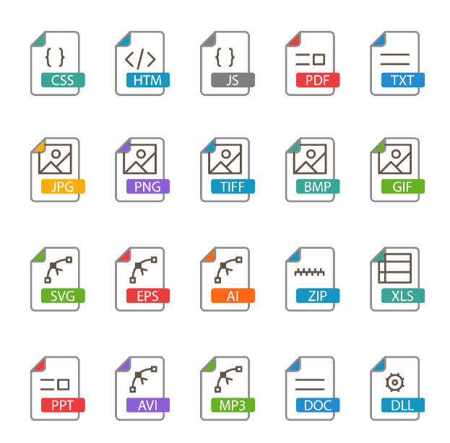 | CHCECE043 3.5 REFJ

IMPORTANT REMINDER
Remember to ensure the privacy and confidentiality of the participants of this assessment activity (e.g., children, family members, and colleagues) at all times.
Do not include their real names in your submissions. Use placeholders instead.
- Replace children’s names with Child A, Child B, etc.
- Replace family names with Family A, Family B, etc.
- Replace colleagues’ names with Colleague A, Colleague B, etc.
Do not use aliases as this might cause unintended breaches of privacy and confidentiality.
Although you are using placeholders to refer to people in the centre, the content of your submissions must always be real and factual.

