3.4 Promoting Creativity in the Service
This part of the assessment requires you to complete the following tasks in the workplace while being observed by your supervisor or endorsed observer(s):
  - Task 1: Provide opportunities for at least two different children to be exposed to three different art forms and at least one artist from each of these three art forms. These art forms and artists must be from diverse cultures, i.e. at least two different cultures overall.
Art forms may include but are not limited to visual arts, such as paintings, drawings, sculptures, photography, etc., or performing arts, such as dance, music, opera, films, theatre, etc.
While artists may include but are not limited to painters, illustrators, musicians, singers, musical groups, etc.
You can do this with the two children together or separately, as shown below:
CHILD 1 | CHILD 2
Art form 1 and Artist 1 | Art form 4 and Artist 4
Art form 2 and Artist 2 | Art form 5 and Artist 5
Art form 3 and Artist 3 | Art form 6 and Artist 6

CHILD 1 and CHILD 2
Art form 1 and Artist 1
Art form 2 and Artist 2
Art form 3 and Artist 3

  - Task 2: Encourage one child who participated in the activities in Parts I and II to extend their creative efforts over at least two days.
This may be done through following up with the child post-activity through intentional teaching strategies over a period of at least two days, for example, regularly encouraging them to use their creativity to overcome challenges in real-life situations, allowing the child to explore different elements in the learning environment (e.g. natural and recycled materials they can use in day-to-day activities) while ensuring their health and safety, providing reasonable time for the child to be creative, encouraging them to express their own ideas, etc.
  - Task 3: Encourage one child (must be a different child from above) who participated in the activities in Parts I and II to extend their creative efforts over at least two weeks.
This may be done through following up with the child post-activity through intentional teaching strategies over a period of at least two weeks, for example, regularly encouraging them to use their creativity to overcome challenges in real-life situations, allowing the child to explore different elements in the learning environment (e.g. natural and recycled materials they can use in day-to-day activities) while ensuring their health and safety, providing reasonable time for the child to be creative, encouraging them to express their own ideas, etc.
You are required to complete the tasks outlined in this Observation Form according to the quality standards set by your organisation and in compliance with the industry standards in early childhood education and care.
As evidence of your successful demonstration of these skills, your supervisor or endorsed observer(s) must observe you and complete an Observation Form as you complete these tasks in the service.
Read the instructions carefully before proceeding.
Steps to take:
- Seek permission and assistance from your supervisor for you to complete this assessment in the service.
- Locate the Observation Form 3.4 on the following pages.
Observation Form 3.4 outlines all the tasks you need to complete in the workplace while being observed by your supervisor or other endorsed observer(s).
Review the instructions here and the contents of the Observation Form 3.4 with your supervisor or other endorsed observer(s) before starting so you can prepare for these tasks.
- Arrange a suitable time for you to complete the tasks listed above in the service and for your supervisor or other endorsed observer(s) to observe you during these tasks.
- Complete the tasks in the Observation Form 3.4, while your supervisor or other endorsed observer(s) observes you.
- As you complete each task in the Observation Form 3.4:
  - Record how you completed this task.
  - Record important details relevant to your completion of this task, where required.
  - Have your supervisor/observer complete and sign their initials in the Observed By section of each task. Their initials must be handwritten.
  - Consolidate the supporting documents/supplementary evidence as you have completed these tasks and submit them to your assessor.
- Once you have completed all tasks and all the relevant sections in this Observation Form 3.4, have your supervisor complete and sign the Supervisor Declaration section of the form. Their signature must be handwritten.
- Save and submit the completed and signed form. Use the filename:
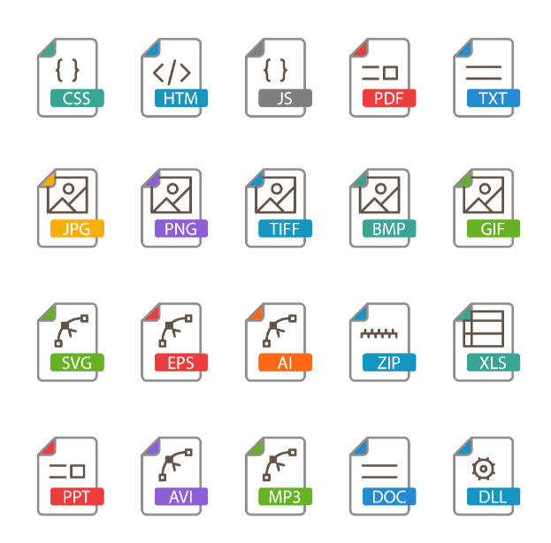 | CHCECE043 3.4 OBSF

IMPORTANT REMINDER
Remember to ensure the privacy and confidentiality of the participants of this assessment activity (e.g., children, family members, and colleagues) at all times.
Do not include their real names in your submissions. Use placeholders instead.
- Replace children’s names with Child A, Child B, etc.
- Replace family names with Family A, Family B, etc.
- Replace colleagues’ names with Colleague A, Colleague B, etc.
Do not use aliases as this might cause unintended breaches of privacy and confidentiality.
Although you are using placeholders to refer to people in the centre, the content of your submissions must always be real and factual.

