3.3 Music and Movement Activity Evaluation
This task requires you to evaluate the music and movement activity you implemented and facilitated in Task 2.3. This will be done in collaboration with the following people:
  - Your supervisor or other endorsed observer(s) who observed you as you implemented and facilitated the activity.
  - The children’s family members you identified in Part G. Feedback Mechanism of your LAECD 1.3
  - The two educators you identified in Part G. Feedback Mechanism of your LAECD 1.3.
Read the instructions carefully before proceeding.
Steps to take:
- Get the LAECD 1.3 you partially completed in Task 1.3 and Task 2.3.
At this point in the assessment, you will be required to complete Part J of the LAECD 1.3.
- Consult with your supervisor regarding opportunities for you to evaluate the activity you implemented in Task 3.3.
Review the instructions here as well as the contents of Part J of the LAECD 1.3 and with your supervisor so you can prepare for this task.
Part J of the LAECD 1.3 outlines the things you must address when evaluating the activity with the key stakeholders listed above.
- Access and review your service’s policies and procedures for gathering and documenting feedback.
Ensure that you follow these policies and procedures as you complete this task in the service.
- Meet with the following people:
  - Your supervisor or other endorsed observer(s) who observed you as you implemented and facilitated the activity.
  - The children’s family members you identified in Part G. Feedback Mechanism of your LAECD 1.3
  - The two educators you identified in Part G. Feedback Mechanism of your LAECD 1.3.
- In your meeting with them, discuss the following to them:
  - A brief overview of the activity, as documented in Part A – G of your LAECD 1.3.
  - Outcomes of the activity, as documented in Part H – I of your LAECD 1.3.
Show them the children’s creations/outputs from the activity or photos of these creations/outputs.
- After discussing the above with them, gather their feedback on the following:
  - The overall activity.
  - The three learning opportunities in this activity.
  - Children’s participation in the activity.
- Document your discussion in Part J of your LAECD 1.3. Complete all other parts of Part J by indicating the following details:
- Attendees of this meeting
- Date and time of the meeting
- Location/venue of the meeting
- At the end of the meeting, have your supervisor complete and sign the Part J Supervisor Declaration section of the LAECD 1.3. Their signature must be handwritten.
- Save and submit the completed and signed LAECD 1.3. Use the filename:
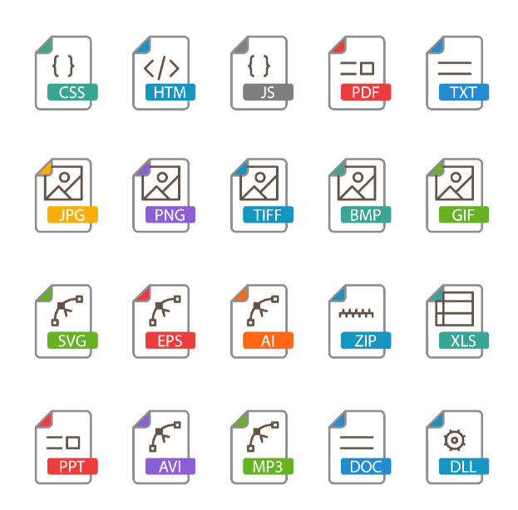 | CHCECE043 3.3 LAECD 1.3

IMPORTANT REMINDER
Remember to ensure the privacy and confidentiality of the participants of this assessment activity (e.g., children, family members, and colleagues) at all times.
Do not include their real names in your submissions. Use placeholders instead.
- Replace children’s names with Child A, Child B, etc.
- Replace family names with Family A, Family B, etc.
- Replace colleagues’ names with Colleague A, Colleague B, etc.
Do not use aliases as this might cause unintended breaches of privacy and confidentiality.
Although you are using placeholders to refer to people in the centre, the content of your submissions must always be real and factual.

