2.3 Music and Movement Activity Implementation and Monitoring
This task requires you to implement and facilitate the music and movement activity you planned in Task 1.3 with three children while being observed by your workplace supervisor or other endorsed observer(s)
IMPORTANT: While completing this task, you must demonstrate the skills outlined in Observation Form 2.3.
Read the instructions carefully before proceeding.
Steps to take:
- Get the LAECD 1.3 you partially completed in Task 1.3.
At this point of the assessment, you will complete Parts H and I of the template. The rest will be completed in Part III of this Skills Workbook.
- Locate and review the Observation Form 2.3 on the following pages.
This form outlines all the skills that you must demonstrate while facilitating the imaginative and dramatic play activity you planned in Task 1.3.
Your workplace supervisor or other endorsed observer(s) will complete this form as they observe you facilitate the activity.
- Consult with your supervisor regarding opportunities for you to implement and facilitate the LAECD 1.3 to the three children you have identified as participants of this activity.
Review the instructions here as well as the contents of Parts H and I of the LAECD 1.3 and the Observation Form 2.3 with your supervisor so you can prepare for this task.
Part H of the LAECD 1.3 outlines the things you must observe and monitor in children’s performance during the activity.
- With the help of your supervisor, prepare to implement and facilitate the LAECD 1.3 you developed in Task 1.3.
- Schedule when you will implement the activity.
- Arrange for your supervisor or other endorsed observer(s) to observe you as you facilitate this activity in the service.
- Seek consent from the family member(s) of each child for you to:
    - Take photos of the children during the activity.
    - Submit copies of de-identified anecdotal records and learning stories to your training provider.
Follow your service’s policies and procedures for privacy and confidentiality and seeking consent from the family member(s).
Access your service’s Consent Forms specifically for ensuring children’s privacy and confidentiality in photo documentation.
Complete one Consent Form for each child and have their family member sign the form. Their signature must be handwritten.
Secure original copies of these signed Consent Forms in accordance with your service’s record-keeping policies and procedures and secure a copy for yourself.
- Gather and organise the resources, including the materials and equipment you listed in Part F. Learning Opportunities of your LAECD 1.3.
- Prepare and organise the learning environment.
- Implement and facilitate the activity developed in Task 1.3.
The format and structure of the activity you will implement and facilitate will greatly depend on your children’s needs, interests, and learning needs, which you have previously identified in Task 1.3. However, the activity must:
- Be relevant to music and movement.
- Involve use of at least one digital technology.
- Involve exposure to Aboriginal and/or Torres Strait Islander Peoples’ art forms and artists.
- Involve the use of creativity to overcome challenges, e.g. figuring out how to incorporate recycled, diverse, and natural materials in their work.
- Involve the use of creativity to improvise equipment and materials, including using recycled materials in their work.
- Involve collaborating creatively with other children.
- Include using and caring for materials and equipment appropriately.
- Be relevant to sustainable outcomes, e.g. at the end of the activity, the children will have created an artwork using recycled/recyclable, diverse, and natural materials, or a product/output that can be reused in future activities.
While implementing and facilitating the activity:
- Demonstrate all the skills outlined in the Observation Form 2.3.
Your assessor must complete this form during the activity.
- Carefully observe each child’s performance during the activity as you will be recording this in Part H of your LAECD 1.3.
Your observation must include:
  - Their engagement and participation in the activity.
  - How they use their creativity to overcome challenges in the activity.
  - How they collaborate with other children.
- After the activity, assess each child’s knowledge, skills, and behaviour against the target knowledge, skills, and behaviour you identified in Part C. Learning Objectives of your LAECD 1.3.
When assessing each child, use the assessment methods you identified in Part D. Evidence of Learning.
- Gather and collate evidence from this activity, including:
  - At least one photo of the learning environment, e.g. the classroom, or outdoor site where the activity was implemented.
  - At least one photo of the equipment and materials used in this activity.
The photo must show at least one of these equipment/materials is recycled and at least one is natural, i.e. found in nature, such as leaves, flowers, etc.
  - At least one photo of the three children during the activity.
The photo must not show the children’s faces or any other details that may lead to their identification.
  - At least one photo of the children’s outputs from this activity.
The photo must show children’s outputs are sustainable, e.g. at the end of the activity, the children will have created an artwork using recycled/recyclable, diverse, and natural materials, or a product/output that can be reused in future activities.
  - At least one documentation of each child’s progress, e.g. anecdotal records, learning stories, etc.
Use your service’s templates for anecdotal records and learning documents and follow your service’s procedures for documenting observations.
Collate these pieces of evidence into a portfolio/folder and submit them using the filenames:
 | Evidence | Filename
1 | Portfolio/folder containing all of the below. | CHCECE043 2.3 Evidence Portfolio
2 | At least one photo of the learning environment, e.g. the classroom, or outdoor site where the activity is implemented. | CHCECE043 2.3 Photo A  If submitting more than one photo:  CHCECE043 2.3 Photo A1  CHCECE043 2.3 Photo A2  CHCECE043 2.3 Photo A3
3 | At least one photo of the materials and resources used in this activity. | CHCECE043 2.3 Photo B
4 | At least one photo of the three children during the activity. | CHCECE043 2.3 Photo C
5 | At least one photo of the children’s outputs from this activity. | CHCECE043 2.3 Photo D
6 | At least one documentation of Child 1’s progress. | CHCECE043 2.2 Child 1  If submitting more than one documentation:  CHCECE043 2.3 Child 1-1  CHCECE043 2.3 Child 1-2
7 | At least one documentation of Child 2’s progress. | CHCECE043 2.3 Child 2
8 | At least one documentation of Child 3’s progress. | CHCECE043 2.3 Child 3

As shown below:
 |  | CHCECE043 2.3 Portfolio
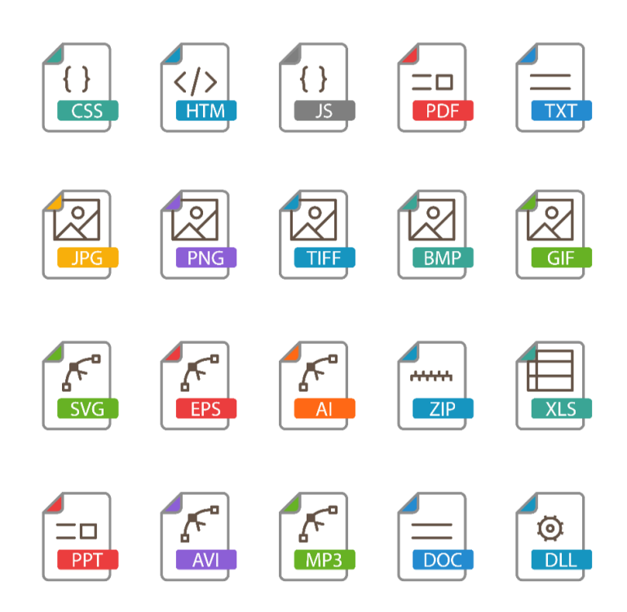 | CHCECE046 2.3 Photo A
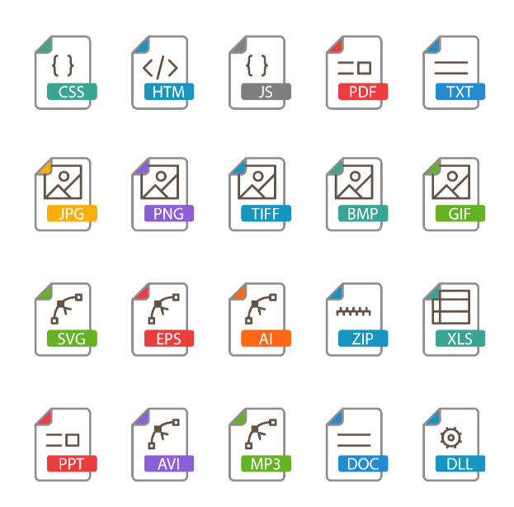 | CHCECE046 2.3 Child 1
- After implementing the three learning opportunities in this activity, gather children’s feedback.
- After the activity, complete Parts H – I of the LAECD 1.3.
Part H. Implementation and Monitoring
- Indicate the date and time of the activity implementation.
- Indicate the location where the activity was implemented.
- Record your observations of each child, including:
  - Their engagement and participation in the activity.
  - How they use their creativity to overcome challenges in the activity.
Critically reflect on what you have observed in each child, by identifying one area in which each child did well and one area in which they need more support.
  - How they collaborate with other children.
- Document each child’s feedback on the activity.
Part I. Assessment
Record your assessment of each child, including:
  - Their knowledge against the target knowledge you identified in Part C. Learning Objectives
  - Their skills against the target skills you identified in Part C. Learning Objectives.
  - Their behaviour against the target behaviour you identified in Part C. Learning Objectives.
  - Your determination of whether each child has achieved these target knowledge, skills, and behaviour.
Tick YES if the child has achieved the target knowledge, skill, and behaviour after the activity and NO if otherwise.
- Have your supervisor or other endorsed observer(s) complete and sign Part H – I Supervisor Declaration. Their signature must be handwritten
- Secure this partially accomplished LAECD 1.3 template. You will complete the rest of the template evidence in Task 3.3.
- After the activity, have your supervisor or other endorsed observer(s) complete and sign the Supervisor Declaration section of the Observation Form 2.3. Their signature must be handwritten
- Save and submit the completed and signed form. Use the filename:
CHCECE043 2.3 OBSF

IMPORTANT REMINDER
Remember to ensure the privacy and confidentiality of the participants of this assessment activity (e.g., children, family members, and colleagues) at all times.
Do not include their real names in your submissions. Use placeholders instead.
- Replace children’s names with Child A, Child B, etc.
- Replace family names with Family A, Family B, etc.
- Replace colleagues’ names with Colleague A, Colleague B, etc.
Do not use aliases as this might cause unintended breaches of privacy and confidentiality.
Although you are using placeholders to refer to people in the centre, the content of your submissions must always be real and factual.

